ESCUELA NORMAL DE EDUCACION PREESCOLAR

EXAMEN EXTRAORDINARIO TERCER GRADO PRIMERA OPORTUNIDAD

TEACHER: MAYELA GAONA GARCIA

NAME:_____________________________________GRADO ____ SECCION_____

**Completion**

**Complete the letter with words from the box.**

3.

|  |  |  |  |  |
| --- | --- | --- | --- | --- |
| **always** | **for** | **lately** | **~~recently~~** | **still** |

Dear Nathan,

**Example:** How are you? I have  *recently*  moved to San Diego! I’ve lived here ____________________ two months. It’s great! I’ve ____________________ wanted to live in California. I have an apartment, but I ____________________ haven’t bought any furniture.

What have you been up to ____________________? Write soon!

Your friend,

Marsha

**Use the information in the chart to complete the sentence. Write what the person would rather (****) or would rather not (****) do.**

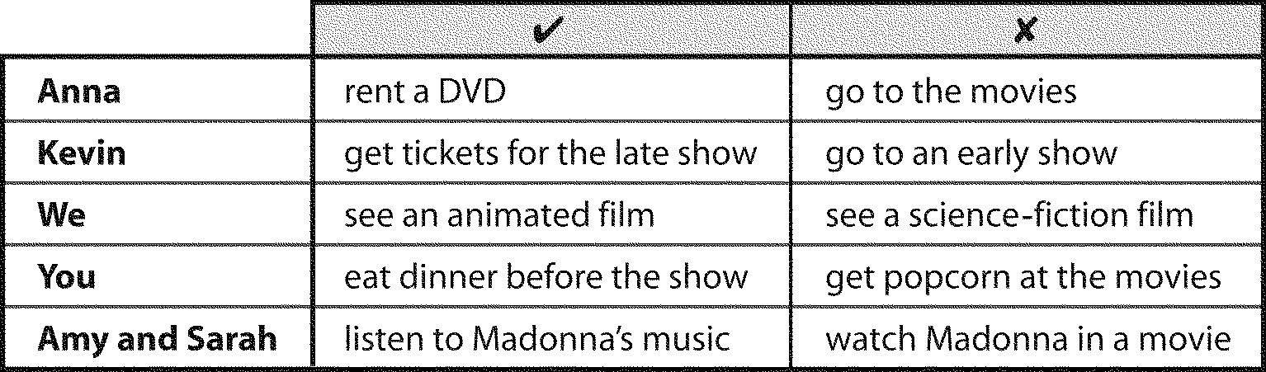

**Example:**

Anna  *would rather rent*  a DVD than go to the movies.

5. Kevin ____________________ to an early show.

6. We ____________________ a science-fiction film.

7. You ____________________ dinner before the show.

8. Amy and Sarah _________________________ Madonna’s music than watch her in a movie.

**Problem**

9. **READING**

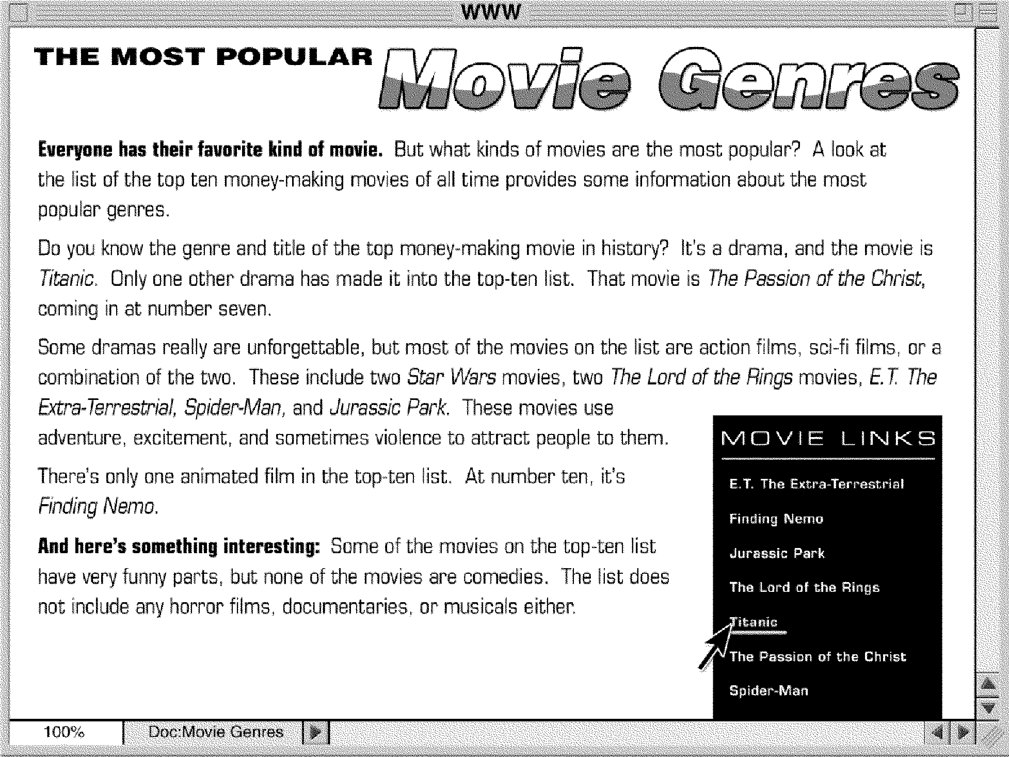

**A. Read the article. Then read the article again and answer the questions.**

**Example:**

Which movie has made more money than any other?

|  |  |
| --- | --- |
| *Titanic* |  |

(1) Which two dramas does the article mention?

|  |  |
| --- | --- |
| ______________________________ | ______________________________ |

(2) What are two of the genres on the top ten money-making list?

|  |  |
| --- | --- |
| ______________________________ | ______________________________ |

(3) What are two genres that are not on the list of top ten money-making movies?

|  |  |
| --- | --- |
| ______________________________ | ______________________________ |

**B. Read the article again. Circle the answer that correctly completes the sentence.**

**Example:**



(4) *The Passion of the Christ* made more money than (***Finding Nemo* / *Titanic***).

(5) The article is about movies that (**make a lot of money / have a lot of action and violence**).

(6) There aren’t any (**comedies / action films**) on the list of top-ten money-making movies.

(7) Action movies sometimes use(**documentaries / violence**).

**Essay**

**Read the situation. Write at least one sentence for the situation.**

10. You arrive late to meet your friend. Apologize and give a reason for why you are late.

11. Your friend has just told you that he thinks violent movies are dangerous. Agree or disagree and give a reason.

12. You are going to a movie with a colleague. Ask about your colleague’s preference for a comedy or a drama.

13. You and your friend are going to a movie. Tell which kinds of movies you like and don’t like.