**AVANZE**

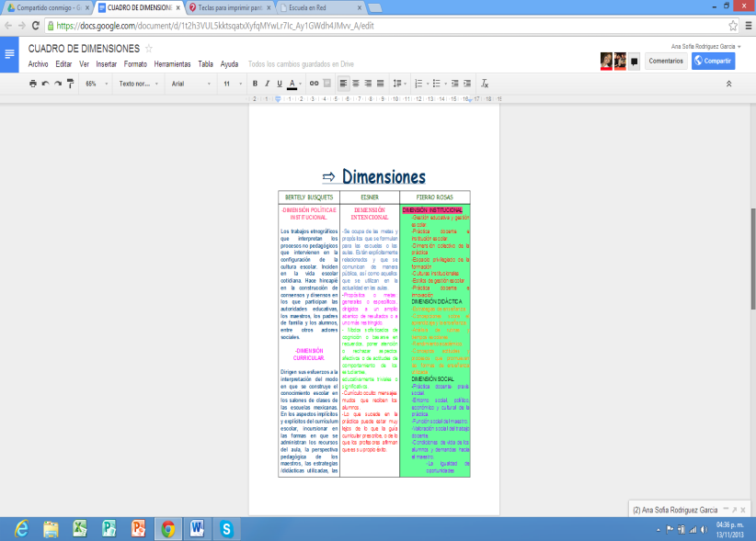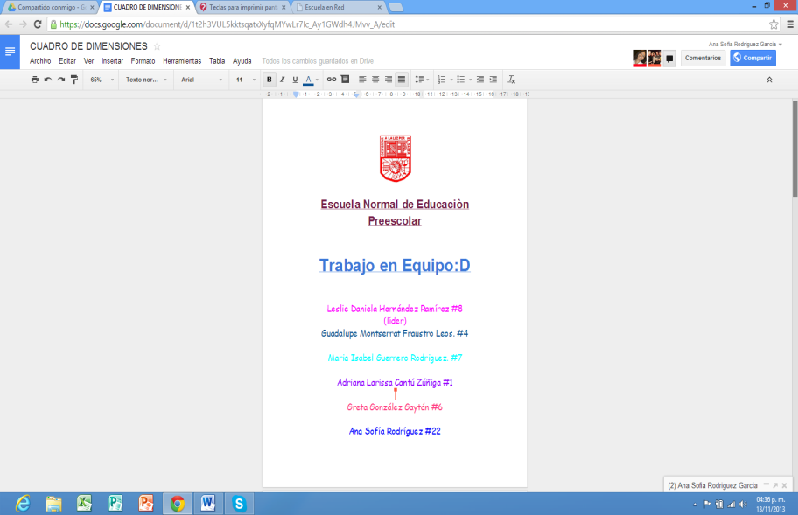

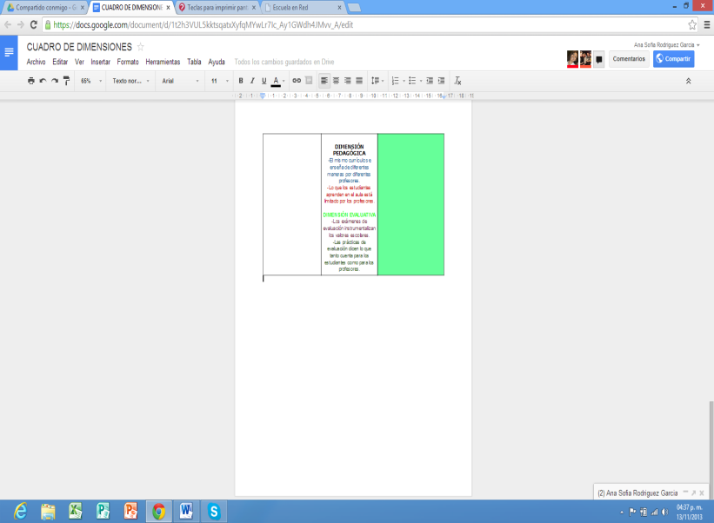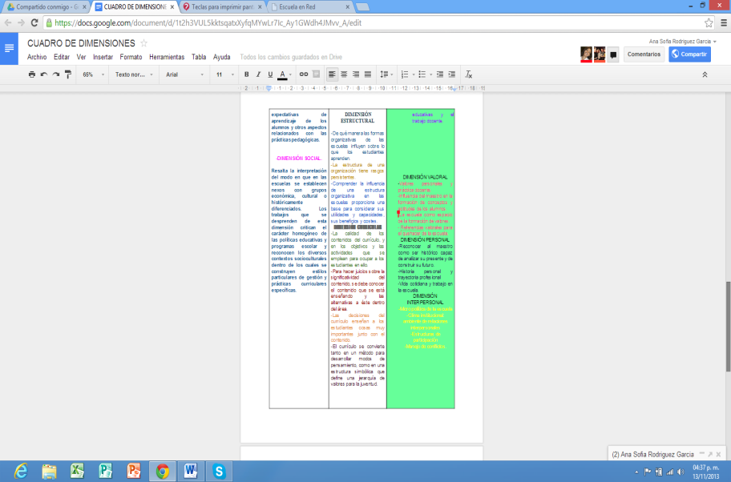

<https://docs.google.com/document/d/1t2h3VUL5kktsqatxXyfqMYwLr7Ic_Ay1GWdh4JMvv_A/edit>