- READING. Look at the photo.
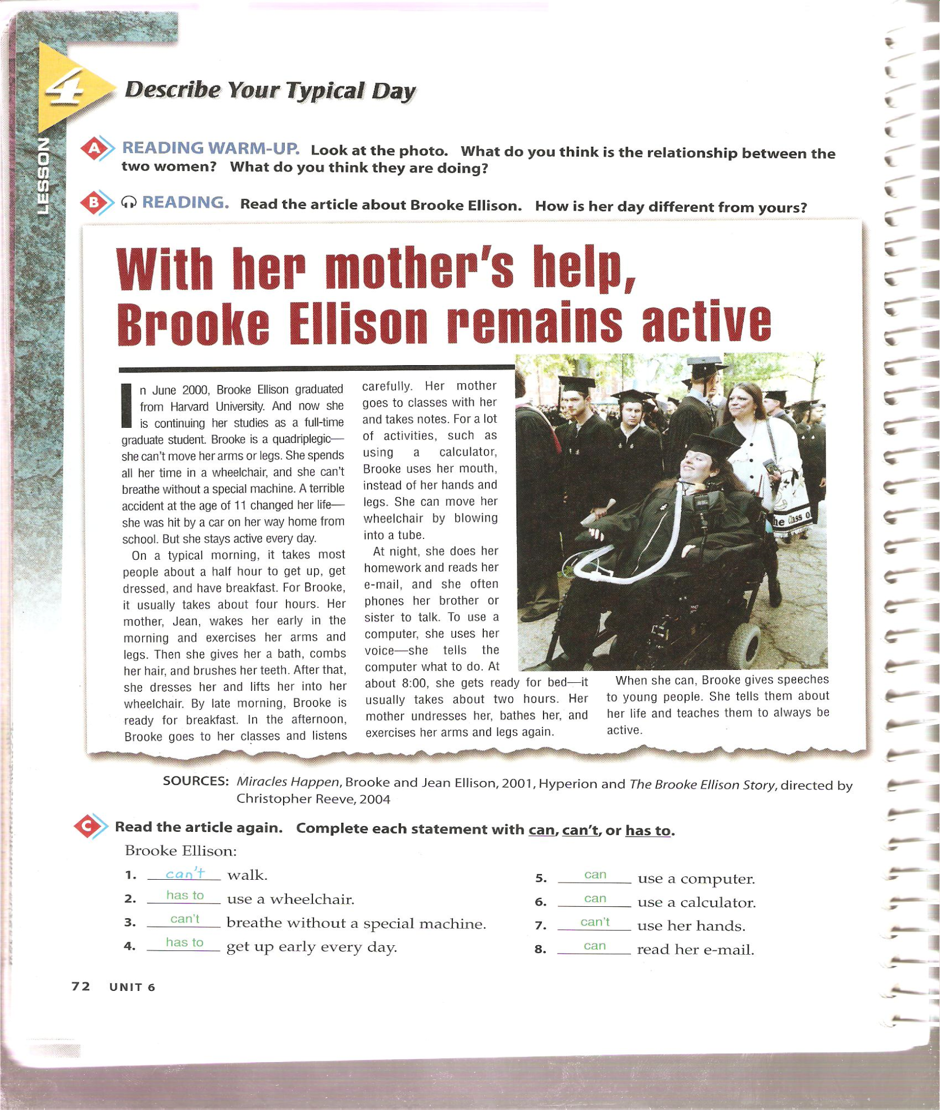
What do you think is the relationship between the two women? What do you think are they doing?
Read the article about Brooke Ellison. How is her day different yours?
In June 2000. Brooke Ellison graduated from university, and now she is continuing her studies as a full-time graduate student. Brooke is quadriplegic, she can´t move her arms or legs. She spends all her time in a wheelchair and she can´t breathe without a special machine. A terrible accident at the age of 11 changed her life she was hit by a car on her way to home from school. But she stays active every day.
On a typical morning, it takes most people about a half hour to get up, get dressed, and have breakfast. For Brooke, it usually takes about four hours. Her mother, Jean, wakes her early in the morning and exercises her arms and legs. Then she gives her a bah, combs her hair an brushes her teeth. After that, she dresses her and lifts her in to her wheelchair. By the morning, Brooke is ready for breakfast. In the afternoon, Brooke goes to her classes and listens carefully. Her mother goes to classes with her and takes notes. For a lot of activities, such a as using a calculator, Brooke uses her mouth, instead of her hands and legs. She can move her wheelchair by blowing in to a tube. At night, she does her homework and reads her e-mail, and she often phones her brother or sister to talk. To use a computer she uses her voice what to do. At about 8:00, she gets ready for bed- it usually takes about two hours. Her mother undresses her, and exercises her arms and legs again.
When she can, Brooke gives speeches to young people. She tells them about her life and teaches them always be active.

I.- Read the article again. Complete each statement with can, can´t or has to
1.- Brooke ________ walk. | 5.- Brooke ________ use a calculator
2.- Brooke ________ use a wheelchair | 6.- Brooke ________ use a computer
3.- Brooke ________ breathe without a special machine | 7.- Brooke ________ use her hands
4.- Brooke ________ get up early | 8.- Brooke ________ read her e-mail

II.- Glossary.- write the definition or a synonym to each word
1.-wheelchair
2.-quadrapegic
3.-breathe
4.-blowing

- Reading. Read the following article then answer.
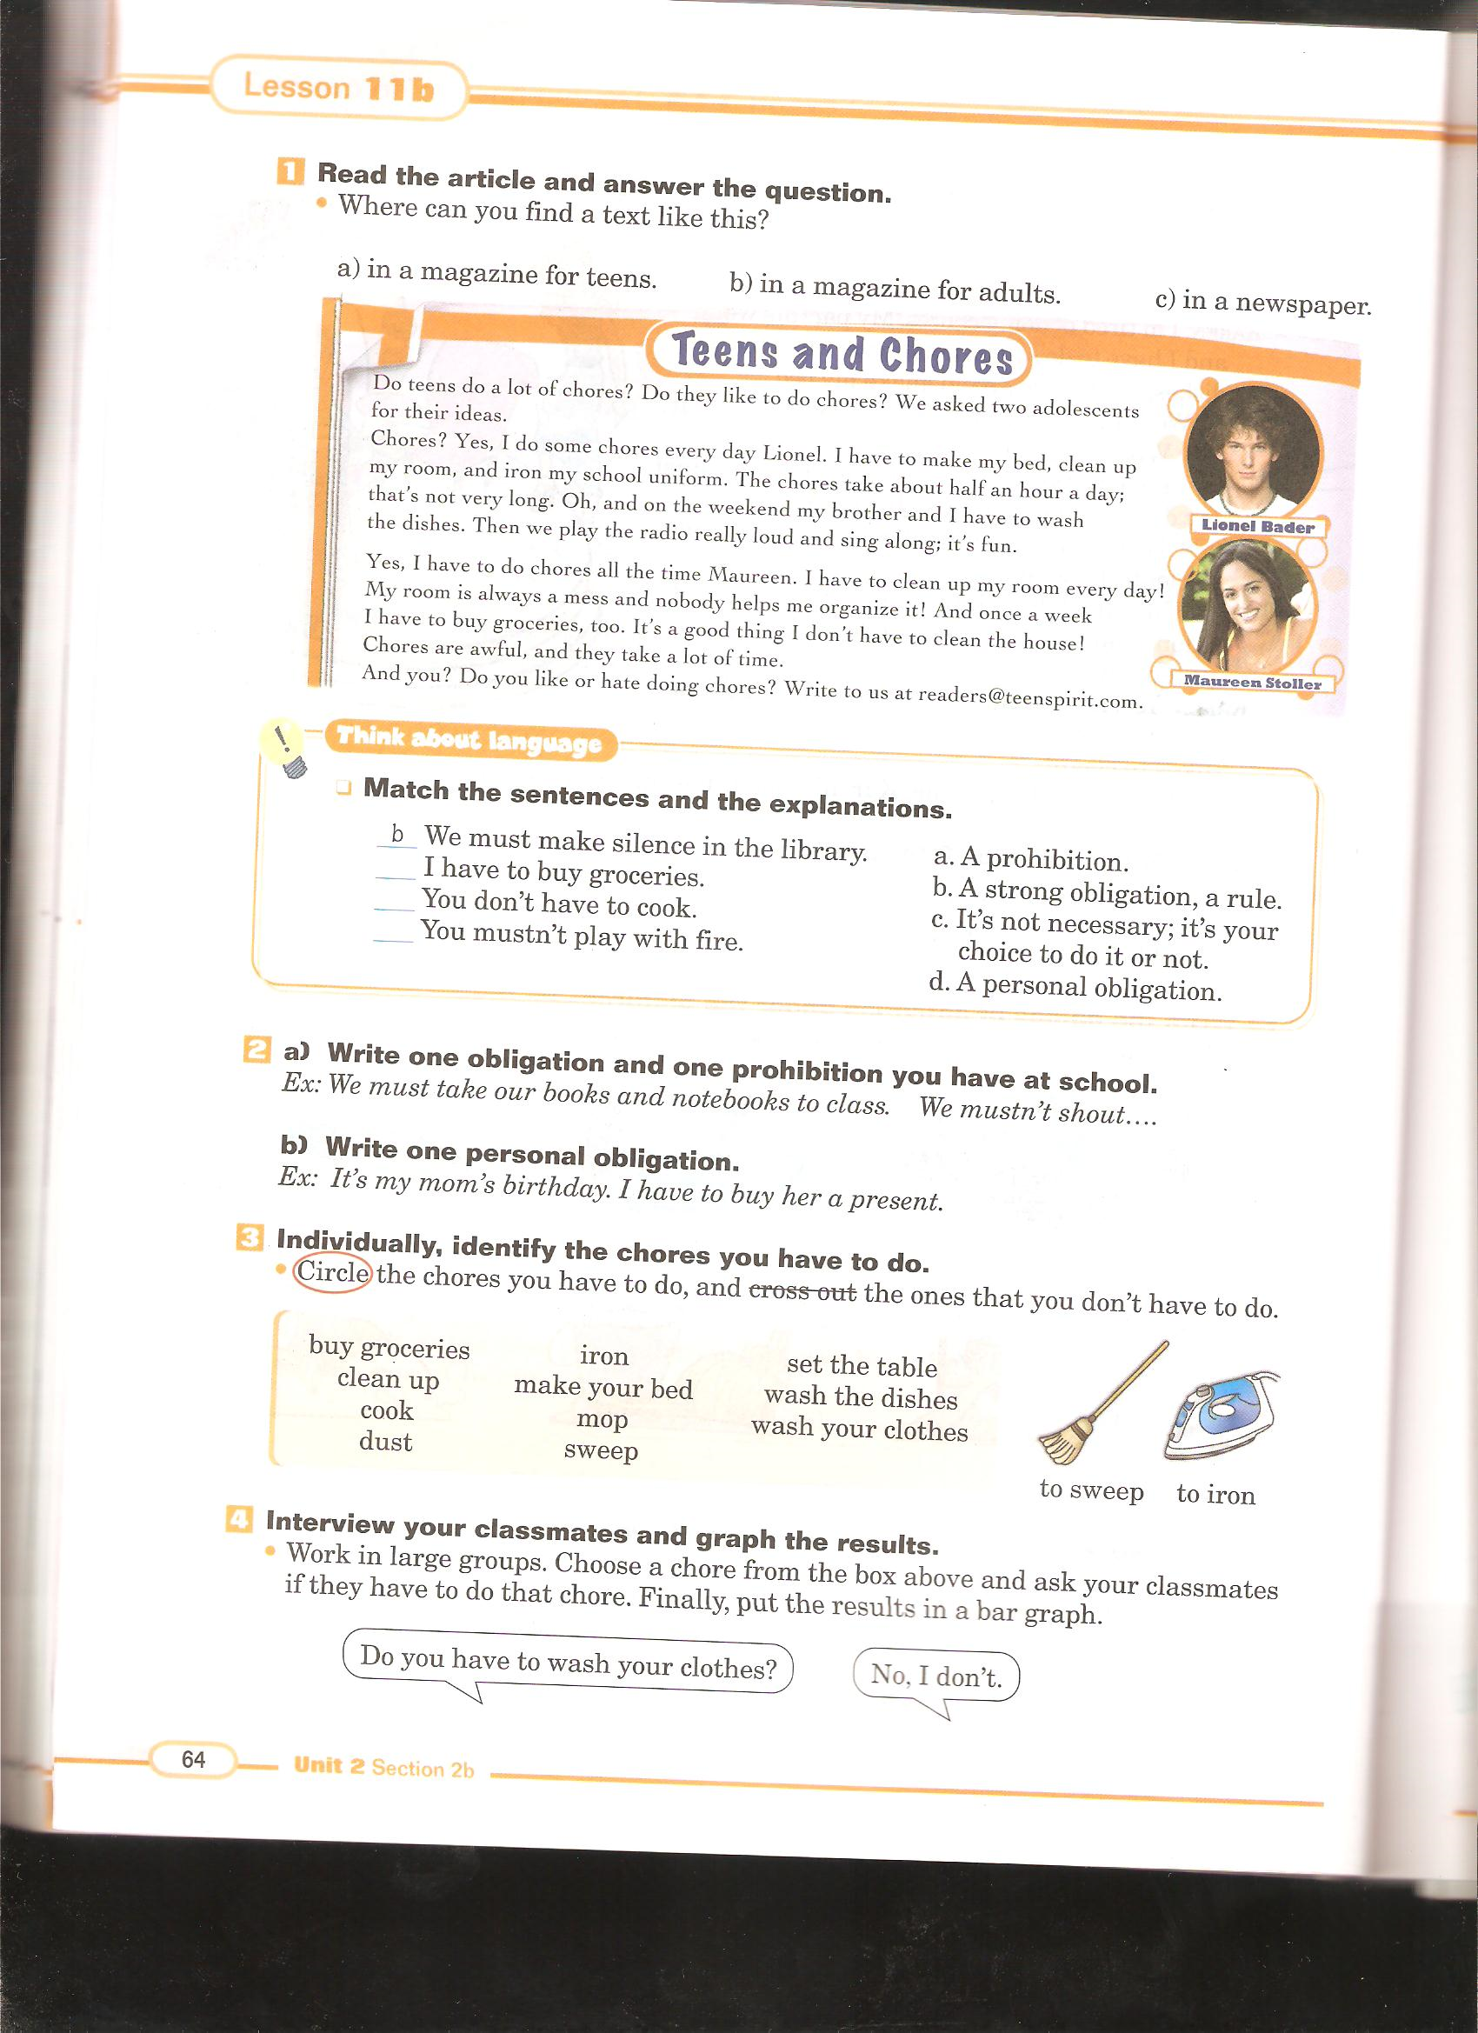
I.- Write the corresponding concepts before the sentences
(ability ----- strong obligation or rule ------ personal obligation)
1.- ________________ I have to write a composition for Spanish class
2.- ________________ Laura can write in Spanish very well
3.-_______________ Students must complete compositions every two months.

II.- Write sentences where you show
Ability________________________________________________________________________________
Strong obligation/rule___________________________________________________________________
Personal obligation_____________________________________________________________________

GRAMMAR
Read and complete the tables
AFFIRMATIVE
I / He /she / it / we/ you / they |  | Dance

NEGATIVE
I / He /she / it / we/ you / they |  | Dance

INTERROGATIVE
 | I / He /she / it / we/ you / they | Dance ?

SHORT ANSWERS
Yes | I / He /she / it / we/ you / they | Dance
No | I / He /she / it / we/ you / they | Dance
PRACTICE WITH THE FOLLOWING EXERCISES
I.- Complete the dialogues with can
1.- Matt : I think Mr. Franklin is a great musician. He________ (play) the piano and the guitar very well.
Bruce: Reslly? ____________ (he/play) the flute too?
Matt: Oh, I don´t know about that.
2.- Carl: _____________ (your sister/ use) a computer?
Brian: Of course, ______________.
Carl: _____________ (she/speak) Spanish and French?
Brian: No, ______________ but, she ___________ (speak) German.
3.- Alison: I _____________ (not/ride) a motorbike.
Debbie: ___________ (you /drive) a car?
Alison: No,___________.

II.- Choose the right answer
1.- Can I go now?
Yes, you can.
Yes, you are.
2.- Can this computer do my homework?
No, you can't.
No, it can't.
3.- Can you help me?
Yes, you are.
Yes, I can.
4.- Can I go to the toilette?
No, you can't.
Yes, I can.
5.- Can I go to the cinema?
No, you can't.
No, you don't.

III.- Complete with can o can't.
1. Where________ see a good rock concert?
2. Can Lisa speak French? No, she ______________.
3. What ______you do?
4. Can Lucy drive? Yes, she __________.
5. Where ________I buy a new camera?
6. __________you read in Portuguese?
7. Can I invite my friends? Yes, they __________come.
8. _______you play the piano?
9. I ________find my keys. Where are they?

IV.- Write the following words in order:
a. milk can please I the have?
_____________________________________________________
b. school can’t to she go.
_____________________________________________________
c. languages can other speak she?
_____________________________________________________
d. can’t he letter a write.
_____________________________________________________
e. you under can’t water the run.
_____________________________________________________
f. vegetarian she because meat eat she’s can’t a.
______________________________________________________
g. come on Sunday to they lunch can.
______________________________________________________

V.- Unscramble the following words and write questions
1) the trumpet she play can
?
2) write e-mails can they
?
3) can I TV watch
?
4) the cat can climb the tree
?

VI.- Look at the following chore chart and write five sentences using adverbs and phrases of frequency

