Read explanartion of grammar in lesson 1b.(stbk pg 9)

Explain in your OWN the grammar of simple past and the use of USED to, in a graphic o gramar square with examples. Print in a 1x1 tabloid

DESIGN two excercises to explain better the lesson (answer your designed excercises)

To hand out: the printed tabloid with the explanation and examples.

To upload: the grammar explanation and designed excercises)

Examples of the grammar of USED TO

GRAMMAR;

|  |  |  |
| --- | --- | --- |
| AFFIRMATIVE | NEGATIVE | QUESTION |
| used to + verb | Didn’t use to | Did use to? |

I ***USED TO*** PLAY GAMES BUT NOW COMPUTER STUDY FOR MY CAREER

***DIDN'T USE TO*** BEING IN THE INTERNET AND NOW THIS ALL DAY

***DID*** YOU ***USE TO*** DO BEFORE YOU CAME TO SCHOOL?

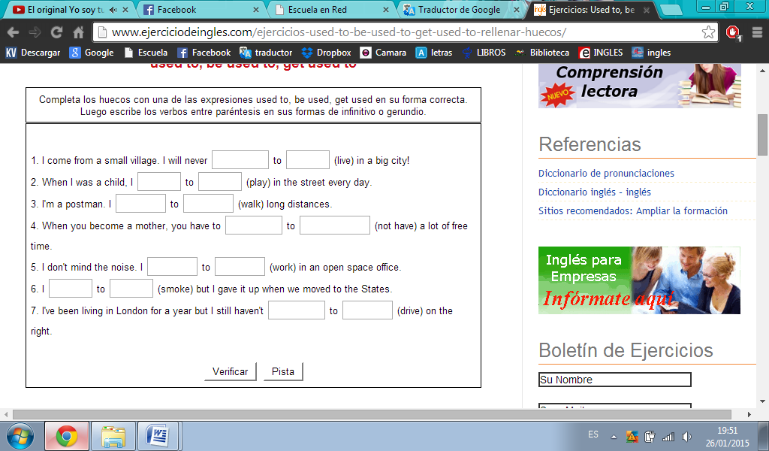

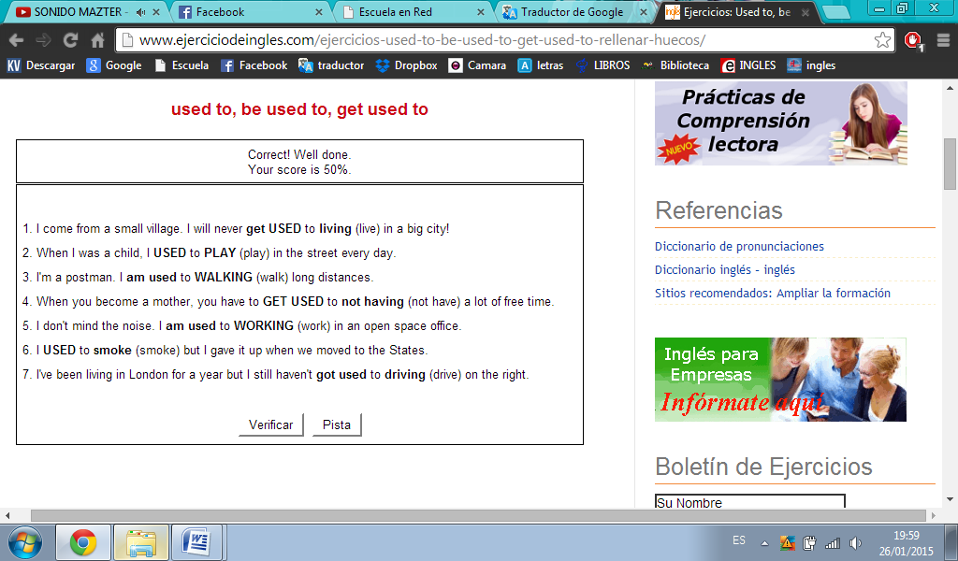

Examples of the grammar of PAST SIMPLE

GRAMMAR;

|  |  |  |
| --- | --- | --- |
| AFFIRMATIVE | NEGATIVE | QUESTION |
| pronouns + (Verb + ed) | Did + pronouns + (verb+ed) | Pronouns + didn’t (verb + ed)? |

***YOU STUDIED*** WITH GRISEL

***DID*** YOU ***STUDIED*** WITH GRISEL

***YOU DIDN'T STUDIED*** WITH GRISEL?

