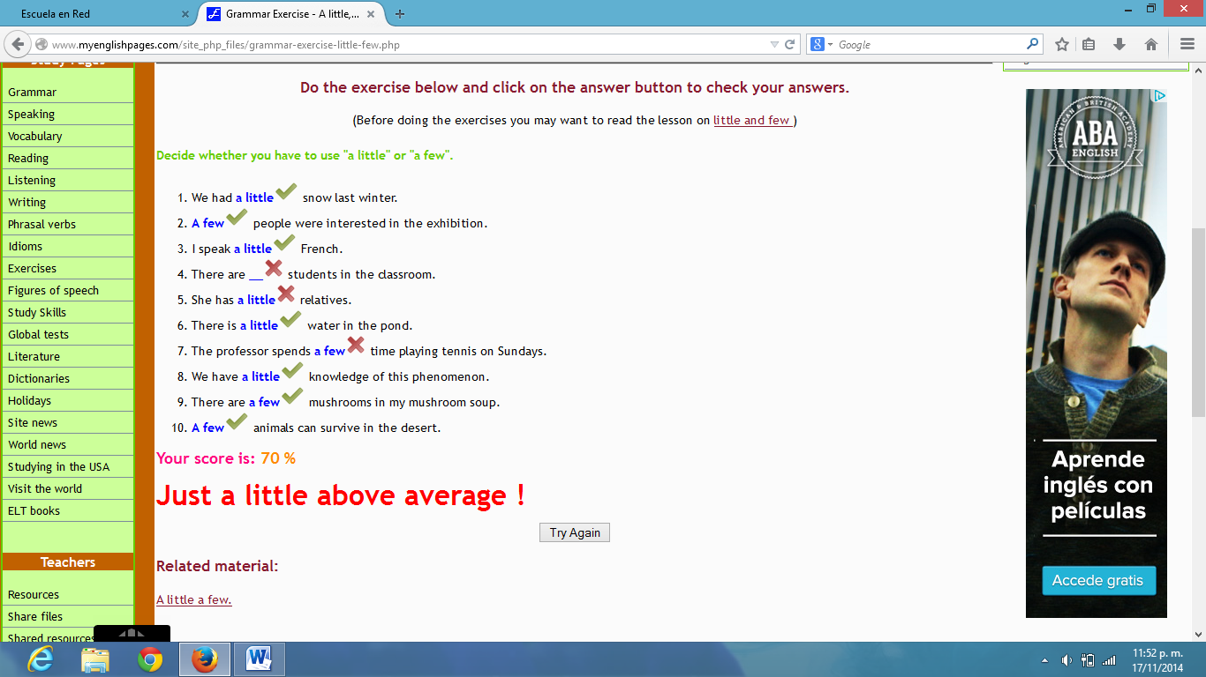

**Larissa Stephanie Martínez Mejia 2° “B” #10**