







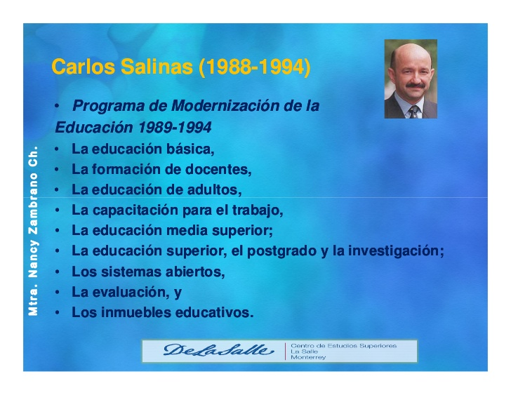







|  |  |  |  |  |  |  |  |  |
| --- | --- | --- | --- | --- | --- | --- | --- | --- |
| PRESIDENTE | SEXENIO |  | INFLACION | VALOR DEL DOLAR | DEVALUACION | SAL.MIN. | % DE VARACION | PODER DE COMPRA |
| [Luis Echeverría Álvarez](http://www.economia.com.mx/luis_echeverria_alvarez.htm) | 1976 | 0.1978 | 126.06% | $15.36 | 22.88% | $120.00 | 275.00% | 118.47% |
| [José López Portillo](http://www.economia.com.mx/jose_lopez_portillo.htm) | 1982 | 1.0240 | 417.69% | $148.50 | 866.80% | $680.00 | 466.67% | 11.72% |
| [Miguel de la Madrid H.](http://www.economia.com.mx/miguel_de_la_madrid_hurtado.htm) | 1988 | 42.2989 | 4030.75% | $2291.24 | 1442.92% | $8640.00 | 1170.59% | -70.96% |
| [Carlos Salinas de Gortari](http://www.economia.com.mx/carlos_salinas_de_gortari.htm) | 1994 | 102.3588 / 28.3567 | 141.99% | N$3.49 | 50.08% | N$16.34 | 89.12% | -37.23% |
| [Ernesto Zedillo Ponce](http://www.economia.com.mx/ernesto_zedillo_ponce_de_leon.htm) | 2000 | 92.2495 | 225.32% | N$9.42 | 173.82% | N$40.35 | 146.94% | -34.79% |
| [Vicente Fox Quesada](http://www.economia.com.mx/vicente_fox_quesada.htm) | 2006 | 120.3019 | 30.41% | N$ 10.9975 | 16.80% | N$50.57 | 25.33% | -16.71% |