ESCUELA NORMAL DE EDUCACION PREESCOLAR
TOP NOTCH 1 – Unit 10 Achievement Test

NAME____________________________________________________GRADE __________

I.- Complete the conversation with the superlative form of the adjective(s).

- A: Which dress do you like?
B: I like them all, but the blue one is the (nice).
2. A: All of these DVD players are good.
B: Yes, but which one is the ____________________ (good)?

3. A: Which of these three digital cameras is the ____________________ (cheap)?
B: The Honshu B100 is the ____________________ (expensive) camera.

4. A: This rug isn’t big enough. Do you have a larger rug in the same color?
B: No, this is the ____________________ (big) one.

5. A: That math exam was really difficult! It was the ____________________ (difficult) exam this semester.
B: I agree. It was the ____________________ (bad) exam I ever had!

II.- Complete the statement or question with too or enough and the adjective.

6. That shirt is (small). You need a larger size.

7. The soup is still ____________________ (hot). Be careful!

8. You’re not driving ____________________ (fast)! We’re going to be late for the party.

9. Your suitcase is ____________________ (heavy). You need a lighter one!

10. It’s ____________________ (cold) today for shorts. You should wear pants.

11. This rug is ____________________ (big). It doesn’t fit in the room.

12. This dress is not____________________ (nice) for the party. I need something prettier.

III.- Write the words and phrases in the correct order.

13.- are / Which / most/ to use / difficult / machines / the /
_________________________________________________________________?

14.- DVD players / think/ the worst / I / are /
_________________________________________________________________.

15.- You / size / It´s not / a larger / big/ need / enough.
______________________________ . _____________________________.

16.- expensive / too / camera / That / is
__________________________________________________________________.

17.- use / John’s / printer / easiest / to / the / is
_________________________________________________________________.

18.- big / isn’t / enough / This / shirt
_________________________________________________________________.

IV.- READING
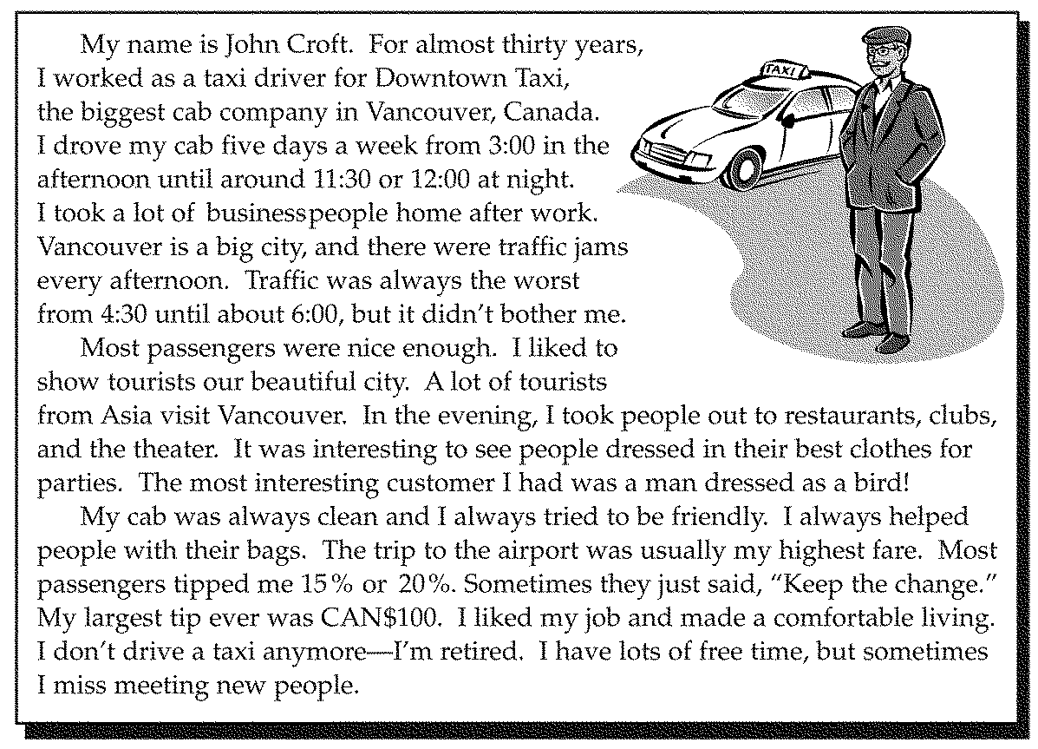

A. Complete the conversations with information from the reading. Use the superlative.

19.- A: When ?
B: From 4:30 until about 6:00.

20.- A: What ____________________?
B: CAN$100.

21.- A: What ____________________?
B: It was usually the trip to the airport.

22.- A: What ____________________ in Vancouver, Canada?
B: Downtown Taxi.

23.- A: Who ____________________?
B: A man dressed as a bird.

B. Read the article again. Then circle the correct answer.

24.-What did this man do?
a. | He was a truck driver.
b. | He drove a taxi.
c. | He worked at the airport.

25.- What does the man do now?
a. | He still drives a cab.
b. | Now he drives a truck.
c. | He no longer works.

26.- Which statement is true?
a. | The man worked seven days a week from 3:00 until 11:30 or 12:00.
b. | For over 30 years, this man drove a cab in Montreal, Canada.
c. | This man worked at the same company for more than 25 years.

27.- Which statement is true?
a. | The man took a lot of businesspeople to work.
b. | The man liked meeting new people at his job.
c. | The man always complained about traffic jams.

V.- CHOOSE THE RIGHT ANSWER

28.- MP3 players are__________________ than portable CD players
( more popular / the most popular/ the popularest)

29.- Which of these three windbreakers is _____________________?
(warmer /the warmest / the most warm )

30.- This digital camera is too expensive. Do you have something ________________?
(the cheapest/ more cheap / cheaper )

31.- Which language is ____________ to learn Mandarin or Hindi?.
(the most difficult / more difficult / the difficultest)

32.- Le Chen restaurant is ____________ in the city.
(more expensive / the expensivest /the most expensive)

33.- I don´t want to spend a lot of money. I´m looking for ____________PDA you have.
( the least difficult / the most comfortable / the cheapest / the most interesting )

34.- I´m not very good with technology. Which of these digital camera is _________to use?
( the least difficult / the most comfortable / the cheapest / the most interesting )

35.- I love these jeans. They are _________ pair I have.
( the least difficult / the most comfortable / the cheapest / the most interesting )

VI. READ THE SENTENCE. WRITE T (TRUE) OR F (FALSE).

36. ______ Last month, the price of the coat was US$200. Pat bought it yesterday for US$100. She saved a lot of money.

37. ______Ms. Doh is on vacation, but she doesn’t have enough money with her. She should go to an ATM.

38. ______Bill and Louise went out for dinner. The service at the restaurant was terrible. They should give the waiter a big tip.

39.______ You only have a little cash with you, but you are going out to dinner at an expensive restaurant. You should use a credit card.

40. _______John and Sheri want to make movies of their new baby. They should buy a camcorder.

VII. COMPLETE THE FOLLOWING SENTENCES USE THE WORD BANK (words can be used twice)
Bargain Credit card tip ATMs traveler´s checks exchange rates

41. If you´re out of cash, you can get money from___________________________
42. If there´s a service charge on the restaurant bill, you don´t have to leave a _______________
43. In many countries, it´s OK to ____________ for a lower price
44. You can get the best _____________________ at banks
45. ______________ are safe and easy way to carry money when traveling
46. Small plastic cards than you can use to buy something now and pay for it later. ______________
47. Machine where you put your card in and take the money out ______________
48. Leaving money for the service you´ve received. ______________
49. Similar to cash but only you can use them because you have to buy them and sing them to buy .
______________
50.Trading money from one country to another. ______________

1. (1) b (2) a (3) a (4) C (5) E (6) B

Audio: Top Notch 1, Track 12

Audioscript:

A.

Customer: I’m looking for a new camcorder, but I don’t want to pay more than a thousand euros.
Salesclerk: We have three excellent camcorders in that price range: the Pusan 5X, the Vision 720, and the Diego P500.
Customer: Which is the easiest to use?
Salesclerk: The Pusan 5X is the easiest to use, but the Diego P500 is the least expensive. It’s our most popular camcorder.
Customer: How much is it?
Salesclerk: The P500 is € 679.
Customer: And how much is the Vision 720?
Salesclerk: That one’s the most expensive of the three— € 949, but it’s also the lightest and most reliable.
Customer: Hmmm. That one sounds nice, but I think I’ll take the least expensive one.

B.

Example:
A: We’ve got four to choose from. They’re all nice.
B: Well, which bowl is the nicest?
A: I’d say that red one is the prettiest.

(4)
A: How about this one?
B: No, that one’s too small. Are these the only paintings you have?
A: We have more in back.

(5)
A: Is that necklace gold?
B: This one? Yes, it is. All of the jewelry in my store is gold or silver.

(6)
A: How much do you want for that rug?
B: $450.
A: That’s too much. I don’t want to spend that much money. What’s your best price?

COMPLETION

2. best

3. cheapest, least expensive

4. biggest

5. most difficult, worst

6. warmest

7. most comfortable

8. too hot

9. fast enough

10. too heavy

11. too cold

12. not small enough

13. not nice enough

TRUE/FALSE

14. T

15. F

16. T

17. T

18. F

19. F

20. F

PROBLEM

21. A.
(1) | was his largest tip
(2) | was his highest fare
(3) | is the biggest cab company
(4) | was his most interesting customer

B.
(5) c (6) c (7) b

ESSAY

22. (Sample response:) The man is looking at some vases. They are discussing the price. He is going to bargain for the vase.

