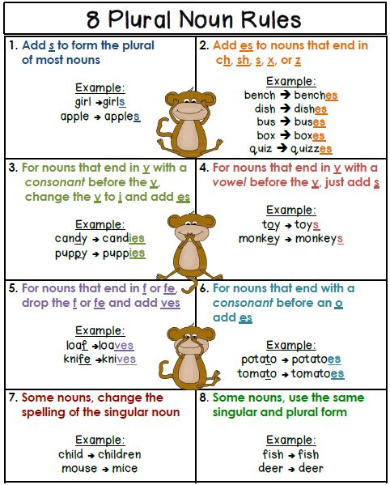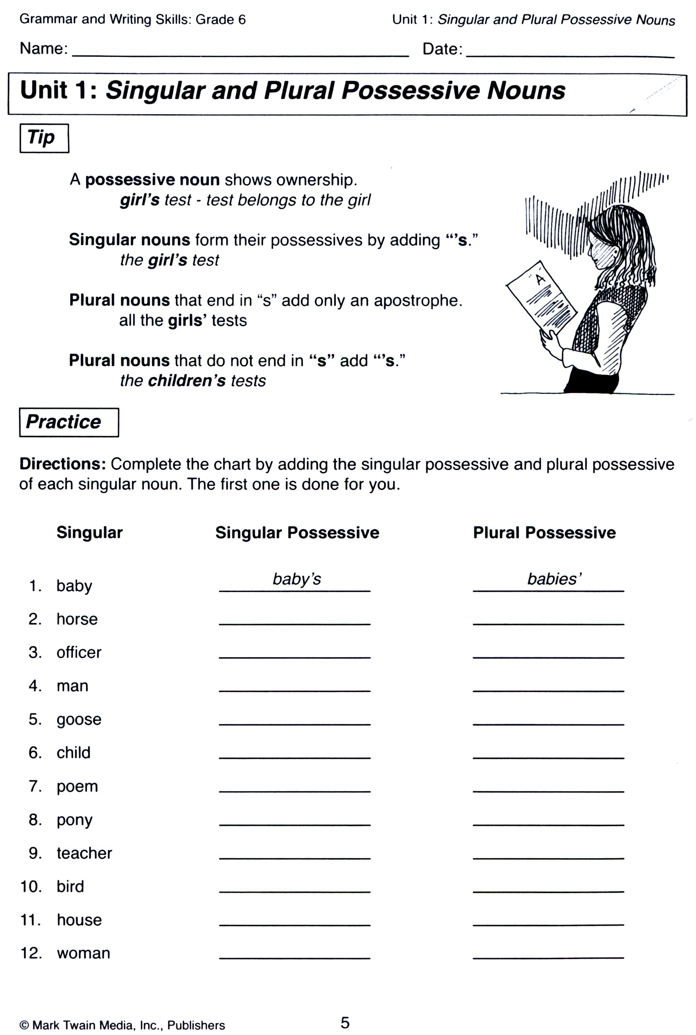

**6**

|  |  |
| --- | --- |
| 1. Umbrellas' handles are sometimes carved. 2. Witches' hats are usually pointed. 3. Judges' wigs were powered in the old days. 4. The fairies' wings were iridescent. 5. Cherries' stones can break your teeth if you are not careful. 6. The tables' legs were all wobbly and needed repair. | 1. Dolphins got caught in the fishermen's nets. 2. Postmen’s bags are made of leather. 3. The geese’s eggs were found on the road, smashed. 4. Hippopotami’s mouths are huge. 5. Servicemen’s fees rise after hours and on weekends. 6. Octopi’s arms number eight and have several functions   **7** |