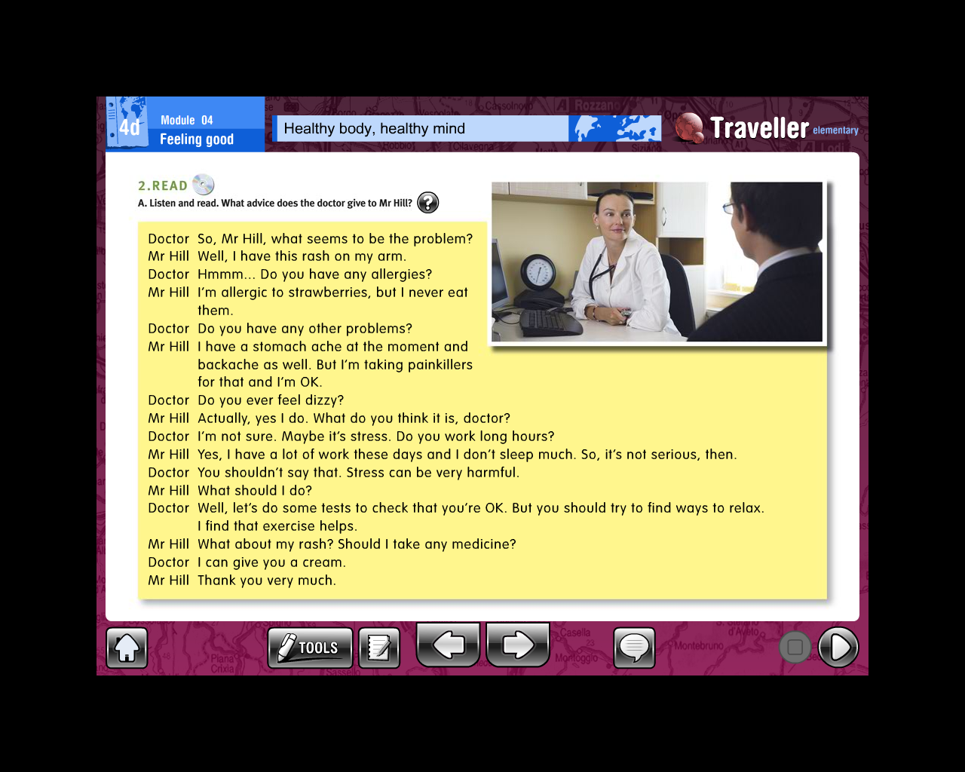

1. Why is Mr. Hill taking painkillers?
2. Does Mr. Hill ever feel dizzy?
3. Does Mr. Hill work long hours?
4. Does Mr Hill sleep much?
5. What does the doctor think about stress?
6. Why is the doctor telling Mr. Hill to do some tests?
7. What advice does the doctor give to Mr. Hill?
8. Why does Mr Hill go to the doctor?
9. Why doesn’t Mr Hill eat strawberries?
10. What does the doctor think the problem is?
11. What does the doctor give Mr Hill for his rash?