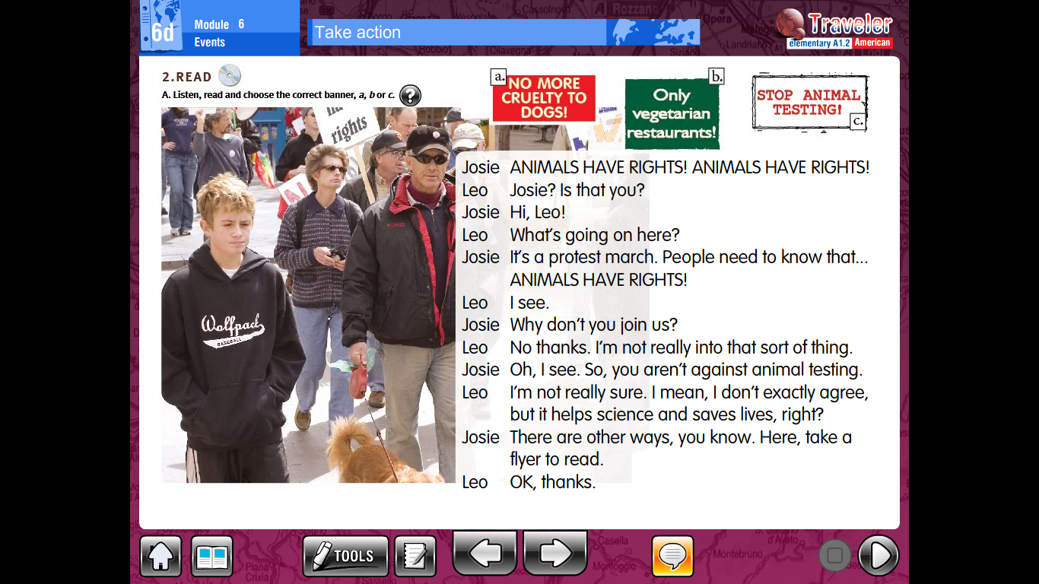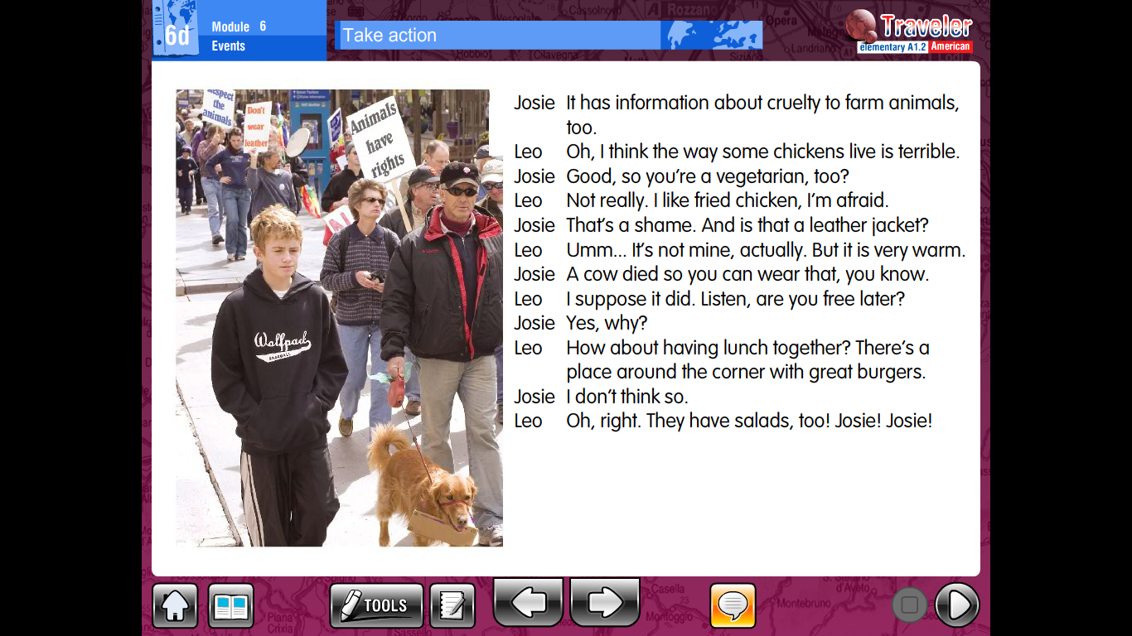

Read the text and answer the following questions in your notebook. You may print and paste the questions.

1. Does Clive want to join the protest march?
2. Why isn’t Clive totally against animal testing?
3. What does Josie reply to this?
4. What kind of information does the leaflet that Josie is giving Clive have?
5. Is Clive a vegetarian?
6. How do you know?
7. What is the jacket that Clive is wearing made of?
8. What does Josie say about Clive’s jacket?
9. Where is Clive inviting Josie to?
10. Does Josie like Clive’s idea?

Read again and write J for Josie, C for Clive and B for Both.

