Alumna Dalila Luna Pérez

2° A

**2.- Find, underline and correct the mistakes in the following sentences**

1.- They **eat** dinner at six ó clock yesterday.

They ate dinner at six at six ó clock yesterday.

2.- **I not finished** my homework last night .

I didnt’ finish my homework last night.

3.- He **not go** to bed early last night.

He didn’t go to bed early last night.

4.- Sam **visits** Vancuver last month.

Sam visited Vancuver last month.

5.- My friends **play** videogames in my house last Sunday.

My fiends played videogames in my house last Sunday.

Activity 2.- spelling game irregular verbs

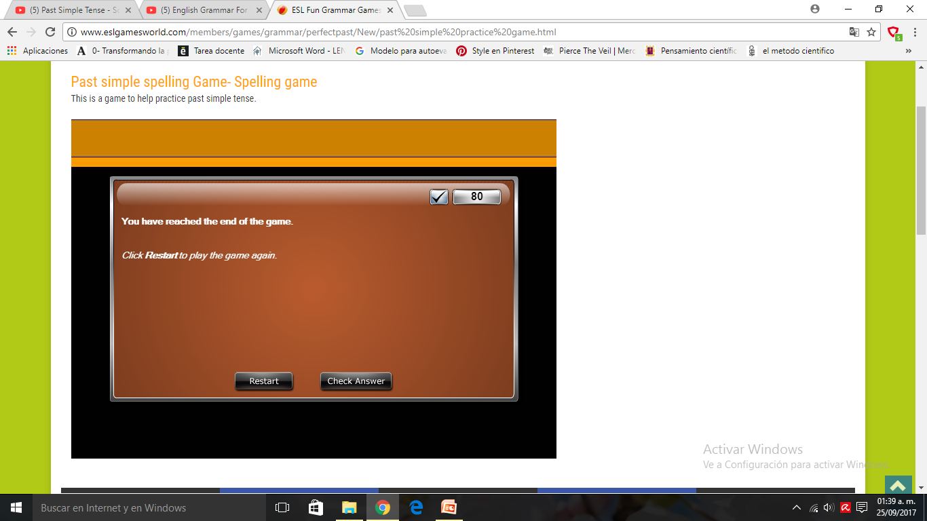

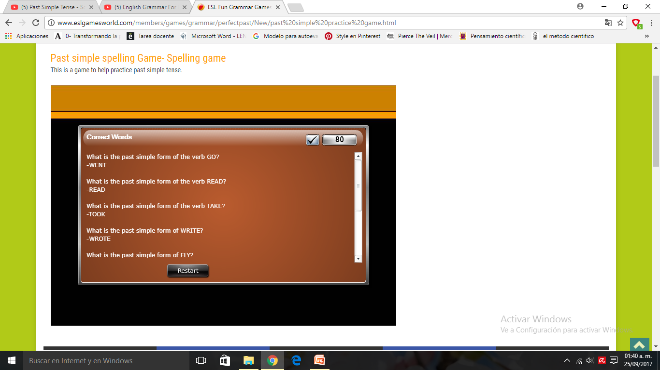

Activity 3.- maching regular and irregular verbs (2 games)

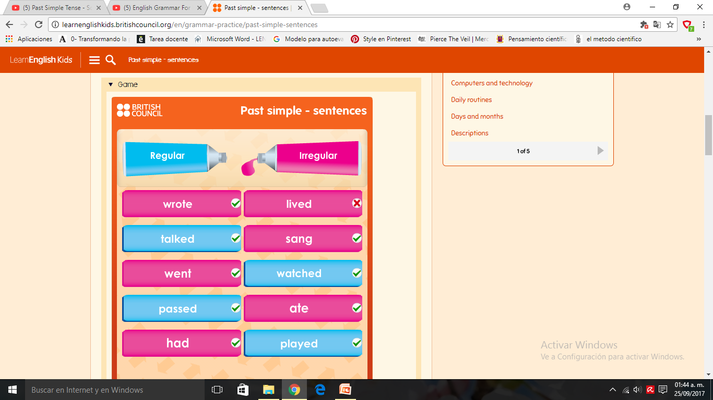

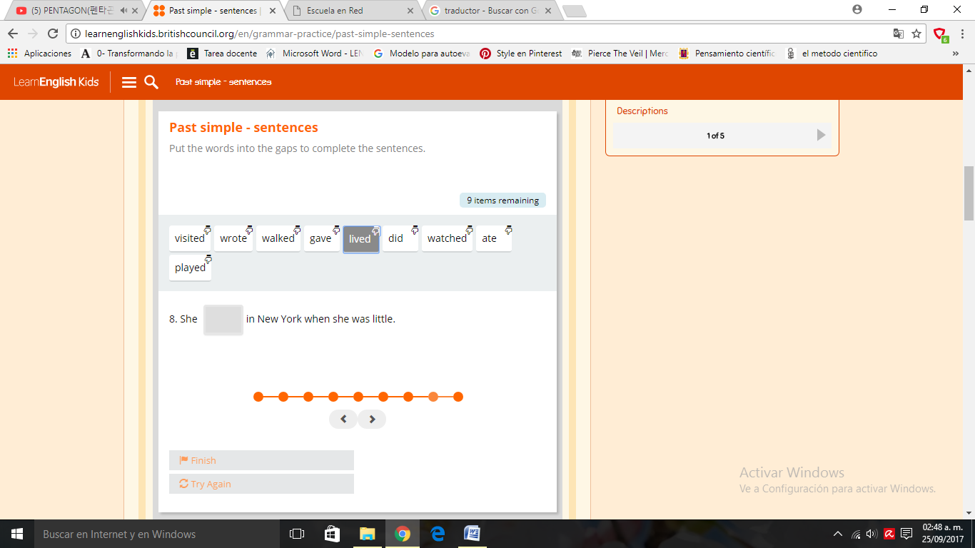

Activity 4.- jeopardy irregular verbs

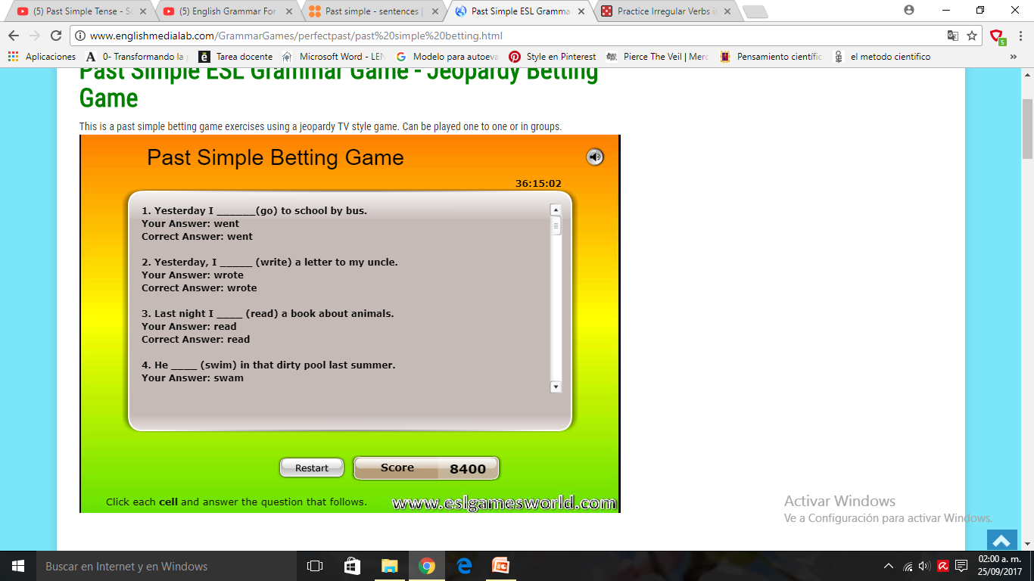

Activity 5.- hangman irregular verbs

