PAST SIMPLE: IRREGULAR

I wore a black dress

You spoke italian

He wrote a letter

She flew in an airplane

It was a long week

We swam on mornings

They knew the exam

I didn’t wear a black dress

You didn’t speak italian

He didn’t write a letter

She didn’t fly in an airplane

It didn’t be a long week

We didn’t swim on mornings

They didn’t know the exam

Did I wear a black dress?

Did you speak italian?

Did he write a letter?

Did she fly in an airplane?

Did it be a long week?

Did we swim on mornings?

Did they know the exam?

did

went

bought

drive

Did

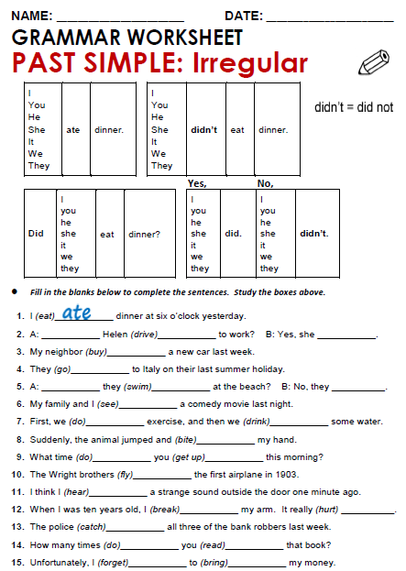

didn’t

saw

swim

Did

PAST SIMPLE: REGULAR

I played videogames

You looked flowers.

He rented a movie.

She worked hard.

It turned difficult.

We jumped high.

They played futbol.

I didn’t play videogames

You didn’t look flowers.

He didn’t rent a movie.

She didn’t work hard.

It didn’t turn difficult.

We didn’t jump high.

They didn’t play futbol.

Did I play videogames?

Did you look flowers?

Did he rent a movie?

Did she work hard?

Did it turn difficult?

Did we jump high?

Did they play futbol?

didn’t walk

cooked

surprised

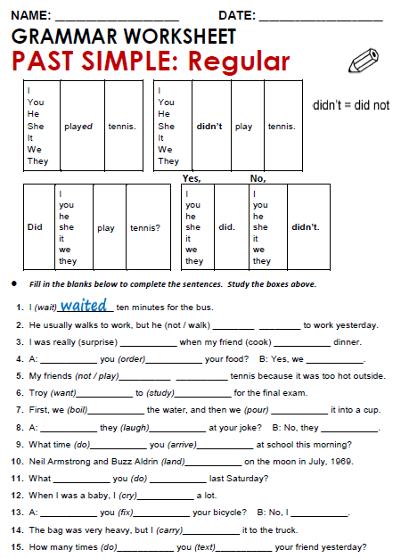

order

did

studied

wanted

didn’t play

Did