**SELF ASSESSMENT for Traveller Elementary Modules 2 and 3**

**Teacher: Maria Elena Meza Aguado**

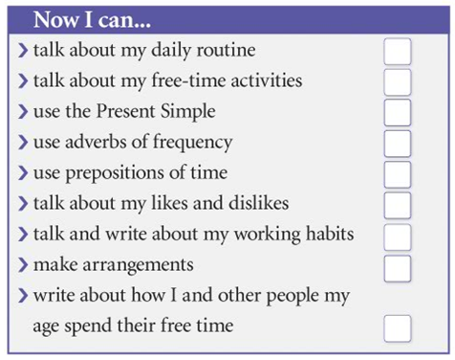

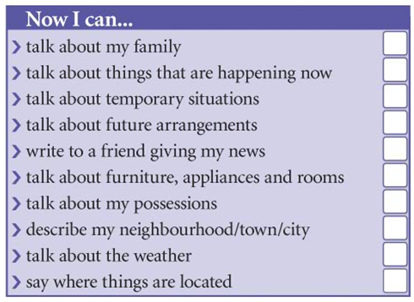

**2**