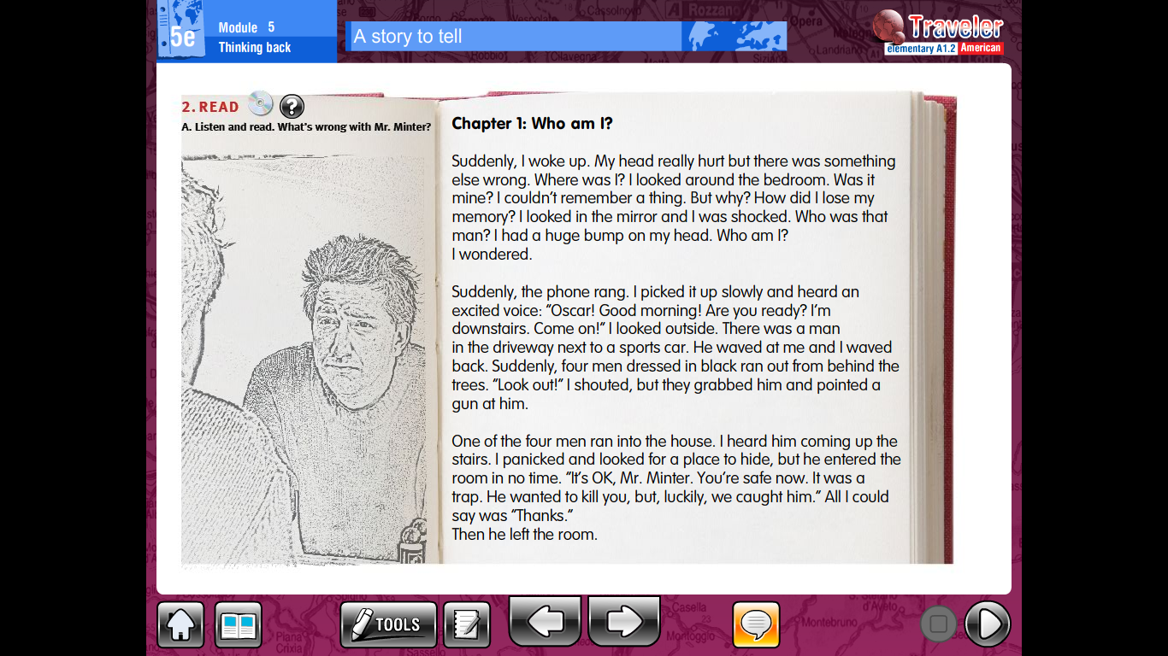

**5e A story to tell**

Read the story and answer the following questions in your notebook. Remember that you need to have questions and answers in your notebook.

1. Where was Mr Minter when he woke up?
2. How did he feel when he looked in the mirror?
3. What is Mr Minter’s first name?
4. What did the man who called Mr Minter ask him?
5. Did Mr Minter reply to the man?
6. What did Mr Minter see when he looked outside?
7. Who ran out from behind the trees
8. What did they do?
9. What did one of the four men do?
10. What did Mr Minter try to do?
11. Why did he try to find a place to hide?
12. What did the man tell Mr Minter when he entered the room?

A. Listen to the continuation of the story you just read. Who is Mr Minter talking to? Listen again and write T for True and F for False.

