**You can also read it on line at:** **<https://well.blogs.nytimes.com/2010/02/18/how-vacations-affect-your-happiness/>**

**How Vacations Affect Your Happiness**

**BY TARA PARKER-POPE**

 FEBRUARY 18, 2010 2:03 PMFebruary 18, 2010 2:03 pm

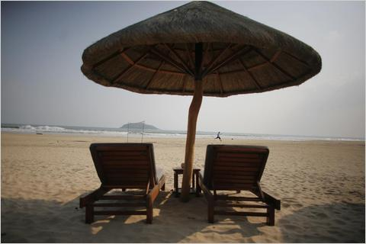Christie Johnston for The New York Times Do vacations make you happy?

Vacations are a chance to take a break from work, see the world and enjoy time with family. But do they make you happier?

Researchers from the Netherlands set out to measure the effect that vacations have on overall happiness and how long it lasts. They studied happiness levels among 1,530 Dutch adults, 974 of whom took a vacation during the 32-week study period.

The study, published in the [journal Applied Research in Quality of Life](https://www.springerlink.com/content/233331654742r175/), showed that the largest boost in happiness comes from the simple act of planning a vacation. In the study, the effect of vacation anticipation boosted happiness for eight weeks.

After the vacation, happiness quickly dropped back to baseline levels for most people. How much stress or relaxation a traveler experienced on the trip appeared to influence post-vacation happiness. There was no post-trip happiness benefit for travelers who said the vacation was “neutral” or stressful.”

Surprisingly, even those travelers who described the trip as “relaxing” showed no additional jump in happiness after the trip. “They were no happier than people who had not been on holiday,” said the lead author, Jeroen Nawijn, tourism research lecturer at Breda University of Applied Sciences in the Netherlands.

The only vacationers who experienced an increase in happiness after the trip were those who reported feeling “very relaxed” on their vacation. Among those people, the vacation happiness effect lasted for just two weeks after the trip before returning to baseline levels.

“Vacations do make people happy,” Mr. Nawijn said. “But we found people who are anticipating holiday trips show signs of increased happiness, and afterward there is hardly an effect.”

One reason vacations don’t boost happiness after the trip may have to do with the stress of returning to work. And for some travelers, the holiday itself was stressful.

“In comments from people, the thing they mentioned most referred to disagreements with a travel partner or being ill,” Mr. Nawijn said.

The research controlled for differences among the vacationers and those who hadn’t taken a trip, including income level, stress and education. However, Mr. Nawijn noted that questions remain about whether the time of year, type of trip and other factors may influence post-vacation happiness.

The study didn’t find any relationship between the length of the vacation and overall happiness. Since most of the happiness boost comes from planning and anticipating a vacation, the study suggests that people may get more out of several small trips a year than one big vacation, Mr. Nawijn said.

“The practical lesson for an individual is that you derive most of your happiness from anticipating the holiday trip,” he said. “What you can do is try to increase that by taking more trips per year. If you have a two week holiday you can split it up and have two one week holidays. You could try to increase the anticipation effect by talking about it more and maybe discussing it online.”

Mr. Nawijn said that while he expected the study results to show a prevacation happiness boost, he was surprised that the study showed that relaxed holidays didn’t affect post-trip happiness levels.

“People start working again,” he said. “They have to catch up. Usually there is a big pile of work for them when they get back from the holiday.”