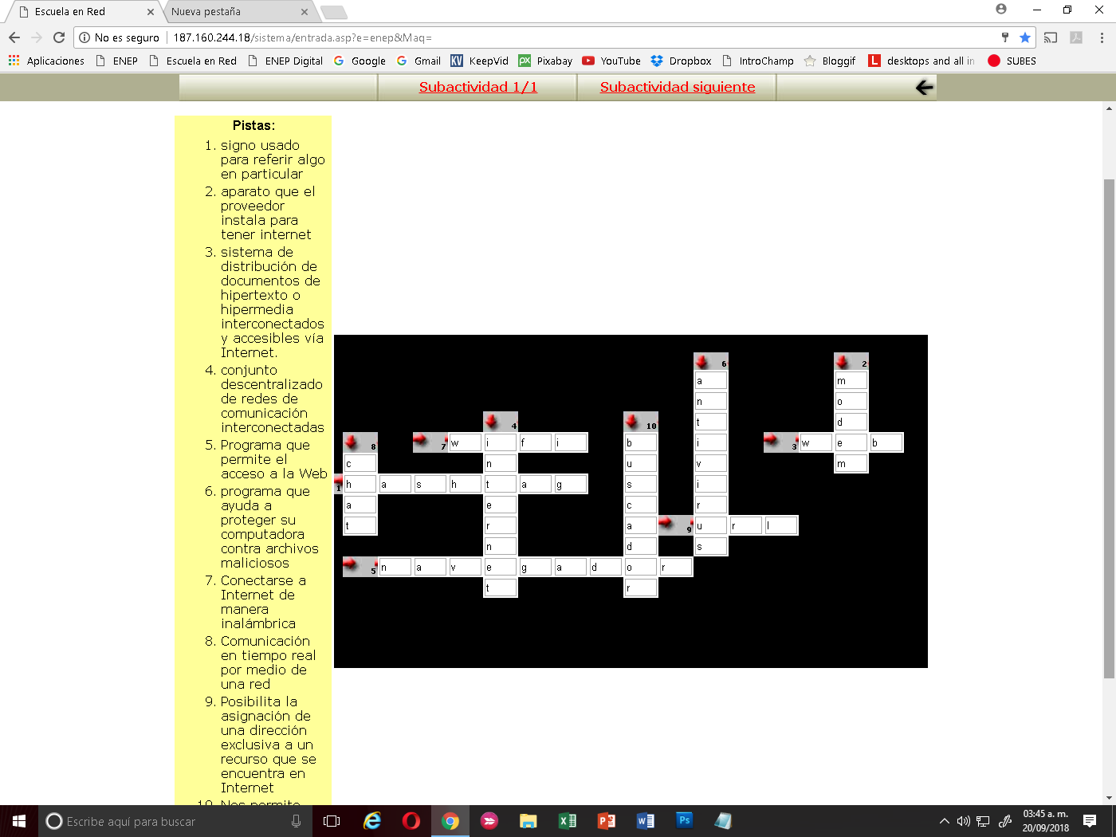

Vanessa Elizabeth Sánchez Gallegos NL.21