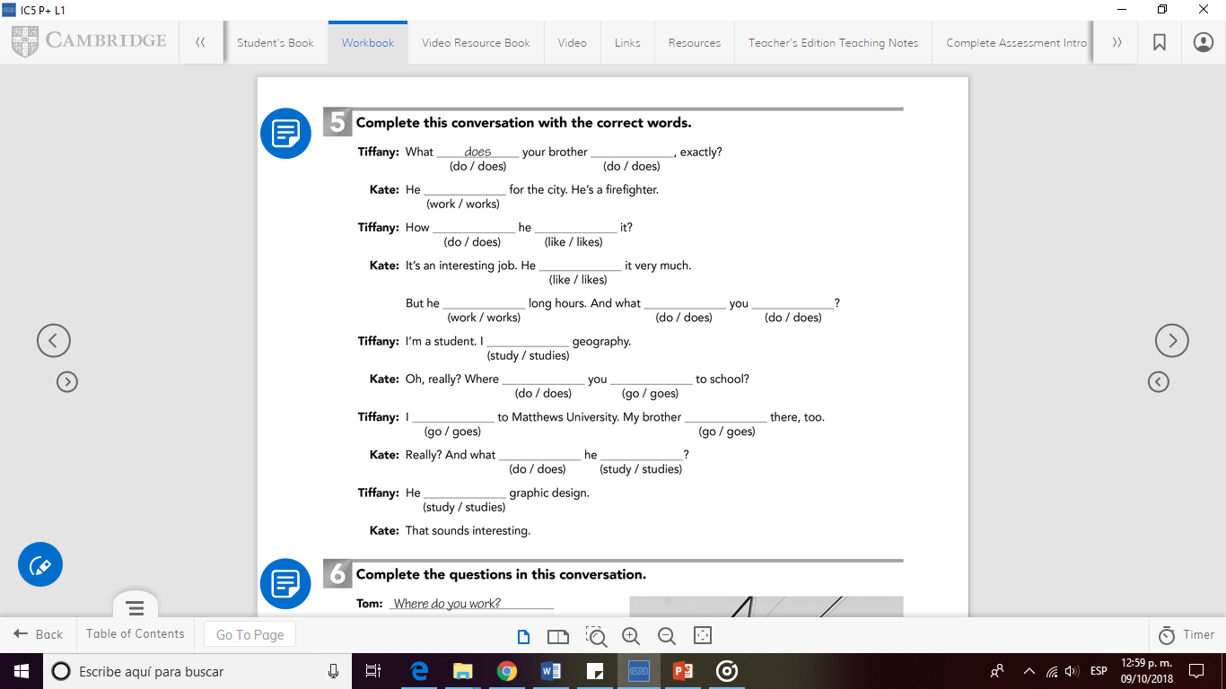

studies

study

does

goes

go

go

do

study

do

do

works

likes

like

does

works

do