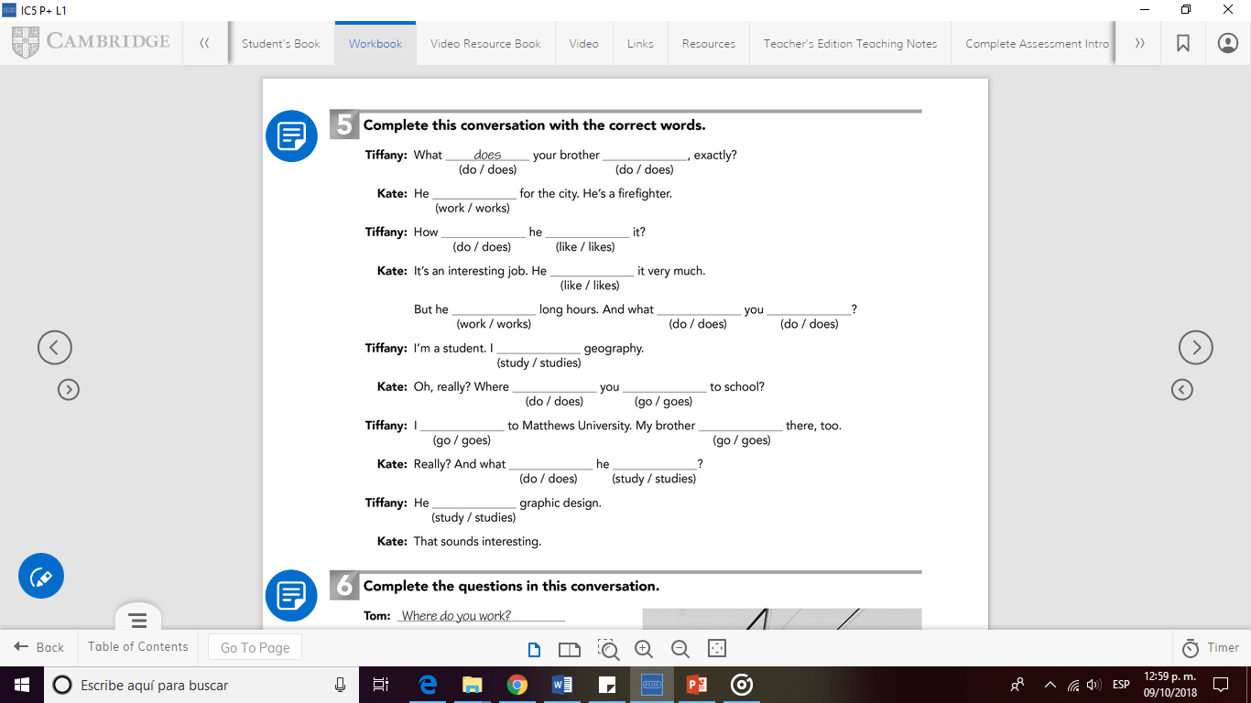

go

goes

do

studies

studies

go

does

study

do

does

works

likes

like

do

works

do