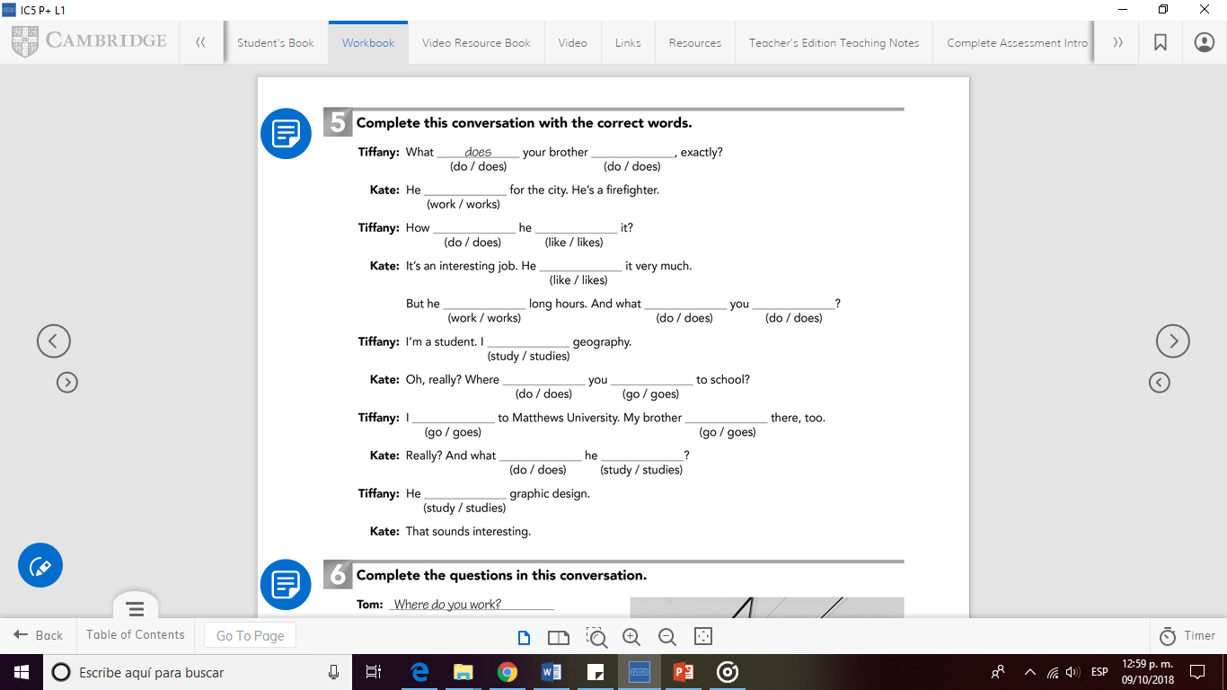

**do**

**works**

**does like**

**likes**

**works do do**

**studies**

**do go**

**goes goes**

**does study**

**studies**