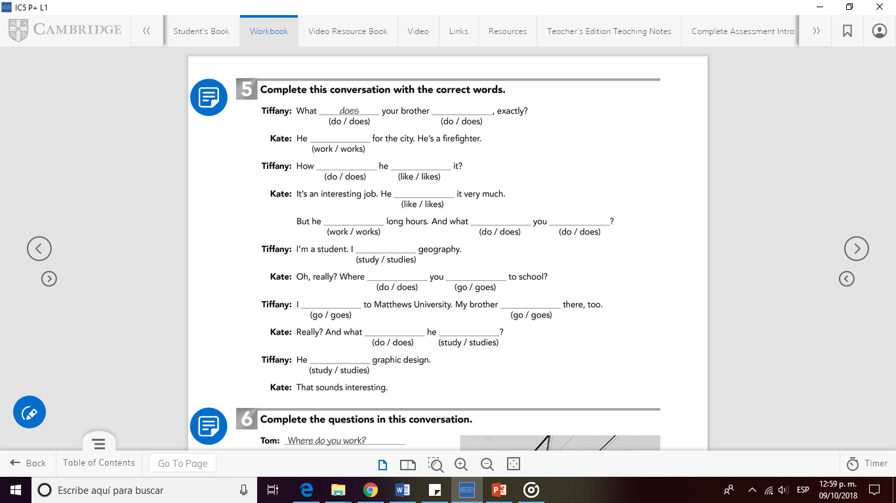

goes

go

study

go

do

studies

study

does

do

do

Iikes

like

does

do

works

works