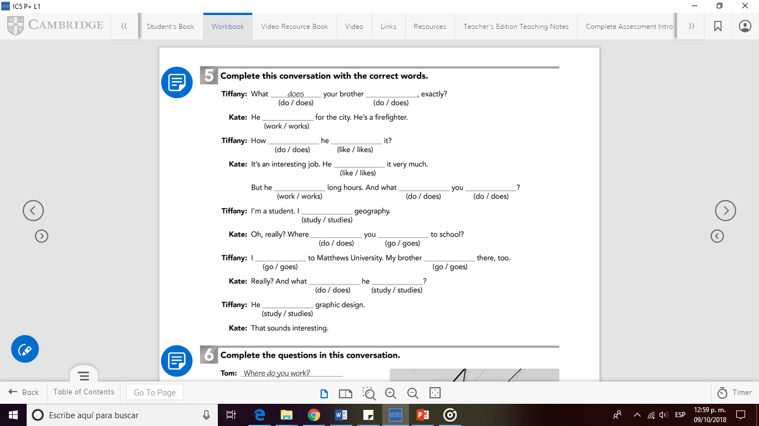

Does

do

does

Do

Study

study

goes

go

Go

Do

study

Works

like

Like

Works

Do