**ESCUELA NORMAL DE EDUCACIÓN PREESCOLAR**

**ENGLISH A1.1 STARTING BASIC COMMUNICATION**

**ENGLISH PROJECT**

**UNIT 3: WHERE ARE YOU FROM?**

**AIM:**

Give students practice to discuss cities, countries, nationalities, and languages using yes/no questions with be and wh-questions with be.

**PREPARATION:**

Complete the information **in the passport outline.**

Unscramble the conversation and complete the frame sentences.

Once you get acquainted with the format, prepare a similar conversation to practice.

Presentation:

For your oral presentation you will “role play” a tourist and a customs officer. You will practice asking and answering Yes/No questions and wh-questions.

Bring “realia” (a suitcase, bag, tourist clothes, etc…) to the class.

**PRODUCTS:**

* You must upload a **word document** to Escuela en Red with a picture of your passport, the unscrambled conversation and the completed sentences on the same page.
* You must **bring your passport and tourist clothes** for your next English class in order to have your speaking activity.

**Name: Mariana Guadalupe Gaona Montes.**

**List number: 7 1° “B”**

**DUE DATE TO UPLOAD PRODUCTS TO THE PLATFORM:** Monday October 29th, 2018

**SPEAKING ACTIVITY:** Wednesday Oct. 31st, 2018

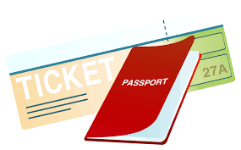I.**Put the conversation in order. Write the numbers.**

__13___Good, Have a good day Ms. Renoir. Welcome to the U.S.

__2__ It´s Renoir. Karla Renoir.

__3___ And how do you spell your last name?

__7 ___Thanks. So where are you from Ms. Renoir?

__9___Oh, What part of Colombia are you from?

__1___ Good morning Ms… I´m sorry, What´s your last name?

__5___ Is your last name French?

__4___ It´s R-E-N-O-I-R

__12___ Yes, it is. My parents are from France, originally.

__11___Is your first language French?

__8___ I´m from Colombia.

__6___No, it´s not. It´s Spanish.

__14___Thanks!

__10___ I´m from Cali.

**\*Conversation in order.**

1- Good morning Ms… I´m sorry, What´s your last name?

2- It´s Renoir. Karla Renoir.

3- And how do you spell your last name?

4- It´s R-E-N-O-I-R

5- Is your last name French?

6- No, it´s not. It´s Spanish.

7- Thanks. So where are you from Ms. Renoir?

8- I´m from Colombia.

9- Oh, What part of Colombia are you from?

10- I´m from Cali.

11- Is your first language French?

12- Yes, it is. My parents are from France, originally.

13- Good, Have a good day Ms. Renoir. Welcome to the U.S.

14- Thanks!

**II. Complete the sentences with the missing words.**

1. Where are you from Mr. Lee?
2. Is your first language German?
3. She´s not from Spain. She´s from Chile.
4. Are you Italian?
5. What´s your sister appearance? She´s tall.
6. Is Leo twenty years old?
7. How old are you? I´m sixteen.

**PASSAPORT**

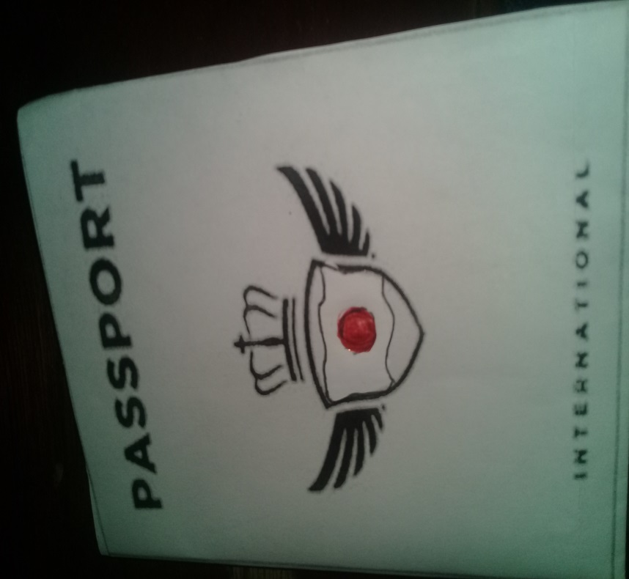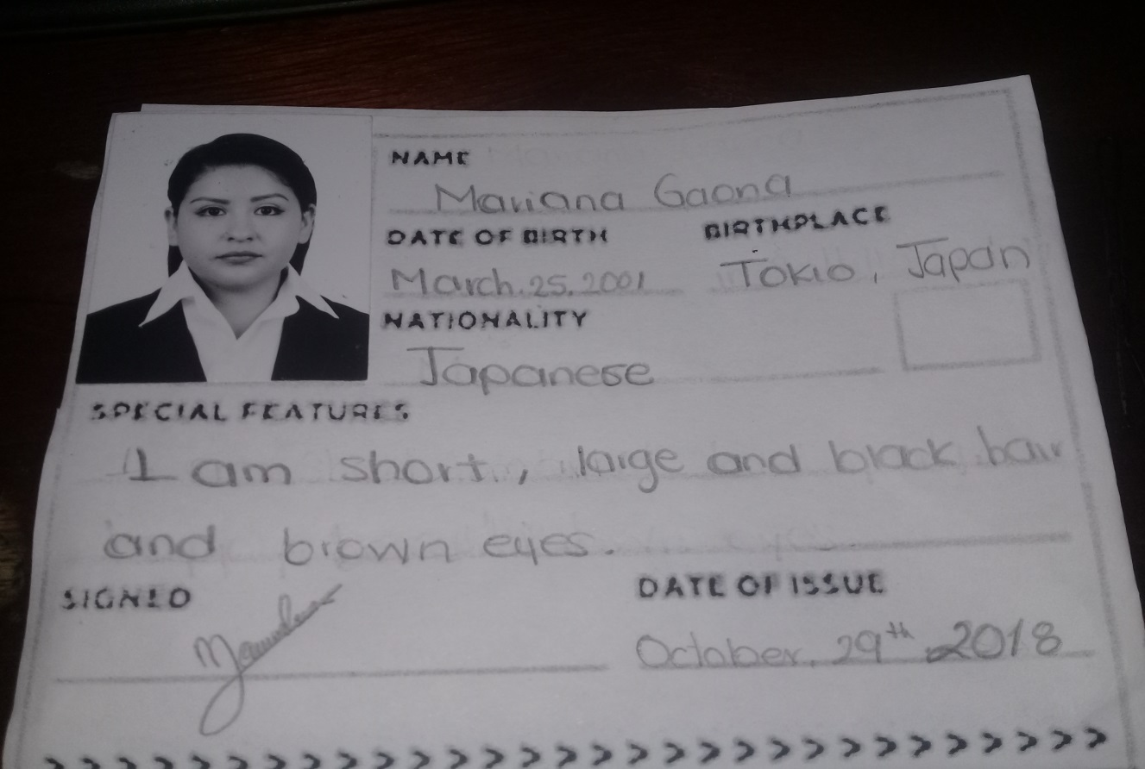

**RUBRIC**

