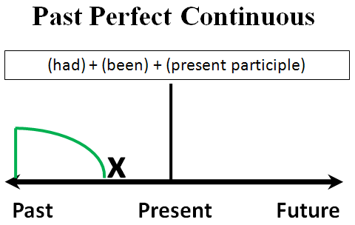 | 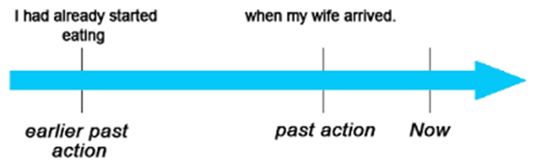
 | 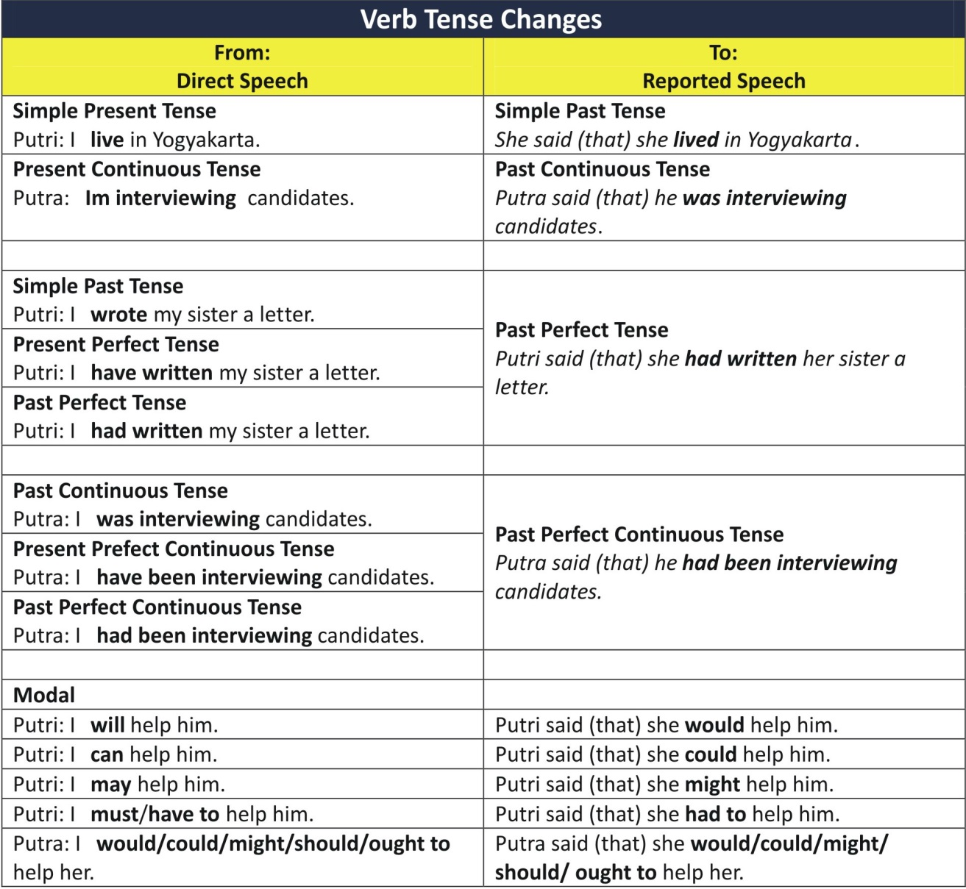
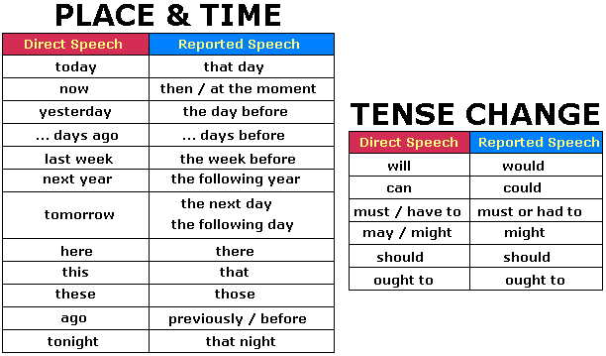

Direct Speech | Reported Speech
Walter:'Don't ring Romy on Sunday!' | Walter told me not to ring Romy on Sunday.
Karen: 'Don't play football in the garden!' | Karen told me not to play football in the garden.
Jane:'Don't watch the new film!' | Jane told me not to watch the new film.
Yvonne:'Please don't visit the neighbors tomorrow!' | Yvonne asked me not to visit the neighbors the next day.
Jamie:'Please don't eat so much junk food!' | Jamie asked me not to eat so much junk food.
Christopher:'Do you want to dance?' | Christopher asked me if I wanted to dance.
Justin:'What are you doing?' | Justin asked me what I was doing.
Ronald:'Where does Maria park her car?' | Ronald asked me where Maria parked her car.
Betty:'When did you come?' | Betty wanted to know when I had come.
Anne:'Must I do the shopping?' | Anne asked if she had to do the shopping.
Mandy:'Are the boys reading the book?' | Mandy asked me if the boys were reading the book.
Grandmother:'Where are my glasses?' | Grandmother asked me where her glasses were.
Elisabeth:'Did you watch the latest film?' | Elisabeth asked me if I had watched the latest film.
Frank:'How much pocket money did Lisa get?' | Frank wanted to know how much pocket money Lisa had got.
Joe: 'Did you really talk to her when she called you last week?' | Joe asked me if I had really talked to her when she had called the week before.'
Emily:'Our teacher will go to Leipzig tomorrow.' | Emily said that their teacher would go to Leipzig the next day.
Michael:'I am going to read a book this week.' | Michael said to me that he was going to read a book that week.
Helen:'I was writing a letter yesterday.' | Helen told me that she had been writing a letter the day before.
Lisa:'Tim went to the stadium an hour ago.' | Lisa said that Tim had gone to the stadium an hour before.
Andrew:'We didn't eat fish two days ago.' | Andrew said that they hadn't eaten fish two days before.
Peggy:'The girls helped in the house.' | Peggy told me that the girls had helped in the house.
Mrs Jones:'My mother will be 50 years old.' | Mrs Jones told me that her mother would be 50 years old.
Stephen and Claire:'We have cleaned the windows.' | Stephen and Claire told me that they had cleaned the windows.
Charles:'I didn't have time to do my homework.' | Charles said that he hadn't had time to do his homework.
Joe: ' By the time the police arrived yesterday, all the books had been stolen.' | Joe said that by the time the police had arrived the day before, all the books had been stolen.

Reference https://www.superteachertools.us/speedmatch/speedmatchfromj.php?gamefile=76626#.VsNbrfnhDIU

