**ESCUELA NORMAL DE EDUCACION PREESCOLAR**

**CURSO DE INGLES**

**TEACHER: MAYELA LAEJANDRA DEL CARMEN GAONA GARCIA**

**RUBRICAS PARA LA EVIDENCIA DE APRENDIZAJE DEL MODULO 3 TRAVELER ELEMENTARY**

|  |  |
| --- | --- |
| Unidad modulo o bloque | Module 3 **Traveller ELEMENTARY** |
| Tema | **MODULE 3 “My home”** |
| Competencia a desarrollar | * Utilizar la lengua para expresar conceptos propios de la unidad. |
| Aprendizaje esperado | * En el aprendizaje del lenguaje se espera que los alumnos tengan la capacidad de comprender, interpretar y producir textos, valorar la literatura y argumentar sobre la importancia de la ética y la técnica en la comunicación. |
| Rasgos o competencias del perfil de egreso. | * Aplica sus habilidades comunicativas en diversos contextos. * Desarrolla sus habilidades comunicativas para adquirir nuevos lenguajes. * Utiliza una segunda lengua para comunicarse. * Emplea las tecnologías de la información y la comunicación. * Participa en comunidades de trabajo y redes de colaboración a través del uso de la tecnología. |
| **TRABAJO A DESARROLLAR. “Daily Activities”**  **Reference: MODULE 3** | |
| Acuerdos sobre la forma de evaluar. Incluir: estructura general del portafolio, autoevaluaciones, coevaluaciones. | Read all the instructions before you begin.  **STEP 1 PRE-TASK**  Students acquire new structures, vocabulary and functions of language in module 3 (Traveller ELEMENTARY)  **STEP 2 PREPARATION**  Students practice withgrammar structures, vocabulary and functions of language in module 3 (Traveller ELEMENTARY)  **STEP 3 REALISATION**  Students develop the project using enough functions, vocabulary and structures on it.    **STEP 4 POST-TASK**  Students close unit with the project which is going to be shared with the group and evaluated by the teacher |
| Identificación de los productos por unidad, tema o actividad (Nombrar los productos) | Turn in the TASK PROJECT by _______________________.  It must contain:   * Cover page with the rubrics * Develop the project including grammar, functions and vocabulary from the unit. * Upload the project in Escuela en Red by_____________________ * Project for portfolios by______________________ |
| Señalar con precisión de características, tiempos y condiciones de entrega | * Pair work writing task module 3 (word or ppt. document) * Make a ppt. presentation with images, sound and text describing your home, places and furniture in your house. * At least 4 slides * Use the vocabulary, grammar structures and language functions from the module3 * Include in your writing task * Vocabulary from the module 3 **(+15 colored in blue)** * Use grammar structures in sentences with prepositions of place ( in , on, opposite, above, in front of, between, behind, under, next to) **(+10 colored in pink)** * Use grammar structures in sentences with there is, there are **(+5 colored in purple)** * Use grammar structures in sentences with possessive pronouns and possessive adjectives **(+5 colored in green)** * Include **Complete cover page, reflective note and checked self-assessment** of the module **(+5pts)** |
| Señalar con precisión Tiempo estimado para la retroalimentación | The teacher’s feedback for the project will be given by the teacher the next English session on ____________________ |
| Describir condiciones y ambiente para la presentación final del portafolio | All the elements of the project **included in portfolios** must be shown to the teacher on__________________________ |
| Matriz o rubrica de evaluación con un apartado de retroalimentación u observaciones por parte del docente y análisis por parte del alumno | |  |  |  | | --- | --- | --- | | Requerimiento | Valor en Puntos | Puntos obtenidos | | * Vocabulary from the module 3 **(+15 colored in blue)** | 15 |  | | * grammar structures in sentences with prepositions of place ( in , on, opposite, above, in front of, between, behind, under, next to) **(+10 colored in pink)** | 10 |  | | * Use grammar structures in sentences with there is, there are **(+5 colored in purple)** | 5 |  | | * Use grammar structures in sentences with possessive pronouns and possessive adjectives **(+5 colored in green)** | 5 |  | | * Include **Complete cover page, reflective note and checked self-assessment** of the module **(+5pts)** | 5 |  |  |  |  |  |  | | --- | --- | --- | --- | | General requirement format (+5 pts) | Good  (1) | Average  (1/2) | Weak  (0) | | Does the student correctly apply in context the new functions and grammar from the module? |  |  |  | | Does the student correctly apply in context the vocabulary from the module? |  |  |  | | Does the student express himself or herself clearly and fluently? |  |  |  | | The task is creative. |  |  |  | | The task fulfill all the elements of the required format |  |  |  | | Total: 5 pts |  |  |  | |

**Self Assessment format.**

Name___________________________________________________________date___________________

Read and check according to the competencies you have achieved during the module.

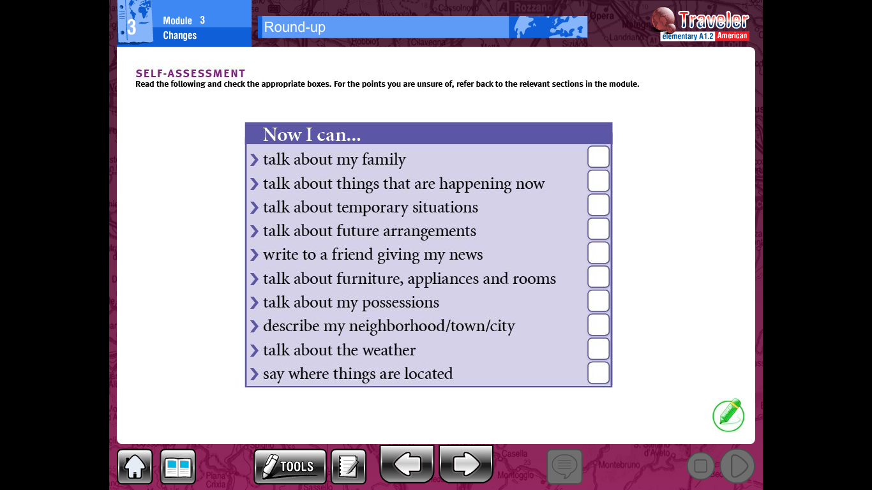

**Reflective note:**

Write down your reflective note about the competencies you have and have not achieved

__________________________________________________________________________________________________________________________________________________________________________________________________________________________________________________________________________________________________________________________________________________________________________________________________________________________________________________________________