LEVEL B1.1 Teacher: Maria Elena Meza Aguado
UNIT 4. Time to Celebrate!
PROJECT: UNUSUAL CELEBRATIONS

Student’s Name: ______________________________________Date___________________

Aim: Give Ss practice describing holidays/celebrations.

A Plan
Choose a member country of the United Nations Organization (ONU) you want to learn more about. Then research an interesting celebration in that country. Use these questions and your own questions.
- Who celebrates it?  - Where is it celebrated?  - Why is it celebrated?  - How is it celebrated?  - What do people wear?  - What do people eat?  - Is there any music or a special ceremony?  - What happens WHEN people celebrate, BEFORE they celebrate and AFTER they celebrate? | 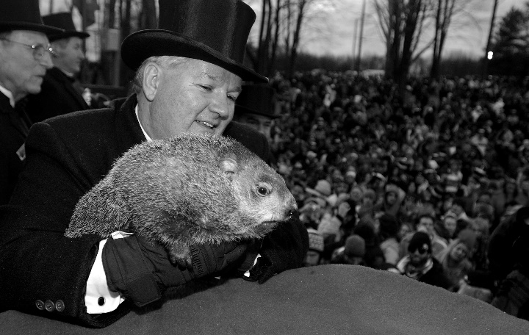  Punxsutawney Phil on Groundhog Day  https://www.youtube.com/watch?v=agyiJKgw9MM
B Prepare a presentation about the celebration. Write it. Use the new language form the unit (vocabulary and relative and adverbial clauses of time). Highlight it. You can find it in your language summary file.
Use pictures, costumes, food, or music to present the information you learned. Be creative!

C Present (October 25th)
Explain the celebration to the class orally. Reading will not be permitted. Share what you learned and be prepared to answer questions.

Take pictures or video of your performance as evidence of work. Upload it in this activity under this instructions, by October 30th.

Speaking will be graded as:
Did the student apply the new functions? | 0 | .5 | 1 | 1.5 | 2
Did the student apply the new vocabulary? | 0 | .5 | 1 | 1.5 | 2
Was the student Fluent? | 0 | .5 | 1 | 1.5 | 2
Was the student’s voice clear? | 0 | .5 | 1 | 1.5 | 2
Did the student apply the new structures? | 0 | .5 | 1 | 1.5 | 2
total
General Comments

Suggestions for improvement

