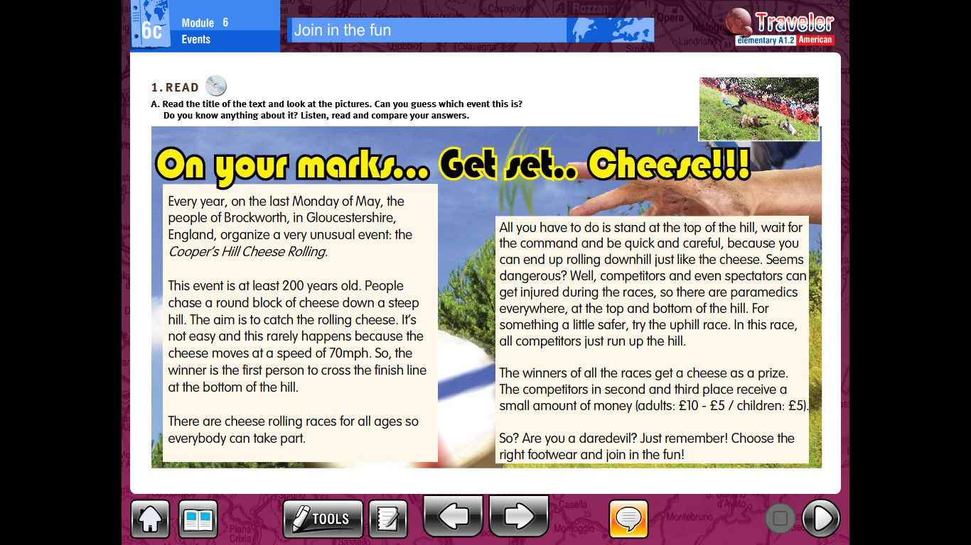

Read the text and answer the following questions in your notebook. You may print and paste the questions.

1. What is the full name of the event?
2. What do the people who take part in the race chase?
3. What is the aim of the race?
4. Is it easy?
5. Why?
6. Who’s considered to be a winner?
7. Can people of all ages take part in the cheese rolling races?
8. Who can get injured during the races?
9. Who may choose to try the uphill race?
10. What do the competitors in second and third place receive?
11. What should you do before you take part in a cheese rolling race?

Read and complete the sentences.

