|  |  |
| --- | --- |
| Unidad modulo o bloque | Module 4-6**Traveller** |
| Tema | **MODULE 4-6 “ENGLISH IN USE,WRITE AN ESSAY”** |
| Competencia a desarrollar | * Utilizar la lengua para expresar conceptos propios de la unidad. |
| Aprendizaje esperado | * En el aprendizaje del lenguaje se espera que los alumnos tengan la capacidad de comprender, interpretar y producir textos, valorar la literatura y argumentar sobre la importancia de la ética y la técnica en la comunicación. |
| Rasgos o competencias del perfil de egreso. | * Aplica sus habilidades comunicativas en diversos contextos.   oDesarrolla sus habilidades comunicativas para adquirir nuevos lenguajes.  oUtiliza una segunda lengua para comunicarse.   * Emplea las tecnologías de la información y la comunicación.   oParticipa en comunidades de trabajo y redes de colaboración a través del uso de la tecnología. |
| **TRABAJO A DESARROLLAR.“ENGLISH IN USE, WRITE AN ESSAY”**  **Reference: Vocabulary from module 4-5-6** | |
| Acuerdos sobre la forma de evaluar. Incluir: estructura general del portafolio, autoevaluaciones, coevaluaciones. | Read all the instructions before you begin.  **STEP 1 PRE-TASK**  Students acquire new structures, vocabulary and functions of language in complete module 4- 6 (Traveller B1+)  **STEP 2 PREPARATION**  Students practice withgrammar structures, vocabulary and functions of language in complete module 4-6(Traveller B1+)  **STEP 3 REALISATION**  Students develop the project using enough functions, vocabulary and structures on it.  **STEP 4 POST-TASK**  Students close unit with the project which is going to be sharedwith the group and evaluated by the teacher |
| Identificación de los productos por unidad, tema o actividad (Nombrar los productos) | Turn in the TASK PROJECT by thursday the 7th of January 2016.  It should contain:   * Cover page with the rubrics * Develop the project including grammar, functions and vocabulary from the unit. * Upload the project in Escuela en Red. (thursday the 7th of January 2016) * Project for portfolios thursday the 14th of January 2016 |
| Señalar con precisión de características, tiempos y condiciones de entrega | * Pair workwritting task ref. pgsmodule 4-6 * 20 lines min/ 120-180 words (12underlined vocabulary words, 10 underlinedgrammar structures, 3underlinedcommon phrases) * Use the next titles as **REFERENCE**: * Flying cars next generation vehicles (reading sb ref. pg 61) * The dark side of the internet (reading wb ref. pg 41) * Inventions and gadgets (reading wb ref. pg 49) * A trip to Peru (reading sb ref. pg 81) * Strange Hobbies(reading sb ref. pg 85) * Cleaning up the environment (reading sb ref. pg 97) * Eco-turism (reading sb ref. pg 99) * Recycling (reading wb ref. pg 71) * The nature reserve (reading wb ref. pg 73) * **Follow** template and include all elements mentioned in the **OUTLINE** ref. pg. stbk 65. **Check** the **TIPS** to better organize your essay and use some list words which are helpful to include in your essay. (example essay “the world at your fingerprints” on sbpg 65)            * Use grammar, vocabulary and expressions from module 4-6   . |
| Señalar con precisión Tiempo estimado para la retroalimentación | The teacher’s feedback for the project will be given by the teacher the next English session on thursday the 14th of January 2016 |
| Describir condiciones y ambiente para la presentación final del portafolio | All the elements of the project **included in portfolios** must be shown to the teacher onthursday the 14th of January 2016 |
| Matriz o rubrica de evaluación con un apartado de retroalimentación u observaciones por parte del docente y análisis por parte del alumno | The project will be graded as: Does the student correctly use grammar, vocabulary and new functions from the module? Overall, is it easy to understand the student? Does the student express himself or herself fluently? Did the student apply the new functions, structures and vocabulary? The work is creative, neat, complete and understandable? |

Answer the following self assessment module 4-6

**Module 4**

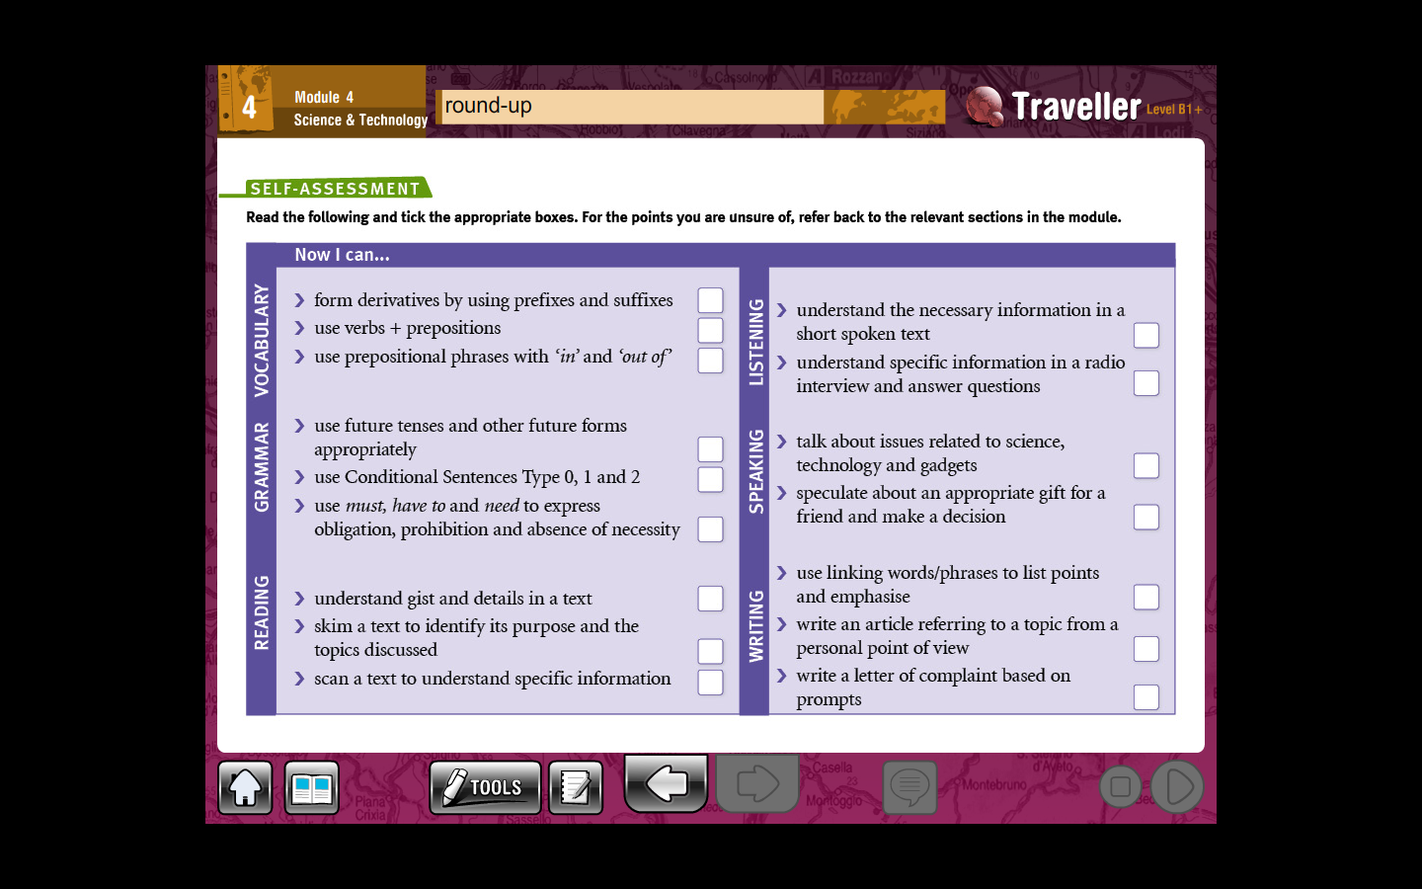

**Module 5**

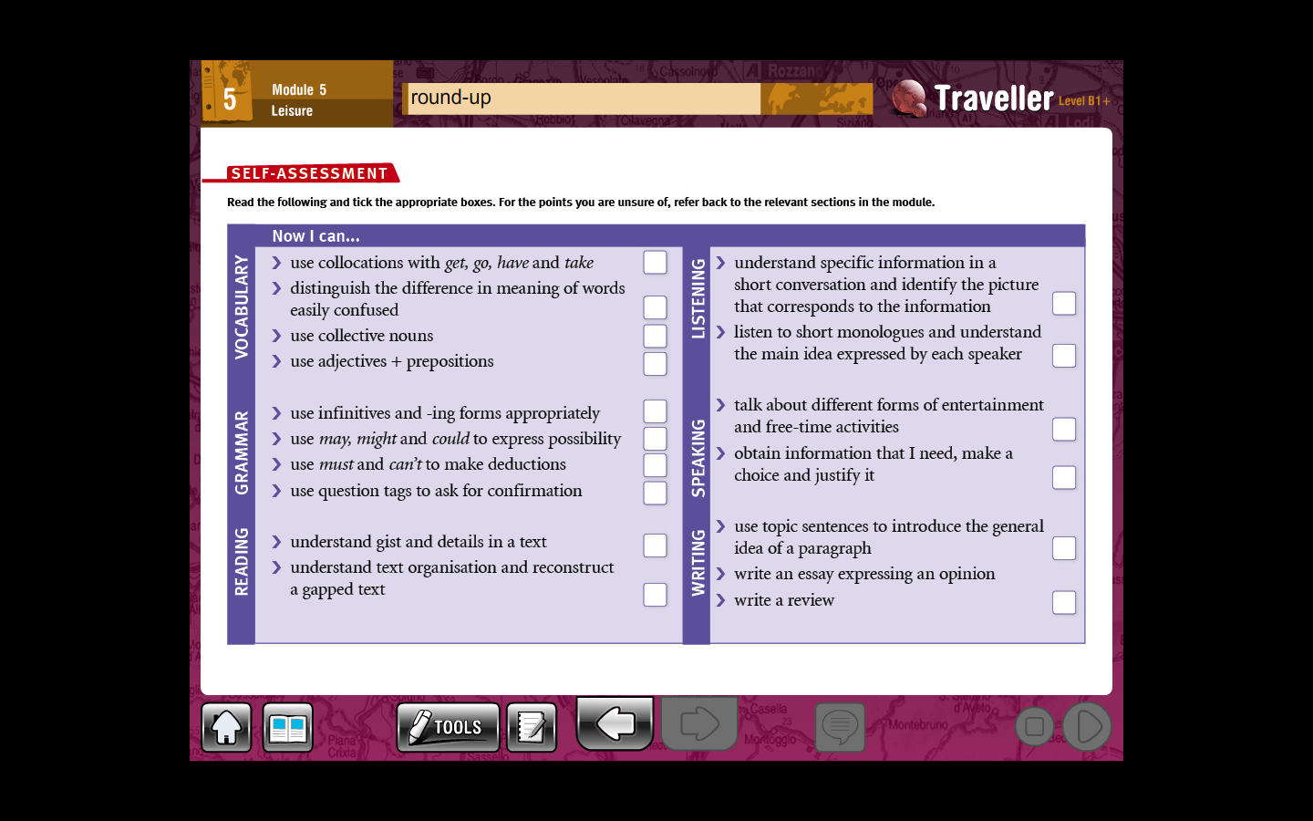

**Module 6**

