**GLOBAL EVALUATION B1.1.2**

PERFORMANCE

The student is expected to demonstrate the examiner, the communicative skills and meet the language requirements listed in the interchange 2 book (see your language summaries), during the exam.

TOPIC DISCUSSION

Choose and develop a topic. (Length 5min talk)

The STUDENT prepares a topic of his/ her own choice. It’s the opportunity to demonstrate what he/she can do in English and to talk about a topic which is of personal interest to him/her and which he/she feels confident talking about.

* During the discussion, the examiner will request more information, facts or details.
* Ask the examiner at least one question about the topic area.
* Take the opportunity provided to use the language functions and language items from the viewed Units in your Interchange 2 book.
* The ideas below are only examples and they are not suggestions:

|  |  |  |
| --- | --- | --- |
| My favorite country | My favorite sport | Different film genres |
| My favorite actor | My favorite film | My favorite musician |
| My favorite book/writer | My school | My favorite city |

See the example map. Complete your own map as you develop your topic. You can use this model or create your own, but you need to break down your subject into at least 5 related sub topics. You may add drawing if it pleases you. The examiner will use it as a basis for the discussion.

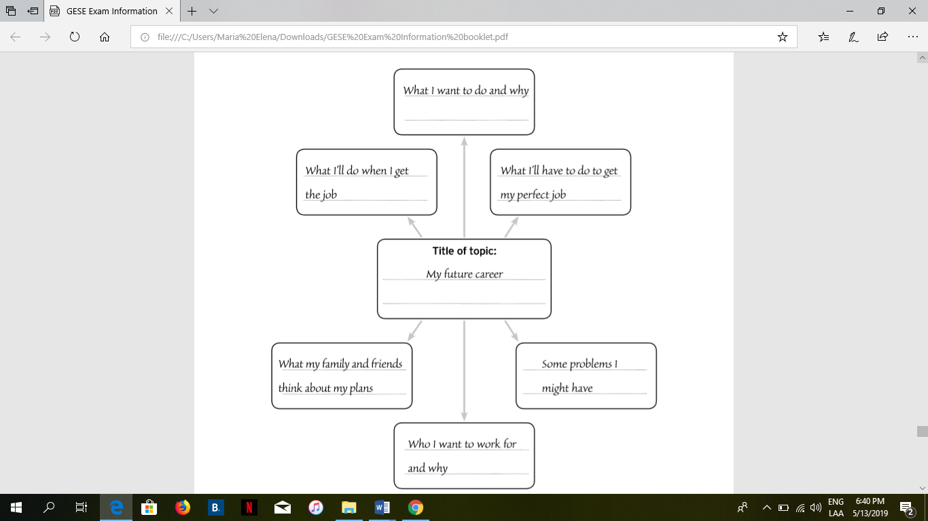 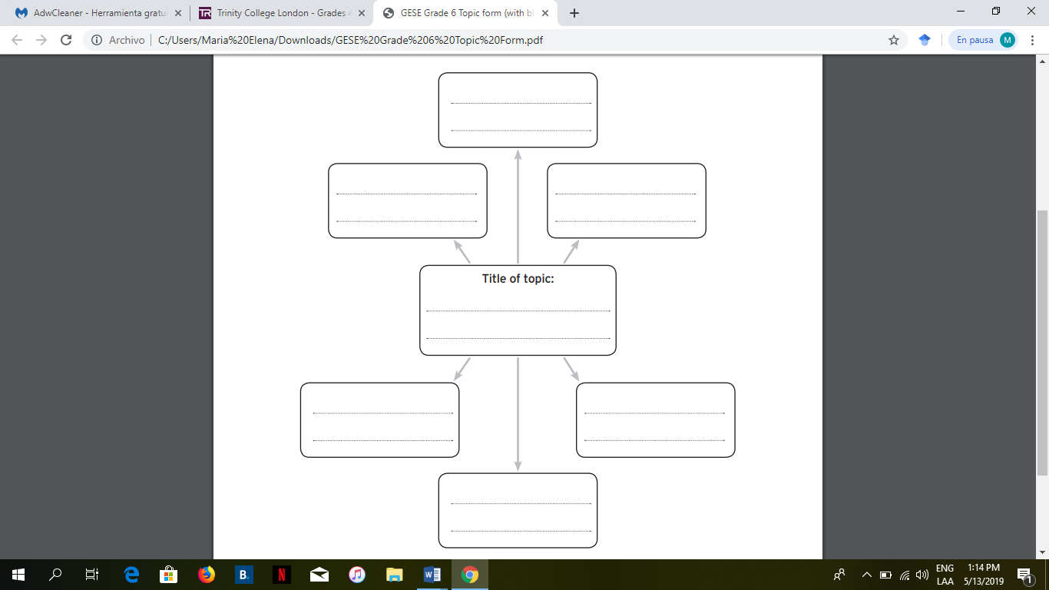

EVALUATION. These are the elements that will be considered in the GLOBAL oral evaluation:

