**WRITING TASK 1**

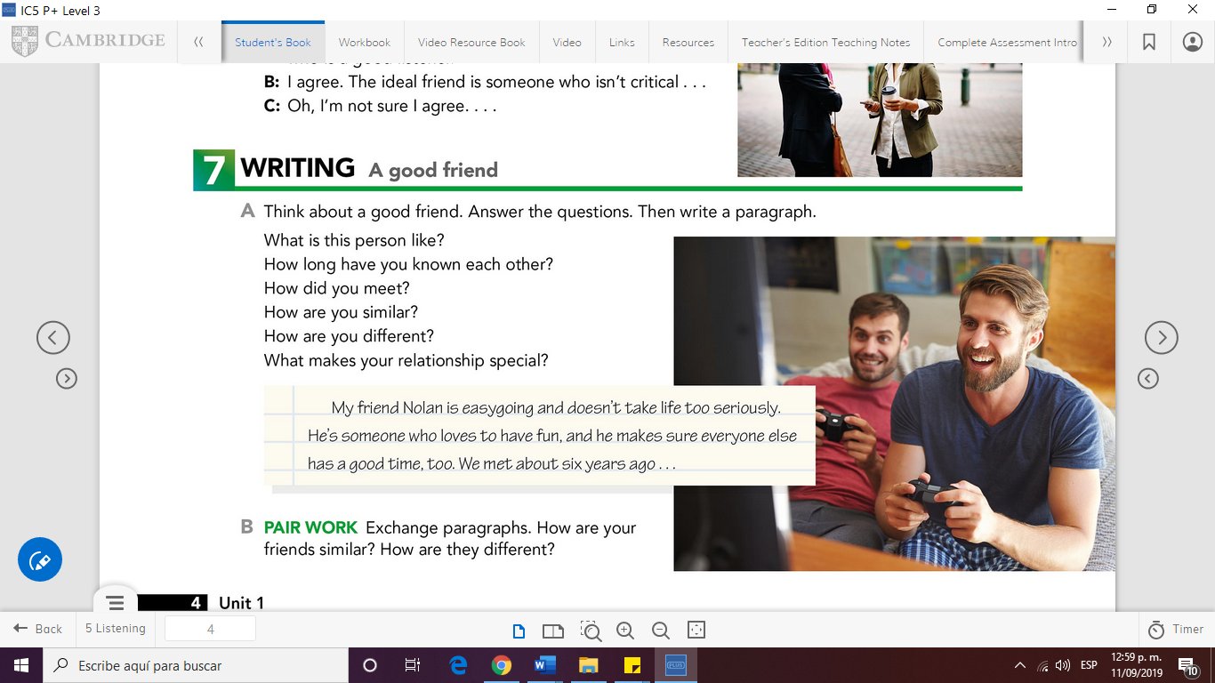**UNIT 1**

**Once you have finished your paragraph use the**

**WRITING CHECKLIST**

|  |  |  |
| --- | --- | --- |
| Have I spelt everything correctly? | **YES** | **NO** |
| Have I used interesting vocabulary? | **x** |  |
| Have I used a selection of varied connectors? | **x** |  |
| Have I used punctuation correctly? |  | **x** |
| Did I write at least 100 words in my paragraph? | **x** |  |
| Have I used the grammar structure revised in class in my assignment? | **x** |  |

Write your assignment in the following page

A GOOD FRIEND

My friend Paulina is very funny and smiling, she likes to go out and meet people.

She is 20 years old, she is a good worker and I like to talk with her about different things.

I have 3 years of meeting her and we have spent many incredible and happy moments.

I met her at the Enep we went to a party together and we started talking and getting to know each other, after that party we started to be friends

We have similar tastes and preferences, in the food, in the pleasure of going out to parties, sleeping and the taste for children.

We are a little different when discussing a problem she gets angry in her own way and I am mine but in general we are not very different

I think that my friendship with Paulina makes her special because she is a person I trust, and is always there when I need her