ESCUELA NORMAL DE EDUCACION PREESCOLAR  
Licenciatura en Educación Preescolar  
Ciclo 2019-2020



Writing task

Ingles B1.2

Unit 1

Brenda Bollain Y Goytia De La Peña

Larissa Elizabeth Davila Patlan

#3

September 20, 2019

**WRITING TASK 1**

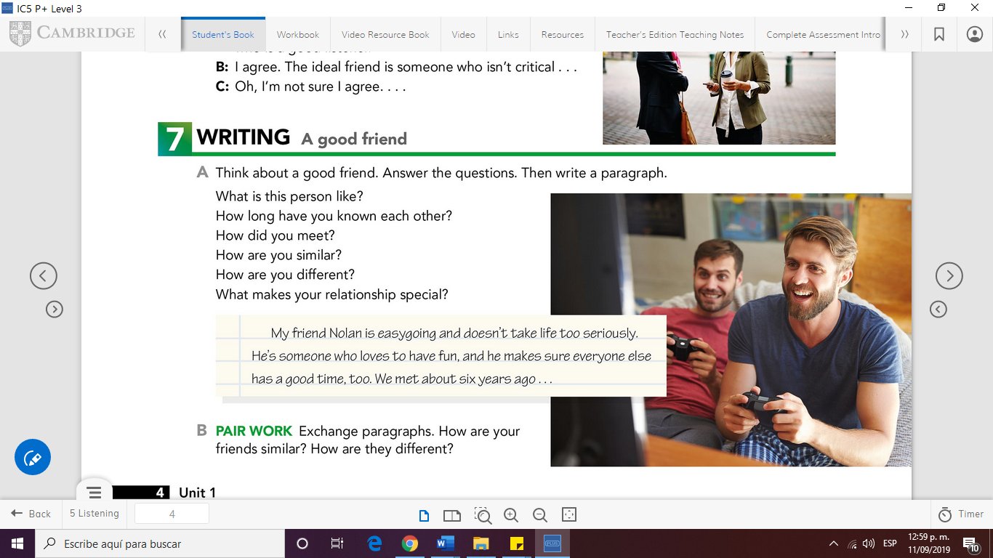**UNIT 1**

**Once you have finished your paragraph use the**

**WRITING CHECKLIST**

|  |  |  |
| --- | --- | --- |
| Have I spelt everything correctly? | **YES** | **NO** |
| Have I used interesting vocabulary? |  |  |
| Have I used a selection of varied connectors? |  |  |
| Have I used punctuation correctly? |  |  |
| Did I write alt least 100 words in my paragraph? |  |  |
| Have I used the grammar structure revised in class in my assignment? |  |  |

Write your assignment in the following page

A GOOD FRIEND

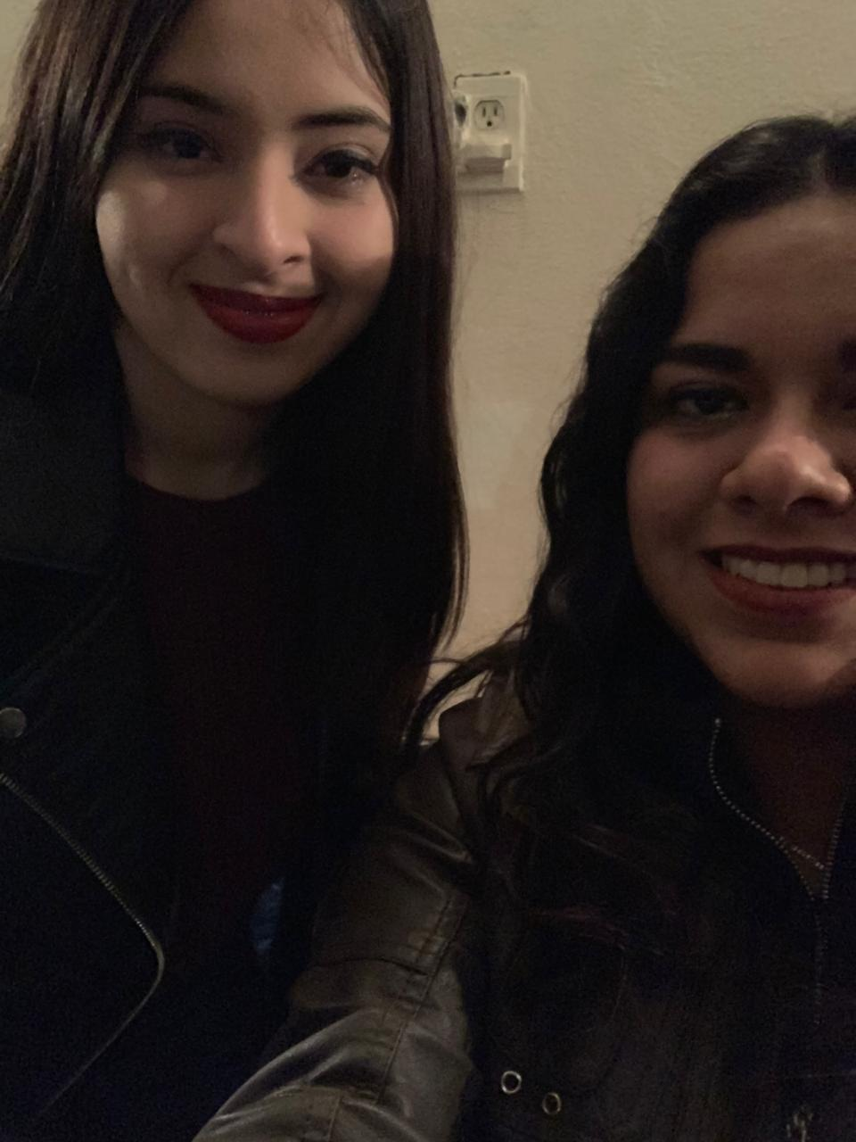The name of my friend is Daniela Elizabeth Luna Rangel, she´s easygoing and maybe she only get angry if we do something she doesn´t like or something that bother her. In addition she´s an outgoing person. She is the kind of person who have a lot of fun and loves go to parties or have a dinner. As a friend she´s supportive, she always try to make her friends feel comfortable and if we have a problem she help us to solve it. We know each other 2 years ago and we met in the Escuela Normal de Educacion Preescolar. Furthermore, we are in the same class since the beginning, we start being friends in second semester, and I realized that she is the kind of person who is a good friend.

I think Daniela and I are similar in many things, one of them is that we love to listen to music and watch series and movies. Maybe we are different by the genres of the movies we like to watch. However, we see the way to watch movies that both of us like and maybe if we watch a horror movie because of me, then we will watch a movie of romance or another genre Daniela choose.

I think that the things that make our relationship special is the way we treat each other, we worry so much for the other and we know that we are going to be there if one of us need the other, it doesn´t matter the day or the hour we always are going to be there.

I love her because she is loyal and supportive. She helps me to go out because I don´t know so much people here and she help me with that, she invite me to go out with her and her friends.