**WRITING TASK 1**

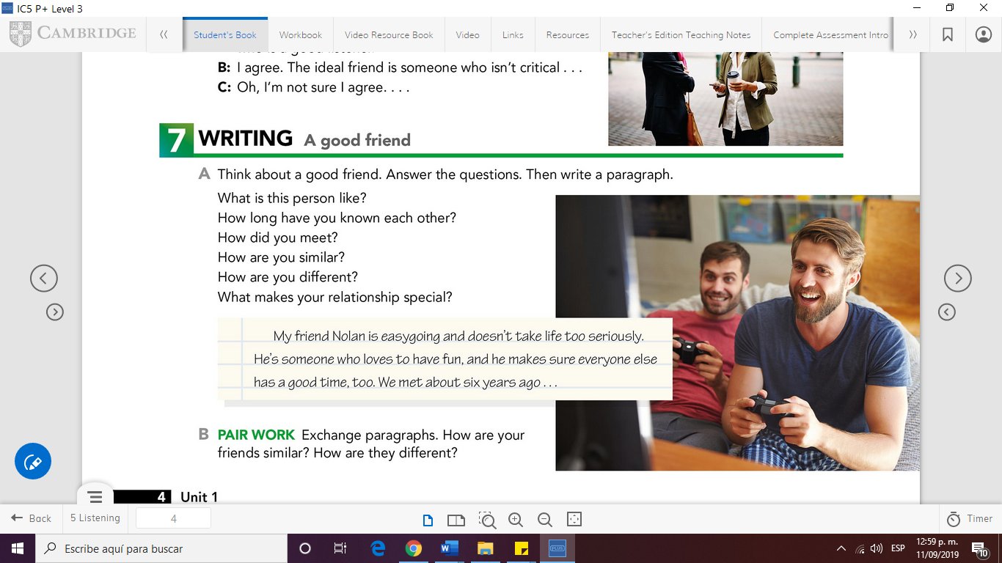**UNIT 1**

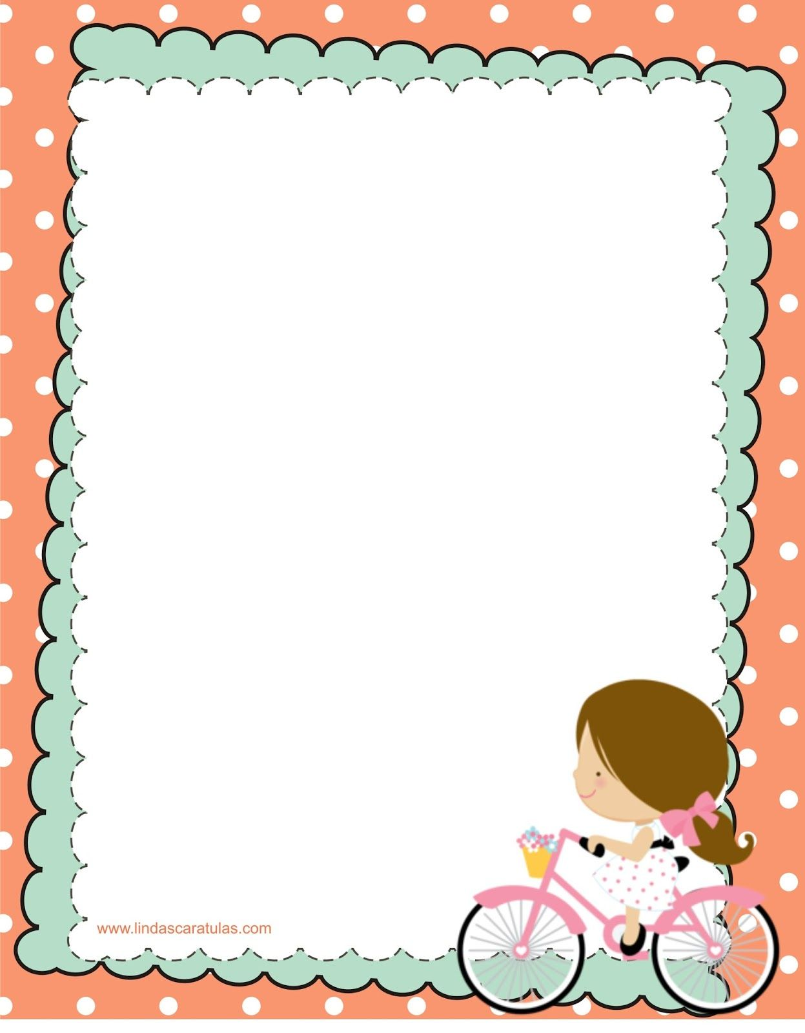A GOOD FRIEND

My friend Itzel is a person who is reliable and she doesn´t mind if other person have problems.

First of all she´s listener and helpful, for example she´s very sensitive, when I tell my thoughts, and she always has a possible solution for me.

I met her 3 years ago, when we enter at university, and our friendship has remained intact, until today.

I think we can have something in common, because she likes to do make-up, fashion trends, go shopping, and heels of colors.

However, we have our difference, for example, she´s very serious, and take things seriously.

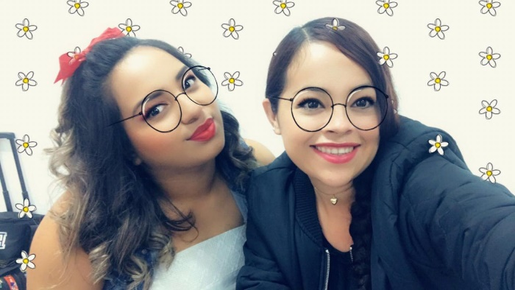On the other, hand my personality it´s different from her, because I like to do jokes, break the rules and be sociable with anothers persons without

Knowing them.

In conclusion, we complement 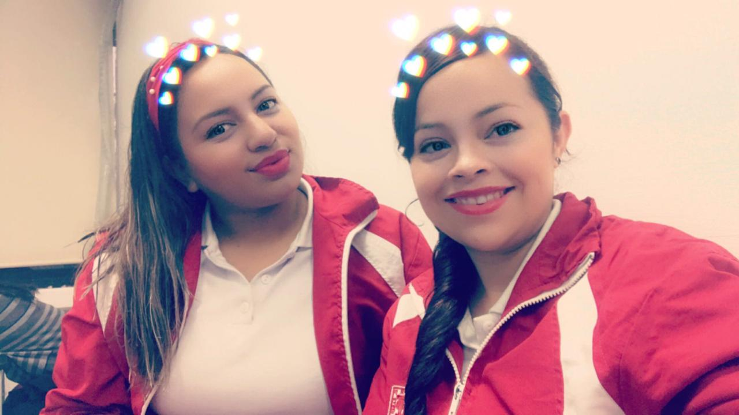each other,

I make her have fun

In addition, she makes

Me reflect on my actions

What makes our relationship

Special

**WRITING CHECKLIST**

|  |  |  |
| --- | --- | --- |
| Have I spelt everything correctly? | **YES** | **NO** |
| Have I used interesting vocabulary? |  |  |
| Have I used a selection of varied connectors? |  |  |
| Have I used punctuation correctly? |  |  |
| Did I write at least 100 words in my paragraph? |  |  |
| Have I used the grammar structure revised in class in my assignment? |  |  |

Write your assignment in the following page