LEVEL B1.1 Teacher: Maria Elena Meza Aguado

**UNIT 1 Sure! I’ll do it.**

**PROJECT:** “Pet Peeves”.

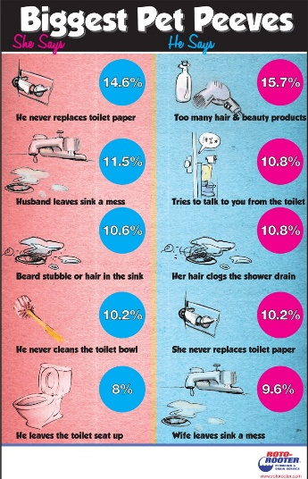**AIM:** Give students practice making complaints, using two-part verbs to make and respond to requests using modals and *would you mind…?*

**LEARNING INDICATORS:** The student can…

* Discuss common complaints.
* Make and respond to requests.
* Apologize and give excuses

|  |
| --- |
| **PRODUCT 1.** |

“What is a pet peeve?” *something that really annoys you*.

People can complain about: *friends, family, school, teachers, neighbors, traffic, cell phones, computers, etc*.

**GROUPS OF 4 PEOPLE.** Choose a category and complete the survey question below. As a group, asks 80 people the same question. Make sure to write their answers.

Start with this question:

*What is your biggest complaint about _____________________?*

***PRESENT******(Friday, September 27th, 2019)***

Compile the results in class, check the grammar and spelling. Then, put the answers in a list on a Word file, from most common to least common. Up load it in the project Unit 2 activity, in Escuela en Red.

Writing will be graded as:

|  |  |  |  |  |  |
| --- | --- | --- | --- | --- | --- |
| Did the student apply the new functions? | 0 | .5 | 1 | 1.5 | 2 |
| Did the student apply the new structures? | 0 | .5 | 1 | 1.5 | 2 |
| Did the student apply the new vocabulary? | 0 | .5 | 1 | 1.5 | 2 |
| The written work is neat, and understandable? | 0 | .5 | 1 | 1.5 | 2 |
| Does it contain the required elements? | 0 | .5 | 1 | 1.5 | 2 |
| total |  | | | | |
| General Comments | | | | | |
| Suggestions for improvement | | | | | |

|  |
| --- |
| **PRODUCT 2.** |

PAIR WORK. Imagine you are going to go on vacation. Make a conversation where you ask and answer questions about each other’s vacation plans. Use the example conversation in your book’s unit’s 1-2 progress check page, activity 2 DISCUSSION as a model.

PAIR WORK. Make four conversations. See the pictures in your book Progress check pages and make requests. Your partner responds by agreeing or refusing/objecting or to your request and giving an excuse. Use the expressions in the box and the vocabulary in the language summary unit 6. **You cannot repeat words within your four conversations**. Prepare to role-play without your notes.

|  |  |  |
| --- | --- | --- |
| * *Can you . . . ?* * *Could you . . . ?* * *Would you please . . . ?* * *Would you mind . . . ?* |  | |
| **Example:**  *A: Could you please turn down the music?*  *I’m trying to study.*  *B: Of course.*  *I didn’t realize it was so loud.* | | Request  Follow-up statement  Agreement/objection  Excuse |

**PRESENT** **(Friday, September 27th, 2019)**

Speaking will be graded as:

|  |  |  |  |  |  |
| --- | --- | --- | --- | --- | --- |
| Did the student apply the new functions? | 0 | .5 | 1 | 1.5 | 2 |
| Did the student apply the new vocabulary? | 0 | .5 | 1 | 1.5 | 2 |
| Was the student Fluent? | 0 | .5 | 1 | 1.5 | 2 |
| Was the student’s voice clear? | 0 | .5 | 1 | 1.5 | 2 |
| Did the student apply the new structures? | 0 | .5 | 1 | 1.5 | 2 |
| total |  | | | | |
| General Comments | | | | | |
| Suggestions for improvement | | | | | |

**GROUP OF 4 PEOPLE**

1. They do not respect signs **15**
2. They don’t have road education **10**
3. Disrespect to pedestrians **6**
4. They do not give way to another vehicle **2**
5. They do not use the directional **10**
6. Do not use the corresponding lane **5**
7. Park instead of disabled **2**
8. Let loose a lot of smoke
9. They don't know how to drive
10. Go late anywhere
11. Do not respect traffic laws **5**
12. There are no tolerant people
13. There is no good public transport
14. It's horrible **8**
15. Bad traffic light synchronization
16. It's the worst
17. Sound the horn
18. Put the directional and do not turn
19. It´s very stressful **2**
20. Causes accidents
21. Taxis and trucks do not park where they should
22. Do not respect traffic lights
23. Cause many accidents
24. It makes you angry
25. They have no respect

**TEAM:**

**Adriana Ferrer**

**Andrea Navarro**

**Fernanda Mendez**

**Ana Lilia Retta**

**PAIR WORK #1**

* **A: Where are you going to go on your next vacation?**
* **B:**  I’m going to go to Nuevo Leon
* **A: What are you going to do?**
* **B:**  I’m going to visit my grandmother
* **A: Why did you choose that?**
* **B:**  Because I want to see and spend time with my grandmother

**PAIR WORK #2**

* **A:** Could you please take out the cat?

Because I’m doing my homework

* **B:** Sorry, I can’t

Because I’m sick

* **A:** Could you please turn off the music?

I’m not listen the tv

* **B:** Yes, no problem

In a minute

* **A:** Can you pick up the garbage off, please?

Because anyone stumble

* **B:** yes, no problem

I’m can.

* **A:** could you put away your clothes, please?

Because we have people over

* **B:** sorry, I’m can’t

I’m sick

**TEAM:**

**Fernanda Alejandra Gonzalez Méndez**

**Ana Lilia Retta Riojas**