LEVEL B1.1 **Teacher:** Maria Elena Meza Aguado

UNIT 1 Sure! I’ll do it.

PROJECT: “Pet Peeves”.

**Team members:**

1. Alvarez Valdez Zaira Vanessa
2. Garcia Samaniego Fatima Araminda
3. Martinez Espinosa Karla Cecilia
4. Quilantan Rangel Daniela Guadalupe

PRODUCT 1.

“What is a pet peeve?” something that really annoys you.

People can complain about: friends, family, school, teachers, neighbors, traffic, cell phones, computers, etc.

GROUPS OF 4 PEOPLE. Choose a category and complete the survey question below. As a group, asks 80 people the same question. Make sure to write their answers.

Compile the results in class, check the grammar and spelling. Then, put the answers in a list on a Word file, from most common to least common. Up load it in the project Unit 2 activity, in Escuela en Red.

**What is your biggest complaint about the school ?**

12 students say that the internet always fails a lot.

7 students say there is very little breack time.

6 students say there is bad organization within the school.

5 students say the platform fails a lot.

4 students say that many times students teach instead of teachers.

3 students say:

The teachers are late.

The classroom furniture is in poor condition.

There is often no toilet paper

That there is no recess.

2 students say:

They have to pay for collegiate.

That many times teachers are missing.

The classrooms are small.

The school system is very bad

They are not given information about managers.

There is no empathy between teachers and managers

1 people say:

There is never a variety of food in cafeteria

There are not enough sockets in the classrooms

There are almost never speakers available in prefecture.

Most of the time they ask for jobs shortly in advance.

There are no places nearby to print

You can never eat in the salon

There are preferences among students.

Lack of clarity to request things.

Never listen to student complaints and comments

It's tired to be sitting all day.

They ask for many impressions.

The entrance is very early

Many times there is water in the bathrooms

There is no soap to wash your hands in the bathrooms.

The system to make the schedules is pity.

In some subjects there are many students.

There is no art class.

Lasey teachers.

What school is two hours from my house.

Few vacations

Lack of furniture and economic resources.

LEVEL B1.1 Teacher: Maria Elena Meza Aguado

**UNIT 1 Sure! I’ll do it.**

**PROJECT:** “Pet Peeves”.

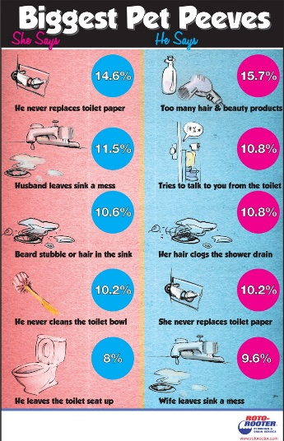**AIM:** Give students practice making complaints, using two-part verbs to make and respond to requests using modals and *would you mind…?*

**LEARNING INDICATORS:** The student can…

* Discuss common complaints.
* Make and respond to requests.
* Apologize and give excuses

|  |
| --- |
| **PRODUCT 1.** |

“What is a pet peeve?” *something that really annoys you*.

People can complain about: *friends, family, school, teachers, neighbors, traffic, cell phones, computers, etc*.

**GROUPS OF 4 PEOPLE.** Choose a category and complete the survey question below. As a group, asks 80 people the same question. Make sure to write their answers.

Start with this question:

*What is your biggest complaint about _____________________?*

***PRESENT******(Friday, September 27th, 2019)***

Compile the results in class, check the grammar and spelling. Then, put the answers in a list on a Word file, from most common to least common. Up load it in the project Unit 2 activity, in Escuela en Red.

Writing will be graded as:

|  |  |  |  |  |  |
| --- | --- | --- | --- | --- | --- |
| Did the student apply the new functions? | 0 | .5 | 1 | 1.5 | 2 |
| Did the student apply the new structures? | 0 | .5 | 1 | 1.5 | 2 |
| Did the student apply the new vocabulary? | 0 | .5 | 1 | 1.5 | 2 |
| The written work is neat, and understandable? | 0 | .5 | 1 | 1.5 | 2 |
| Does it contain the required elements? | 0 | .5 | 1 | 1.5 | 2 |
| total |  | | | | |
| General Comments | | | | | |
| Suggestions for improvement | | | | | |