LEVEL B1.1 Teacher: Maria Elena Meza Aguado

**UNIT 1 Sure! I’ll do it.**

**PROJECT:** “Pet Peeves”.

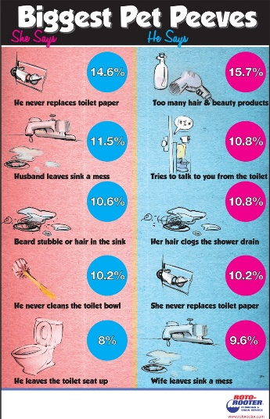**AIM:** Give students practice making complaints, using two-part verbs to make and respond to requests using modals and *would you mind…?*

**LEARNING INDICATORS:** The student can…

* Discuss common complaints.
* Make and respond to requests.
* Apologize and give excuses

|  |
| --- |
| **PRODUCT 1.** |

“What is a pet peeve?” *something that really annoys you*.

People can complain about: *friends, family, school, teachers, neighbors, traffic, cell phones, computers, etc*.

**GROUPS OF 4 PEOPLE.** Choose a category and complete the survey question below. As a group, asks 80 people the same question. Make sure to write their answers.

Start with this question:

*What is your biggest complaint about _____________________?*

***PRESENT******(Friday, September 27th, 2019)***

Compile the results in class, check the grammar and spelling. Then, put the answers in a list on a Word file, from most common to least common. Up load it in the project Unit 2 activity, in Escuela en Red.

Writing will be graded as:

|  |  |  |  |  |  |
| --- | --- | --- | --- | --- | --- |
| Did the student apply the new functions? | 0 | .5 | 1 | 1.5 | 2 |
| Did the student apply the new structures? | 0 | .5 | 1 | 1.5 | 2 |
| Did the student apply the new vocabulary? | 0 | .5 | 1 | 1.5 | 2 |
| The written work is neat, and understandable? | 0 | .5 | 1 | 1.5 | 2 |
| Does it contain the required elements? | 0 | .5 | 1 | 1.5 | 2 |
| total |  | | | | |
| General Comments | | | | | |
| Suggestions for improvement | | | | | |

**Denisse Alejandra Rojas Sanchez**

**COMPLAINS**

1. Two people said take off my things without permission.
2. Two people said pick up the table.
3. Don´t put on things in the places they go.
4. Don´t hang up the towels.
5. Turn on the music very loudly.
6. Two people said don´t pick up your shoes.
7. Two people said don´t throw out the trash.
8. Three people said doesn´t help clean up the house.
9. People step on when I´m cleaning the floor.
10. Don´t tell me when I have to go down to the dinner.
11. Turn on the lights and they´re not using them.
12. When let open the soda.
13. That my sister doesn’t pick up her backpack and notebooks.
14. Turn on the television and don´t watch it.
15. Two people said take off my things without permission
16. When they take on my food
17. Two people said don´t pick up the dirty clothes
18. That´t my siblings turn on the music so loud
19. Two people said let on dishes on the table
20. Take out my makeup and use without permission
21. To take on a slow shower
22. That don´t make sure the door in the night
23. That shut off the lights in inapptopriate moments
24. That my dad drive crazy when they're in a hurry
25. Let out the dog before of ate
26. Two people said don't hang up the towel after of the shower
27. Not look after my nephew good
28. Don´t put away the groceries
29. Don't be look out with food
30. Get in the house with dirty shoes.

|  |
| --- |
| **PRODUCT 2.** |

PAIR WORK. Imagine you are going to go on vacation. Make a conversation where you ask and answer questions about each other’s vacation plans. Use the example conversation in your book’s unit’s 1-2 progress check page, activity 2 DISCUSSION as a model.

PAIR WORK. Make four conversations. See the pictures in your book Progress check pages and make requests. Your partner responds by agreeing or refusing/objecting or to your request and giving an excuse. Use the expressions in the box and the vocabulary in the language summary unit 6. **You cannot repeat words within your four conversations**. Prepare to role-play without your notes.

|  |  |  |
| --- | --- | --- |
| * *Can you . . . ?* * *Could you . . . ?* * *Would you please . . . ?* * *Would you mind . . . ?* |  | |
| **Example:**  *A: Could you please turn down the music?*  *I’m trying to study.*  *B: Of course.*  *I didn’t realize it was so loud.* | | Request  Follow-up statement  Agreement/objection  Excuse |

**PRESENT** **(Friday, September 27th, 2019)**

Speaking will be graded as:

|  |  |  |  |  |  |
| --- | --- | --- | --- | --- | --- |
| Did the student apply the new functions? | 0 | .5 | 1 | 1.5 | 2 |
| Did the student apply the new vocabulary? | 0 | .5 | 1 | 1.5 | 2 |
| Was the student Fluent? | 0 | .5 | 1 | 1.5 | 2 |
| Was the student’s voice clear? | 0 | .5 | 1 | 1.5 | 2 |
| Did the student apply the new structures? | 0 | .5 | 1 | 1.5 | 2 |
| total |  | | | | |
| General Comments | | | | | |
| Suggestions for improvement | | | | | |

**Product 2**

**A: Where are you going to go to on you next vacation?**

**B: I´m going to go to Chiapas**

**A: What are you going to do?**

**B: I´m going to visit Cañon del Sumidero, Maybe I´ll see the Zona arqueologica**

**A: Why did you choose that?**

**B: Well, I want to know the Tourist Zone**

1. **Can you please clean up the room? I have a guest**

**No problem, I´ll clean it**

1. **Would you please pick up the towels? I´m trying to wash clothes**

**Sorry, I´ll pick them up right away**

1. **Can you take off the groceries? I have to cook**

**Sure, I´ll take it the groceries**

1. **Could you please take out the garbage? I´m trying to clean**

**No problem, I´ll take it out**

1. **Can you please take out the cat please? He wants to go hunting**

**Sure I´ll take it out**