ESCUELA NORMAL DE EDUCACIÓN PREESCOLAR

LICENCITURA EN EDUCACIÓN PREESCOLAR

CICLO ESCOLAR

2019- 2020



Inglés

Mtra. María Elena Meza Aguado

Alumna. Natalia Elizabeth Rodriguez Ramos

3°A N.L: 17

VEL B1.1 Teacher: Maria Elena Meza Aguado

**UNIT 1 Sure! I’ll do it.**

**PROJECT:** “Pet Peeves”.

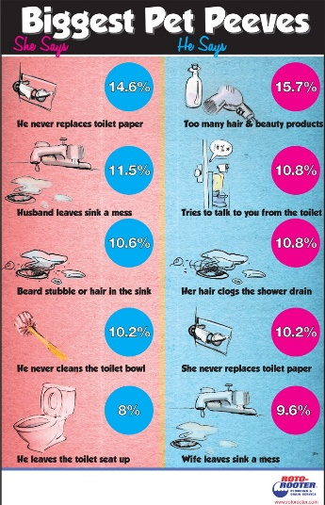**AIM:** Give students practice making complaints, using two-part verbs to make and respond to requests using modals and *would you mind…?*

**LEARNING INDICATORS:** The student can…

* Discuss common complaints.
* Make and respond to requests.
* Apologize and give excuses

|  |
| --- |
| **PRODUCT 1.** |

c“What is a pet peeve?” *something that really annoys you*.

People can complain about: *friends, family, school, teachers, neighbors, traffic, cell phones, computers, etc*.

**GROUPS OF 4 PEOPLE.** Choose a category and complete the survey question below. As a group, asks 80 people the same question. Make sure to write their answers.

Start with this question:

*What is your biggest complaint about _____________________?*

***PRESENT******(Friday, September 27th, 2019)***

Compile the results in class, check the grammar and spelling. Then, put the answers in a list on a Word file, from most common to least common. Up load it in the project Unit 2 activity, in Escuela en Red.

Writing will be graded as:

|  |  |  |  |  |  |
| --- | --- | --- | --- | --- | --- |
| Did the student apply the new functions? | 0 | .5 | 1 | 1.5 | 2 |
| Did the student apply the new structures? | 0 | .5 | 1 | 1.5 | 2 |
| Did the student apply the new vocabulary? | 0 | .5 | 1 | 1.5 | 2 |
| The written work is neat, and understandable? | 0 | .5 | 1 | 1.5 | 2 |
| Does it contain the required elements? | 0 | .5 | 1 | 1.5 | 2 |
| total |  | | | | |
| General Comments | | | | | |
| Suggestions for improvement | | | | | |

1. Don't take showers so late without schedules  
2. Take objects without having borrowed  
3. Take care of the house and car keys  
4. have respect when taking the floor  
5. Be punctual at school and at work  
6. Don't talk with food in your mouth  
7. Don't ask for anything in return when you do favors  
8. stop eating the food of others  
9. let say groceries at home  
10. stop talking badly behind others  
11. Do not take out the trash from home  
12. pick up clothes lying on the floor  
13. Take the dog for a walk  
14. collect bath towels  
15. turn down the sound of the music  
16. turn up the radio sound  
17. throw your shoes into your room  
18. hang your jacket on the coat rack  
19. throw dirty clothes into the laundry  
20. pick up the dirty dishes from the table