CLOTHES, ACCESSORIES, JEWELRY, MATERIALS
Your Vocabulary Log
Make a vocabulary log. Copy the words in your notebook and write sentences or draw pictures to help you remember.
MATERIALS | ACCESSORIES | CLOTHES | JEWELRY
The church bell is brass.  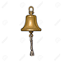 | My best friend’s backpack is under the table.  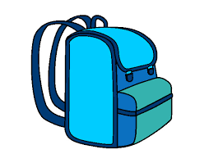 | My aunt’s favorite boots are brown.  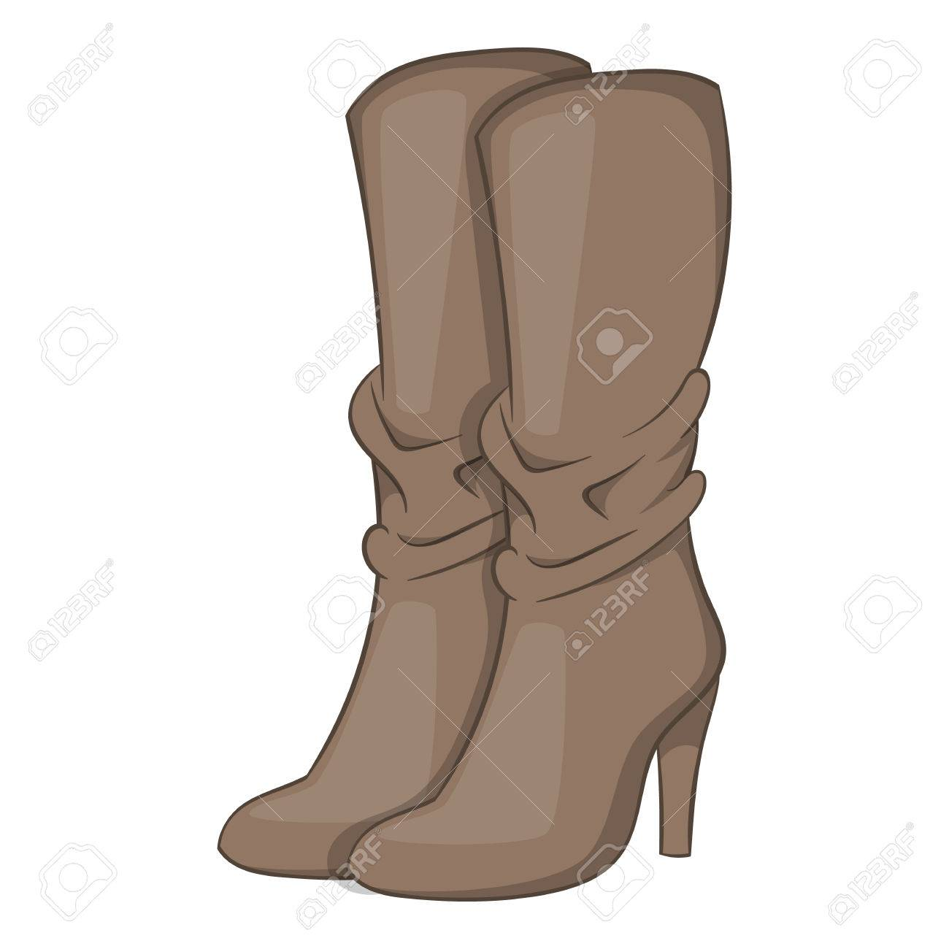 | The bracelet is made with nylon.  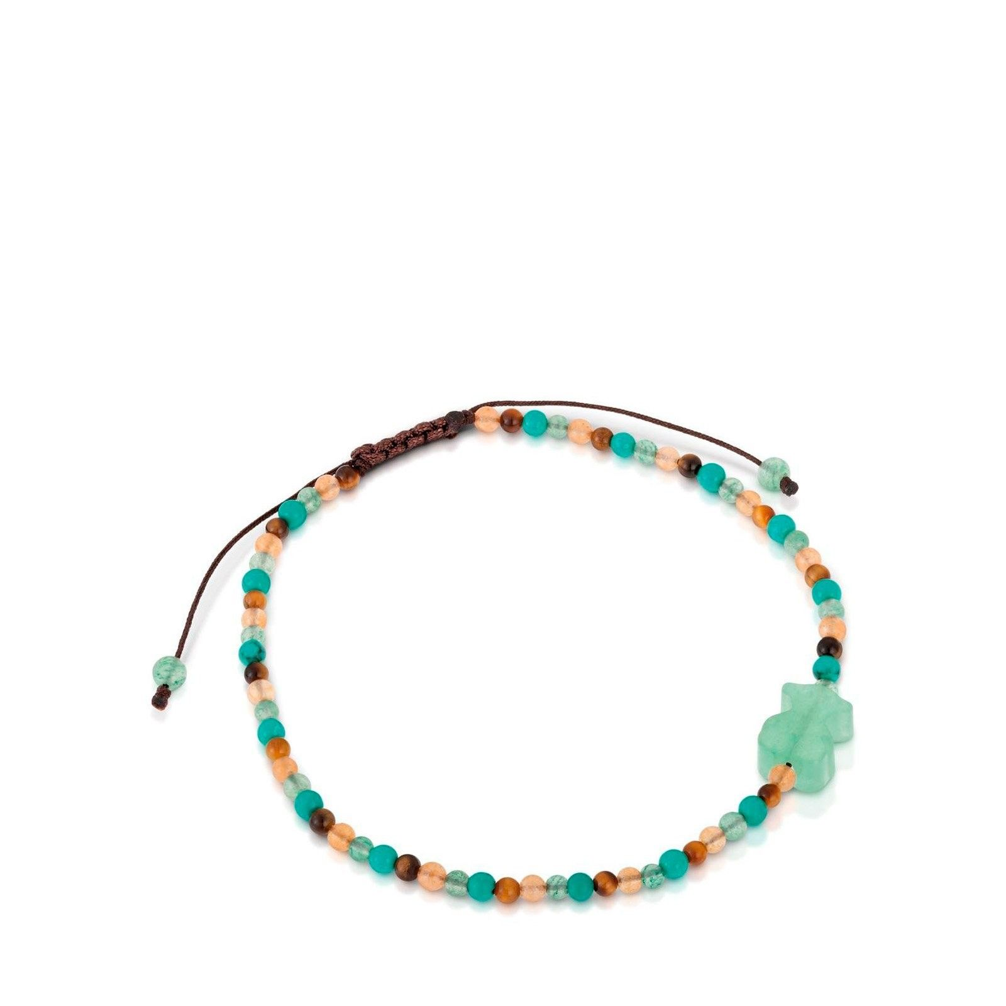
My dress is cotton. 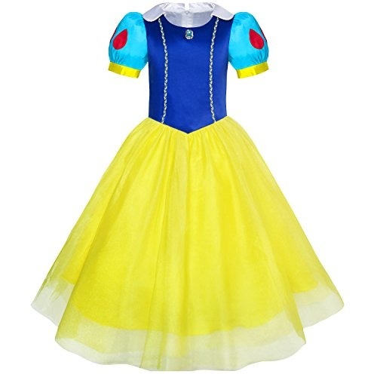 | My dad’s belt is cowboy.  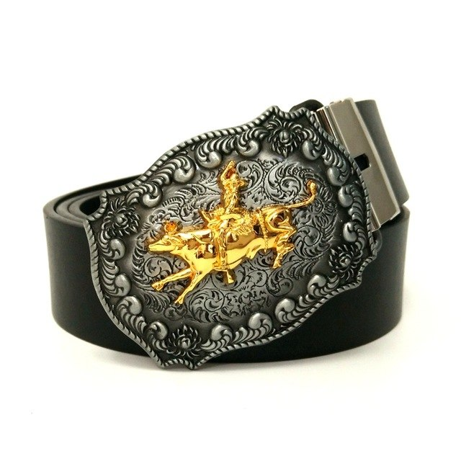 | My boyfriend’s jacket is leather.  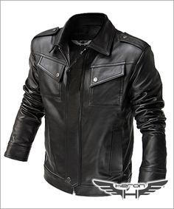 | Yesterday I lost one of my earrings.  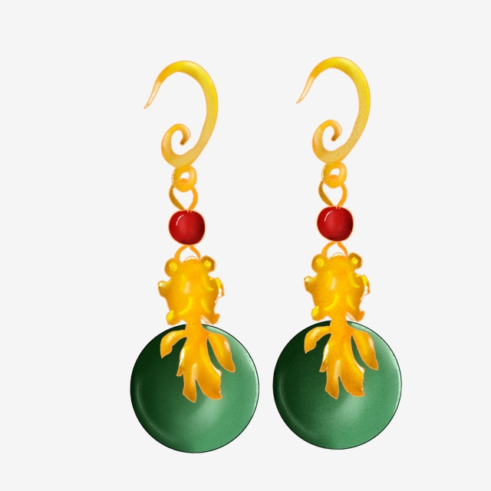
My mom’s ring is gold.  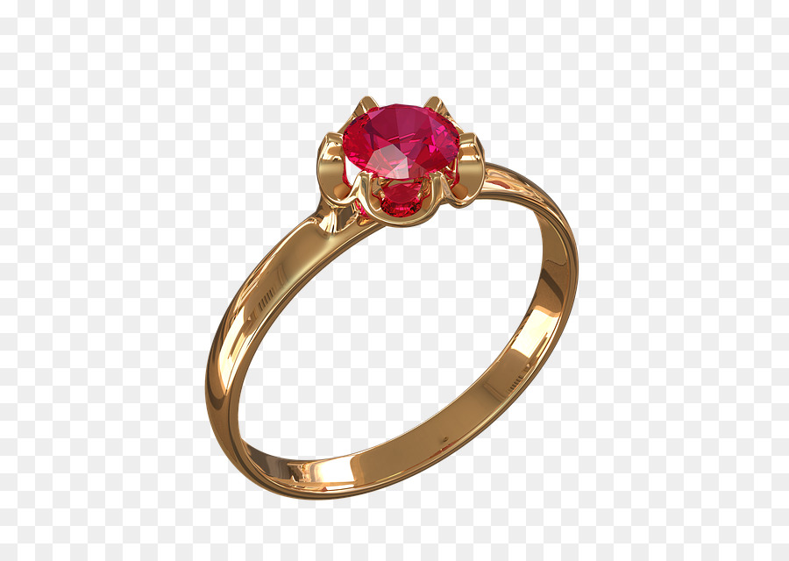 | My older brother wears a cap almost every day.  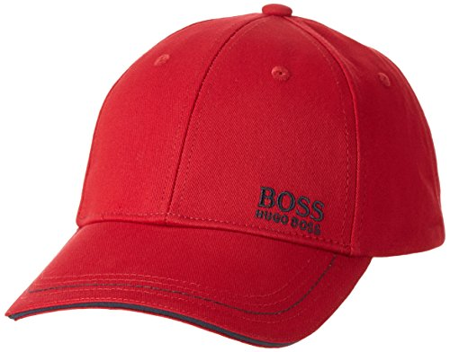 | The jeans are blue.  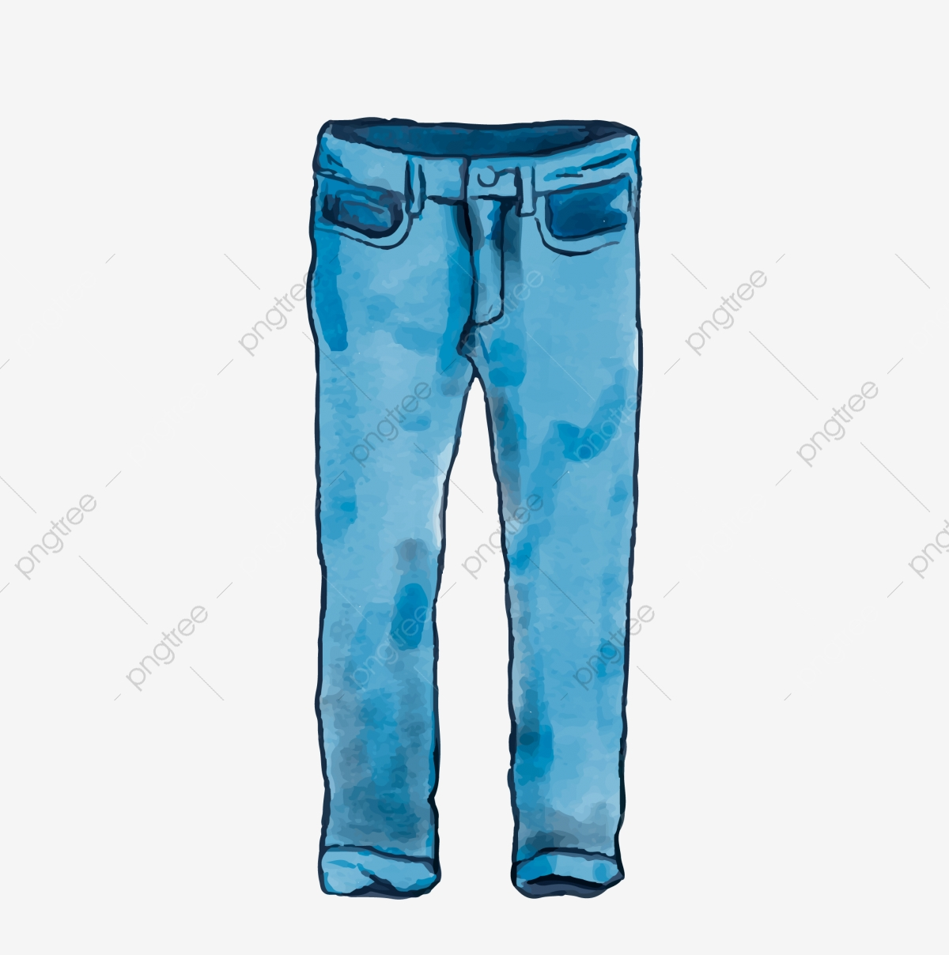 | The heart necklace is silver.  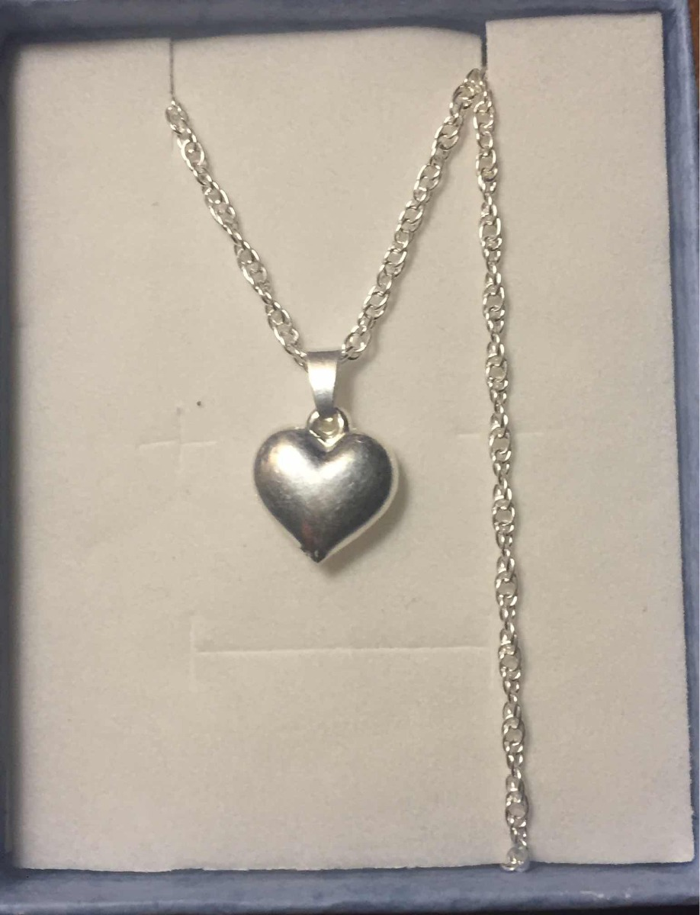
My boyfriend’s jacket is leather. | In the winter it is necessary to wear a scarf to avoid getting a cold.  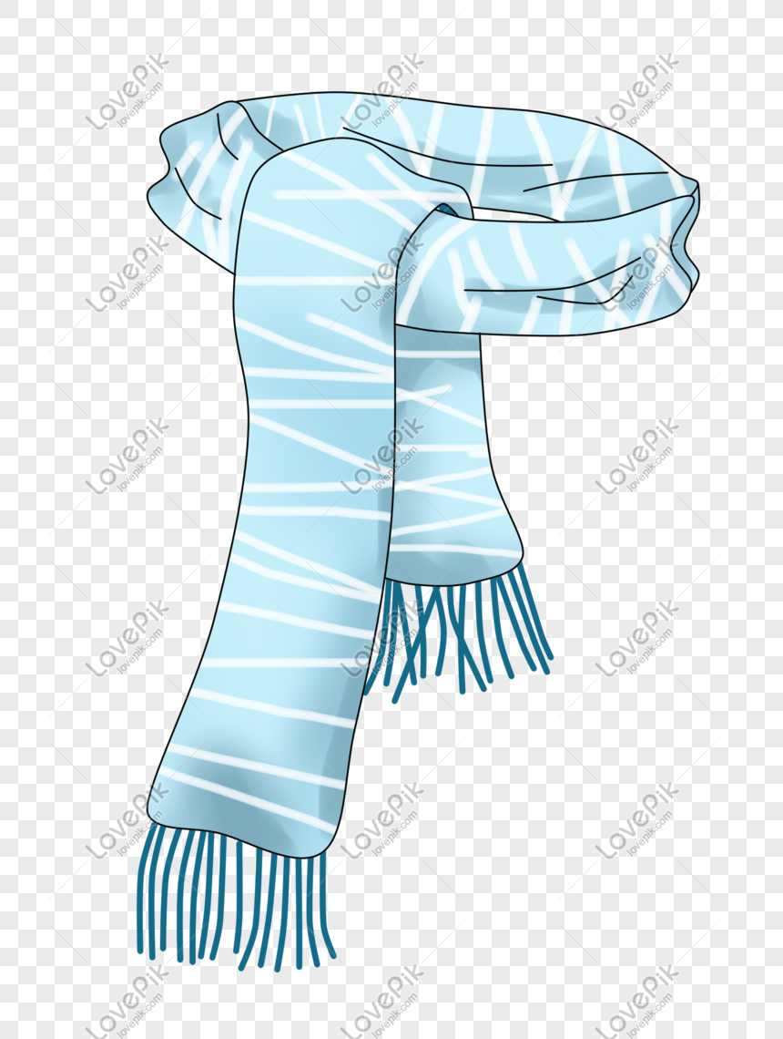 | I don’t like wearing pants.  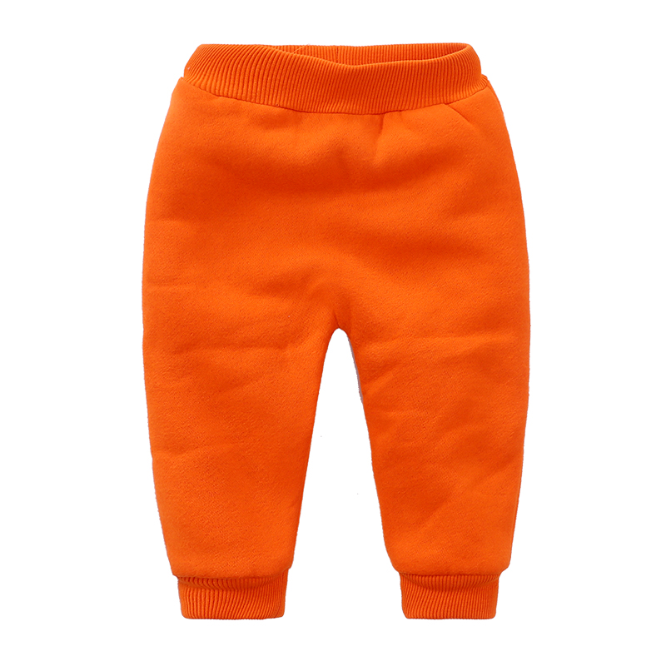 | My mom’s ring is gold.
The tablecloth is linen.  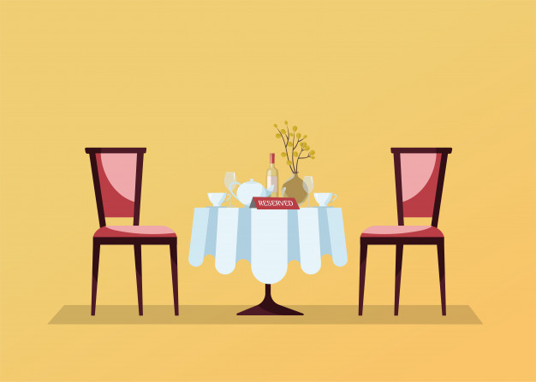 | Sunglasses serve to protect your eyes.  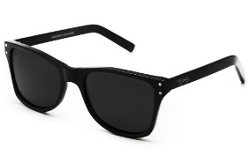 | The white shirt is polyester.  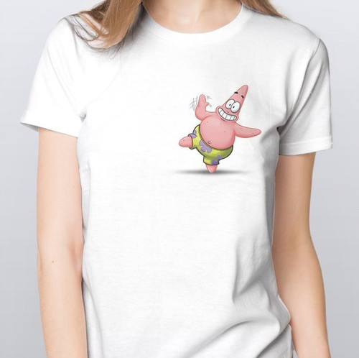 | My dad always use wears watch.  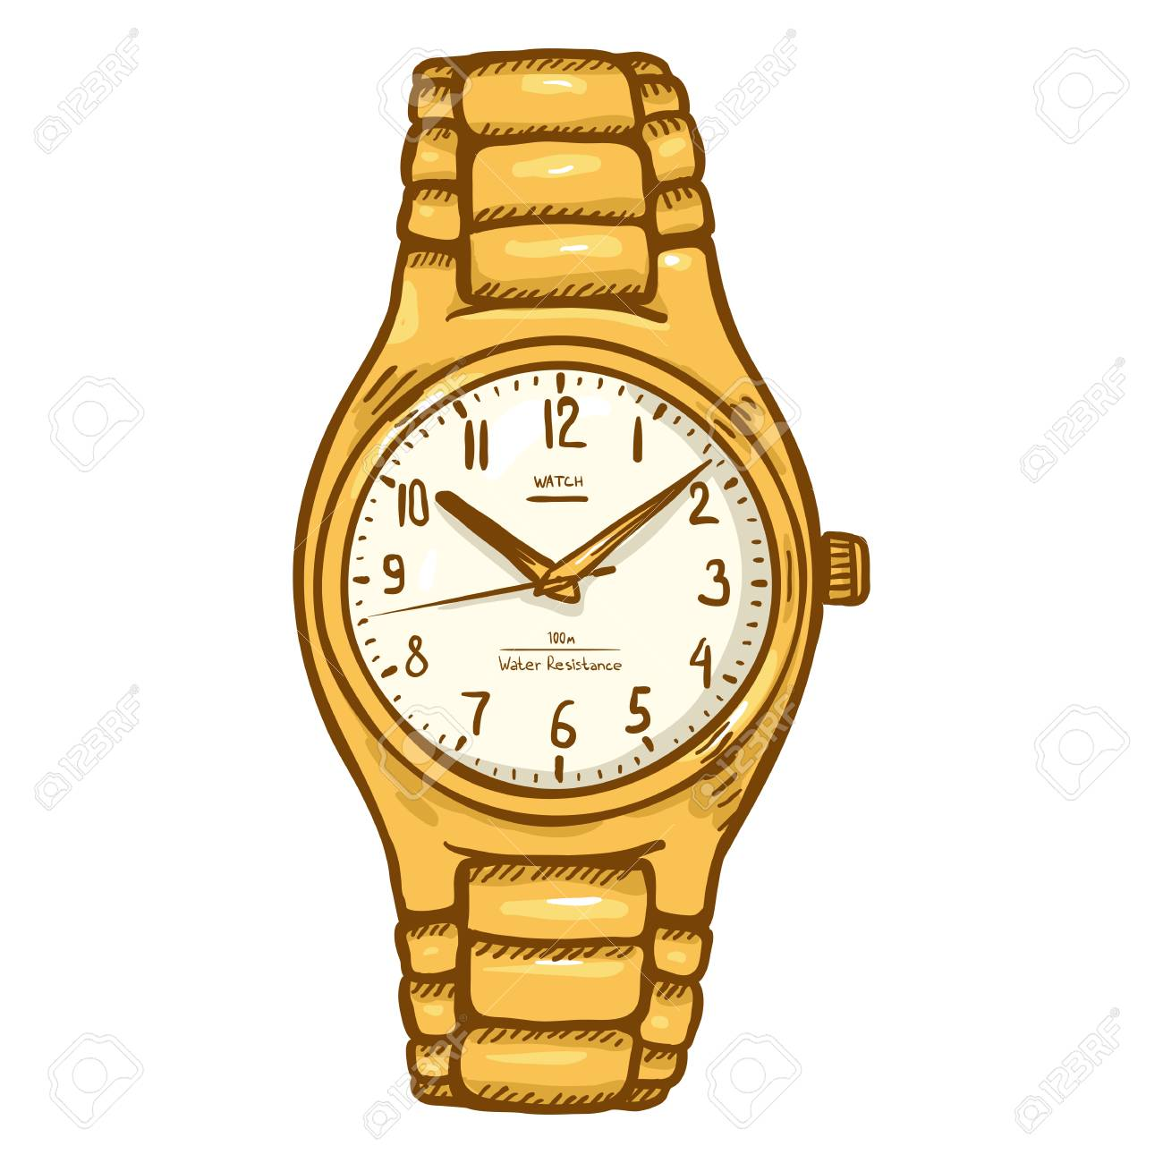
The bracelet is made with nylon. | The tie is commonly used in formal events.   | My younger brother wears shoes rarely.  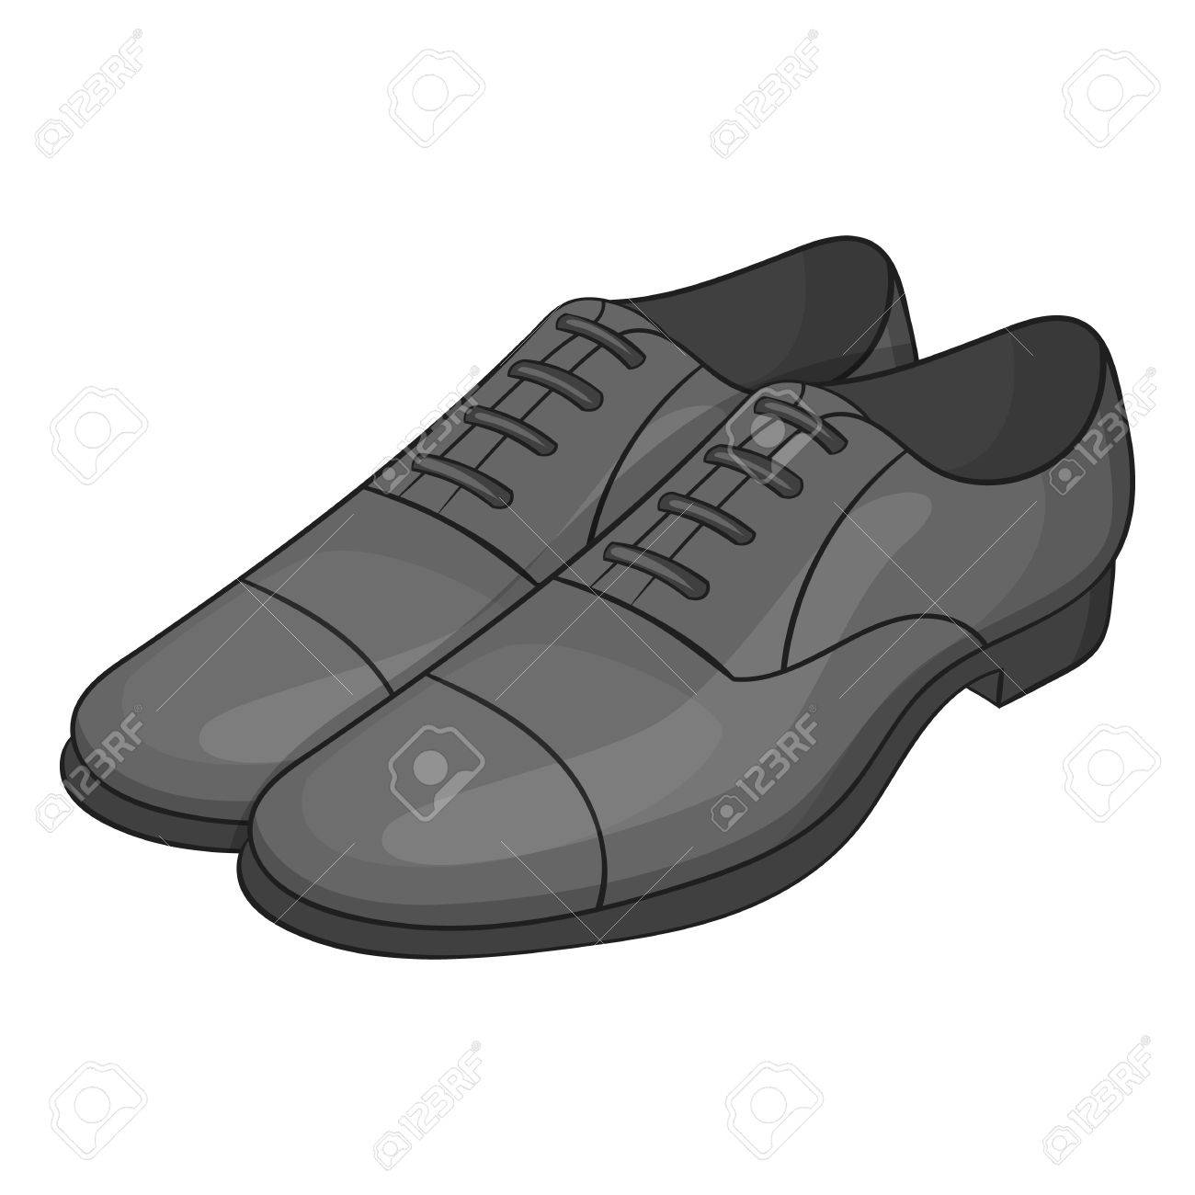
The toys are in the plastic boxes.  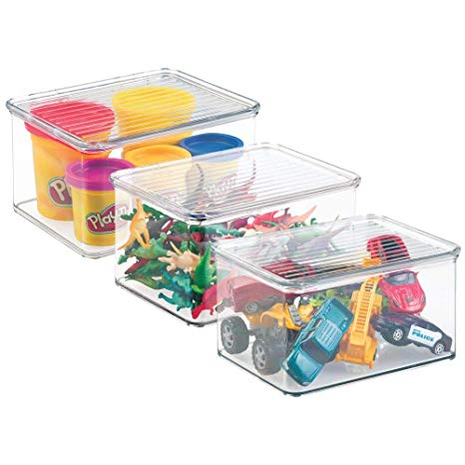 |  | My cousin’s likes socks with cartoons.  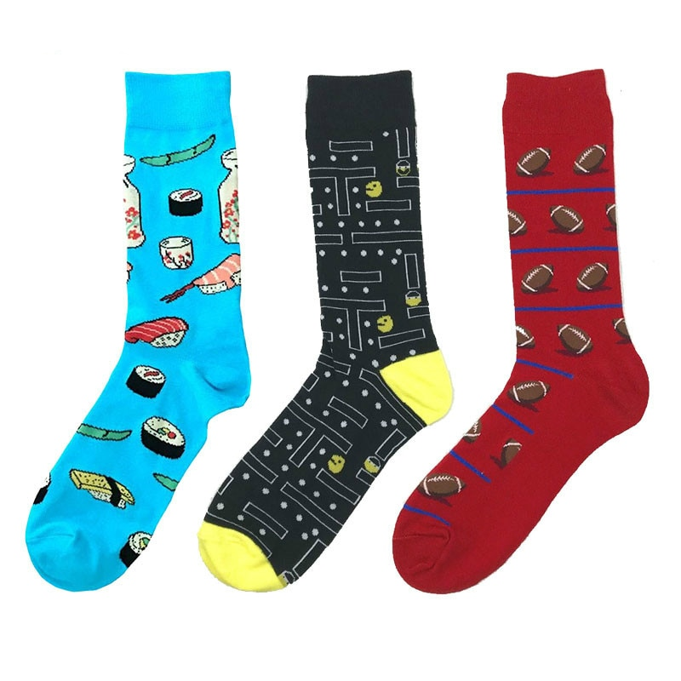
The white shirt is polyester. |  | The sweater that my grandmother gave me is very comfortable.  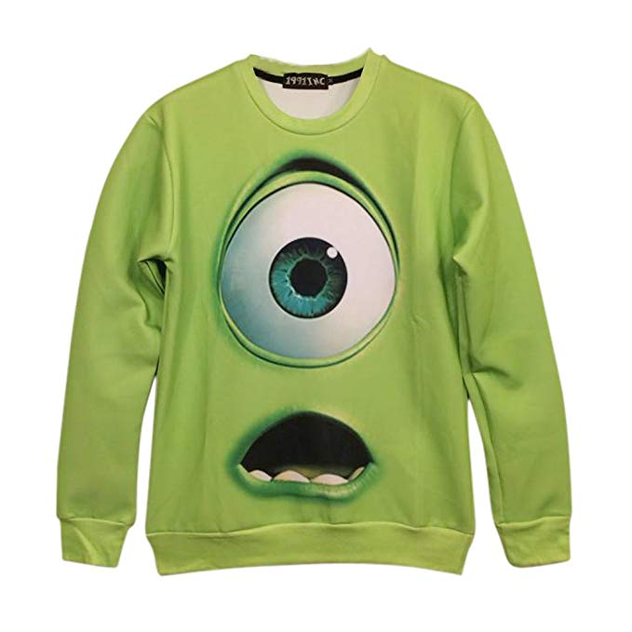
The tires are made of rubber.  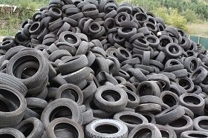 |  | I always use sneakers.  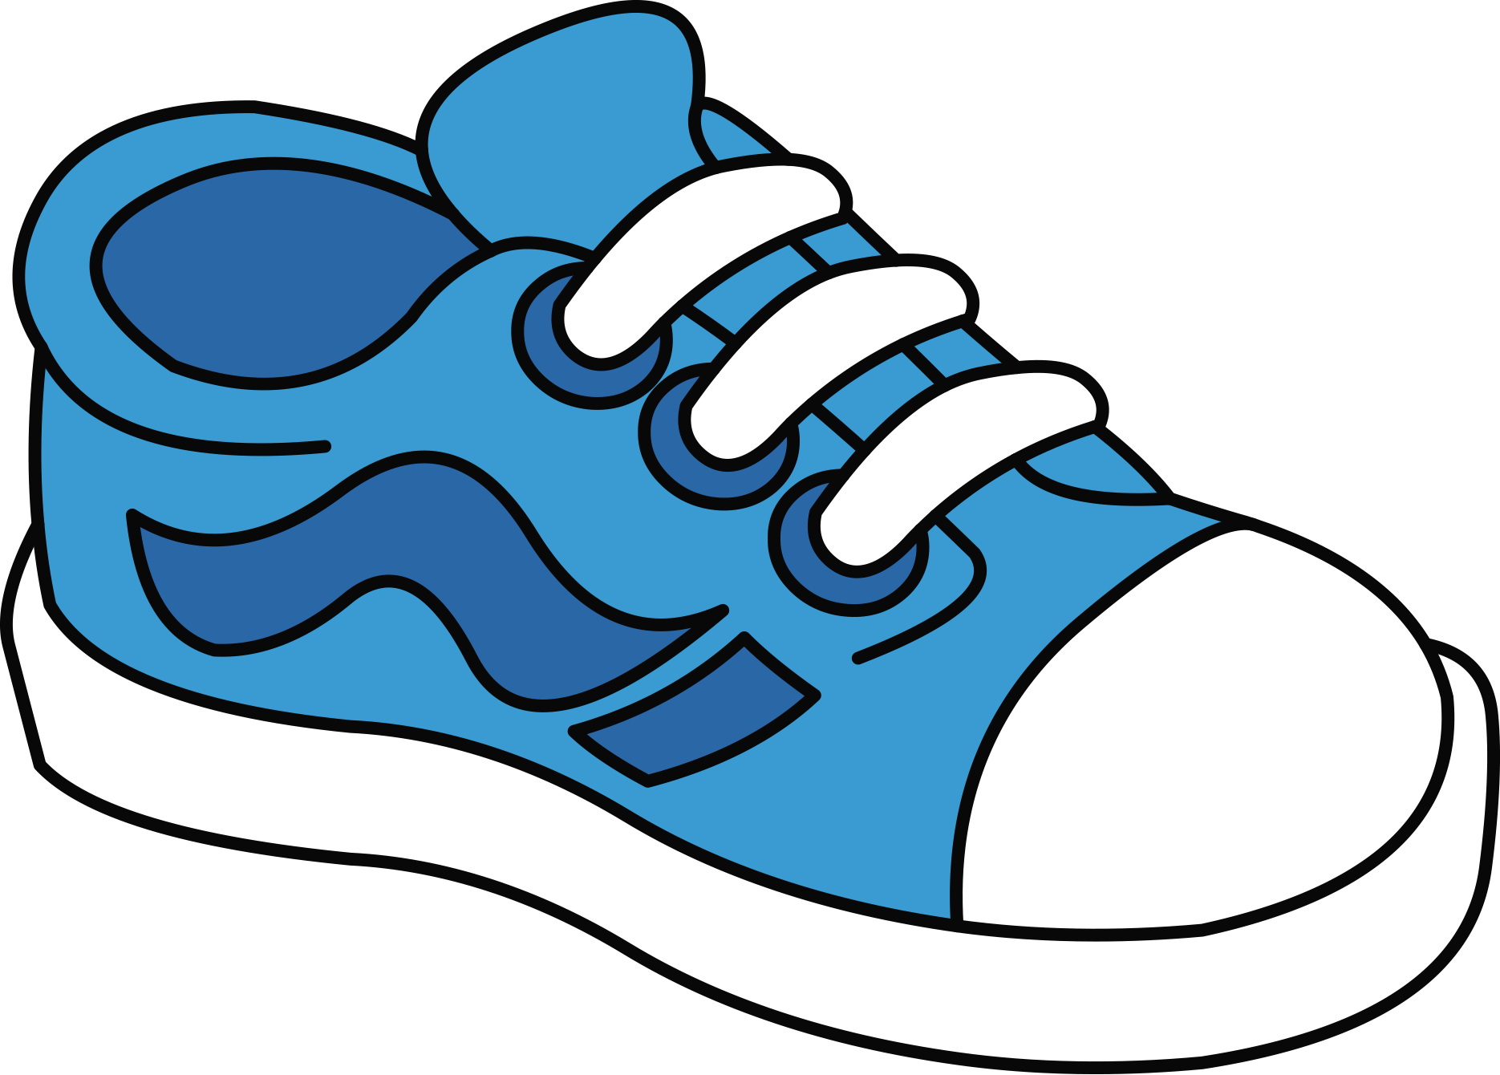
The work shirt is made with satin.
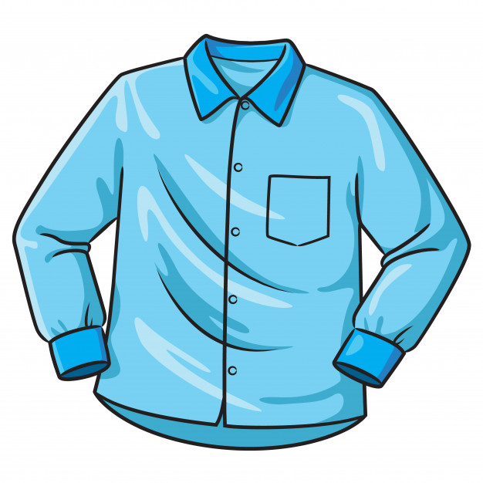
The costumes of the kings are silk.
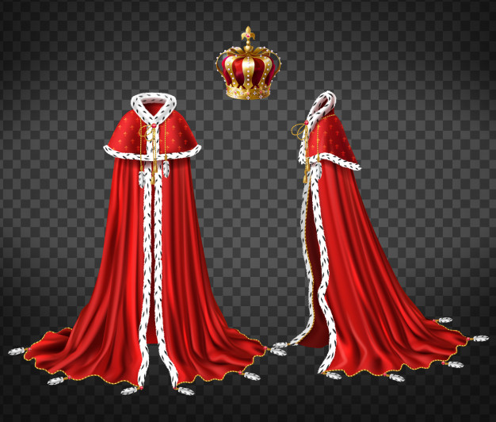
The heart pendant is silver.
The pajamas is wool.
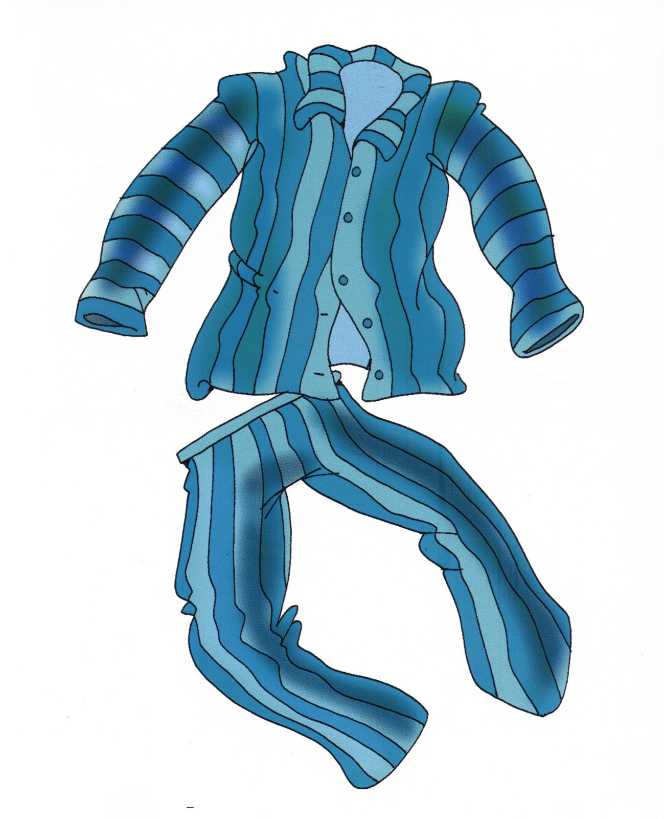

Practice
A PAIR WORK Complete the ad. Use words from your vocabulary log.

2.- Brass bracelet. 1.- Wool jeans.
3.- Silver earrings. 2.- Satin shirt.
4.- Cotton scarf. 3.- Leather jacket.
5.- Silk dress. 4.- Polyester tie.
5.- Cotton pajamas.

B PAIR WORK Role-play conversations between a customer and a salesperson
at H&S Department Store. Talk about the special offers.
A: Excuse me. How much is this gold ring, please?
B: It’s $265.99.
A: Hmm. That’s expensive.

