CLOTHES, ACCESSORIES, JEWELRY, MATERIALS
Your Vocabulary Log
Make a vocabulary log. Copy the words in your notebook and write sentences or draw pictures to help you remember.

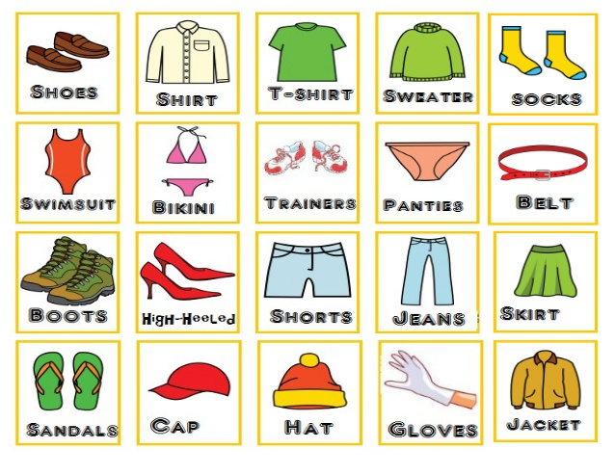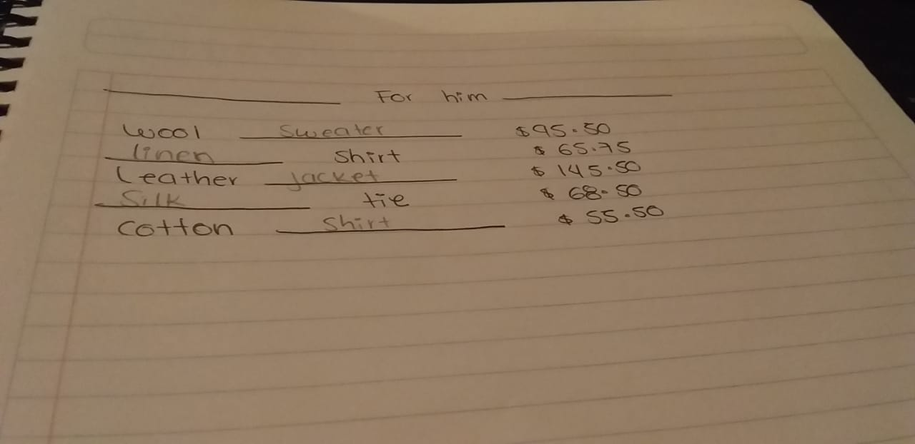
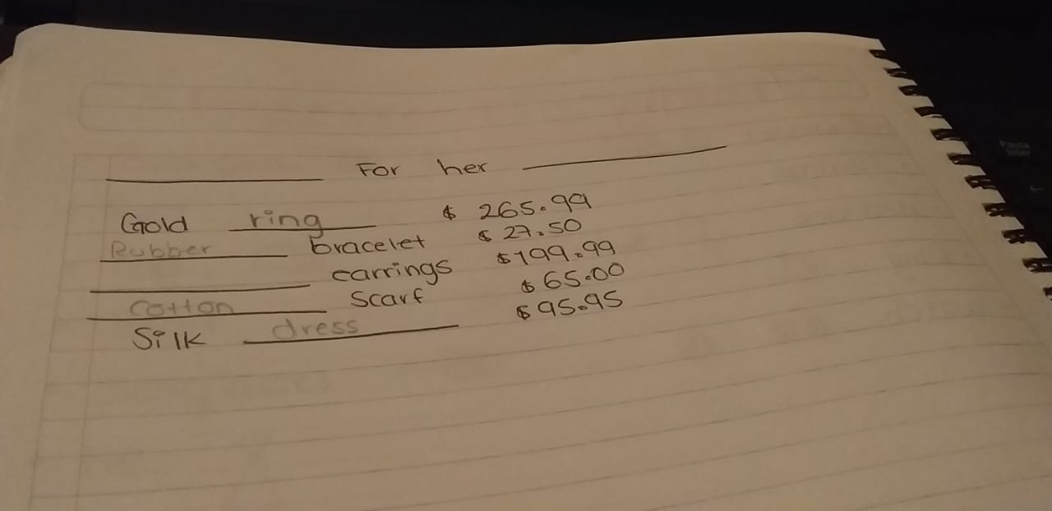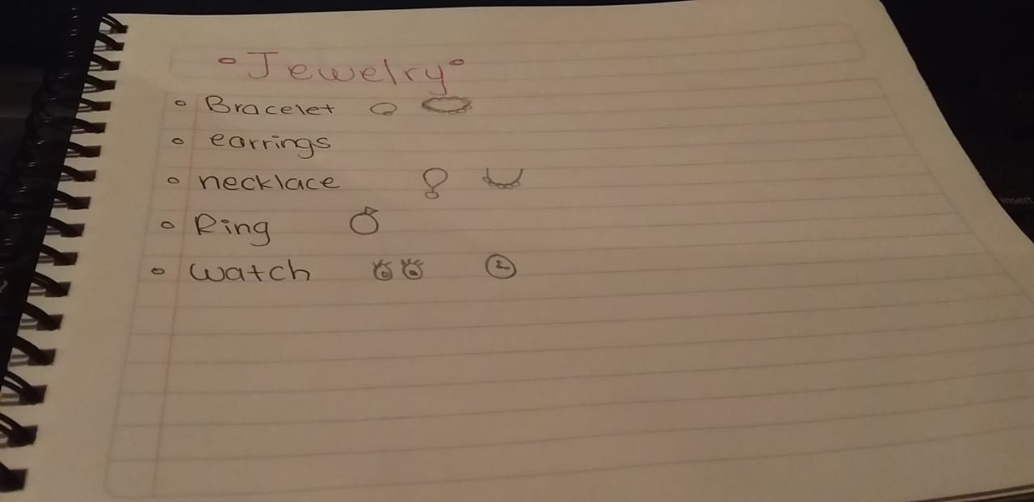

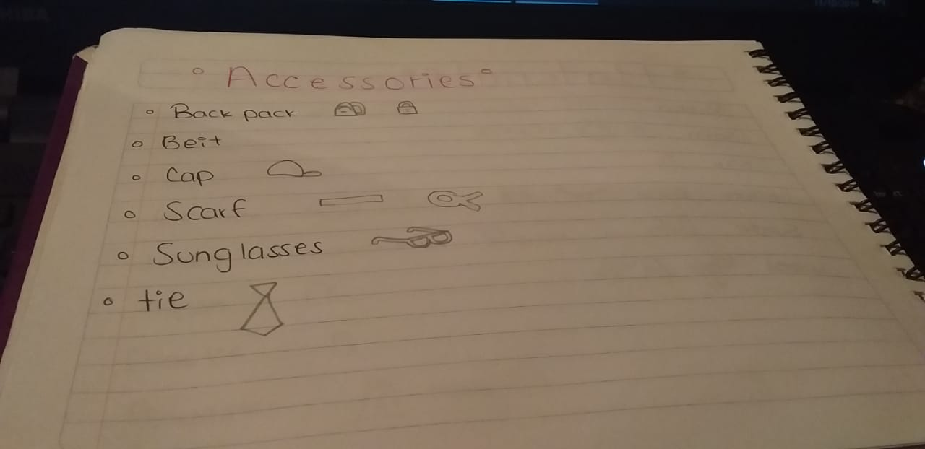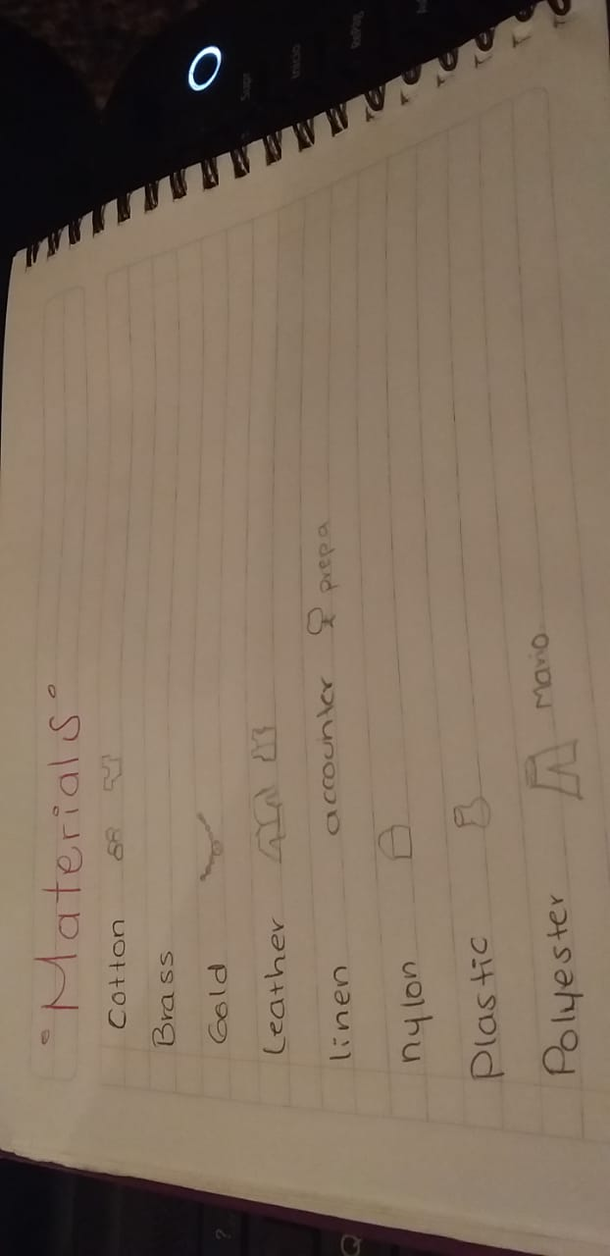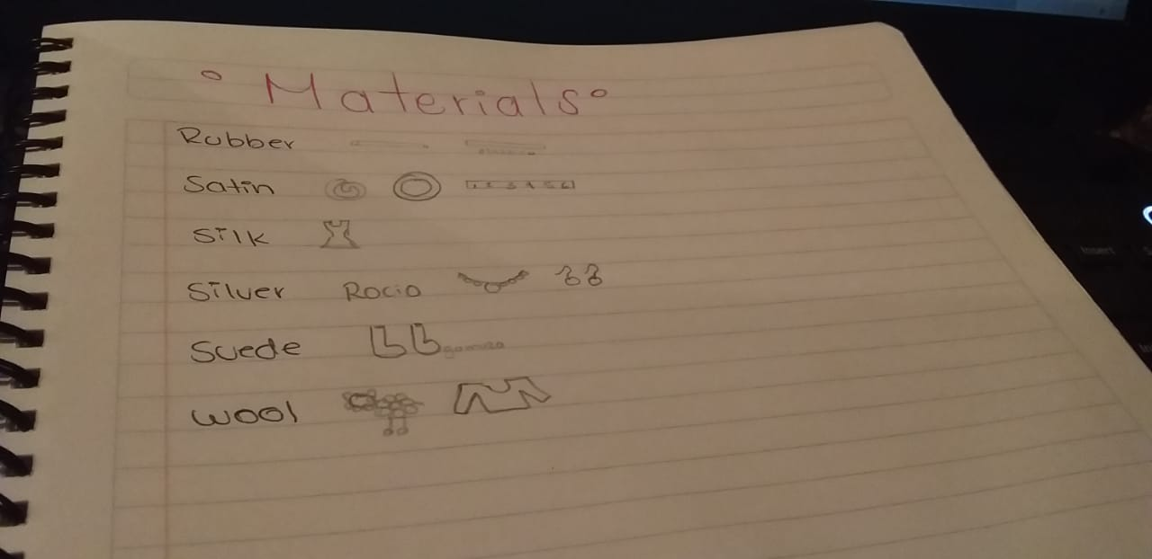
Practice
A PAIR WORK Complete the ad. Use words from your vocabulary log.

B PAIR WORK Role-play conversations between a customer and a salesperson
at H&S Department Store. Talk about the special offers.
A: Excuse me. How much is this gold ring, please?
B: It’s $265.99.
A: Hmm. That’s expensive.

