**Escuela Normal de Educación Preescolar**



**Ingles**

**“Encuestas sobre quejas”**

**Maestra: Beatriz Eugenia Valdés Rodríguez**

**Alumna: María Fernanda Dávila Bustos**

**1 C**

**40-Noviembre-2019**

**Saltillo, Coahuila, México**

***What is your biggest complaint about restaurants?***

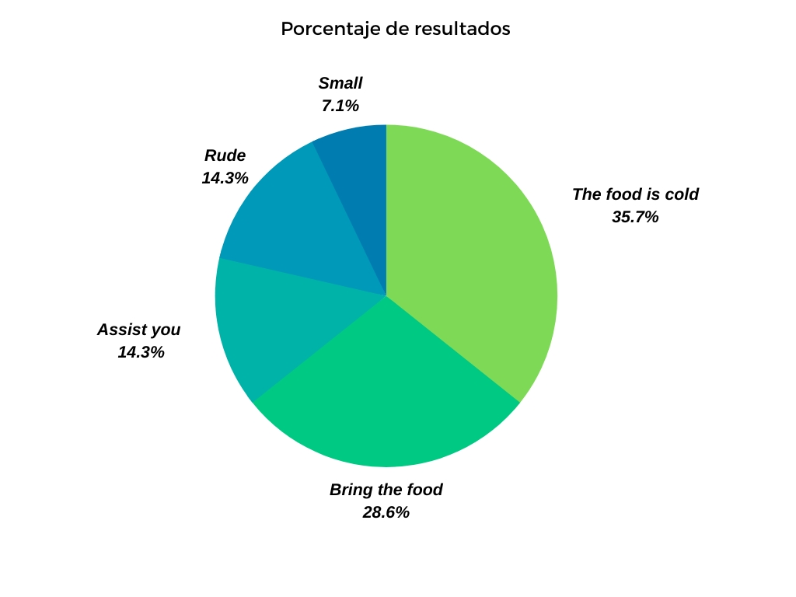

The food is cold—10 persons

Bring the food- 8 persons

Assist you- 4 persons

Rude- 4 persons

Small- 2 persons

***What is your biggest complaint about gobernment?***

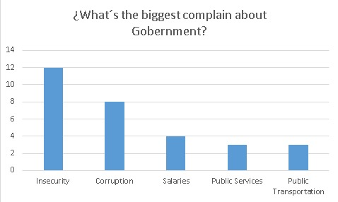

***What is your biggest complaint abo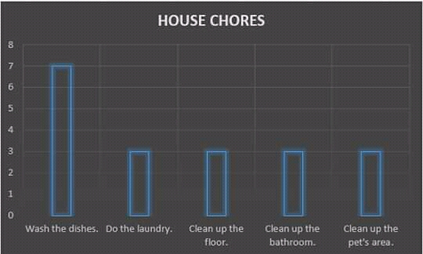ut house chores?***

***What is your biggest complaint about school?***

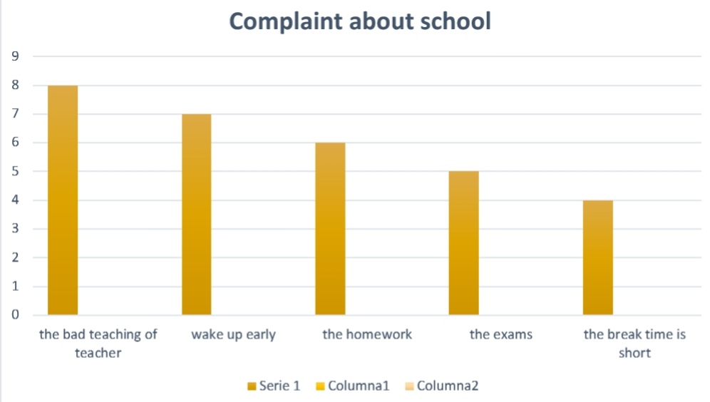

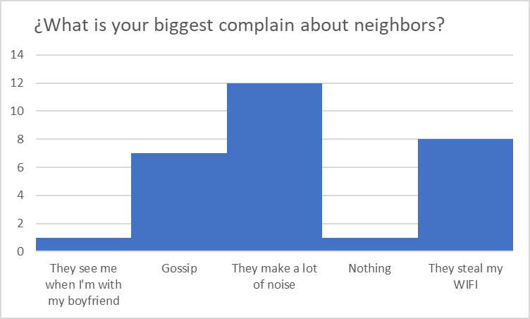***What is your biggest complaint about neighbors?***

***What is your biggest complaint about neighbors?***

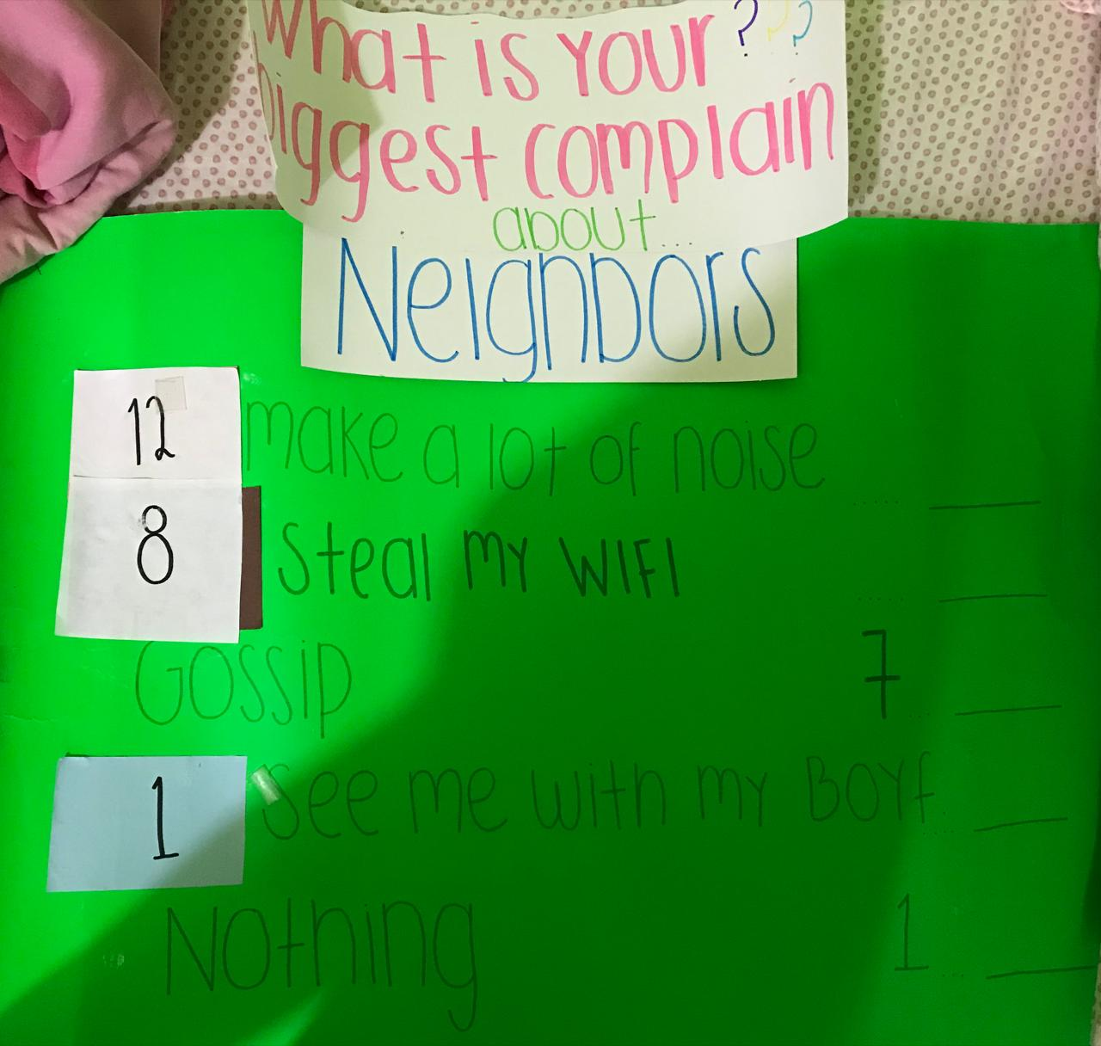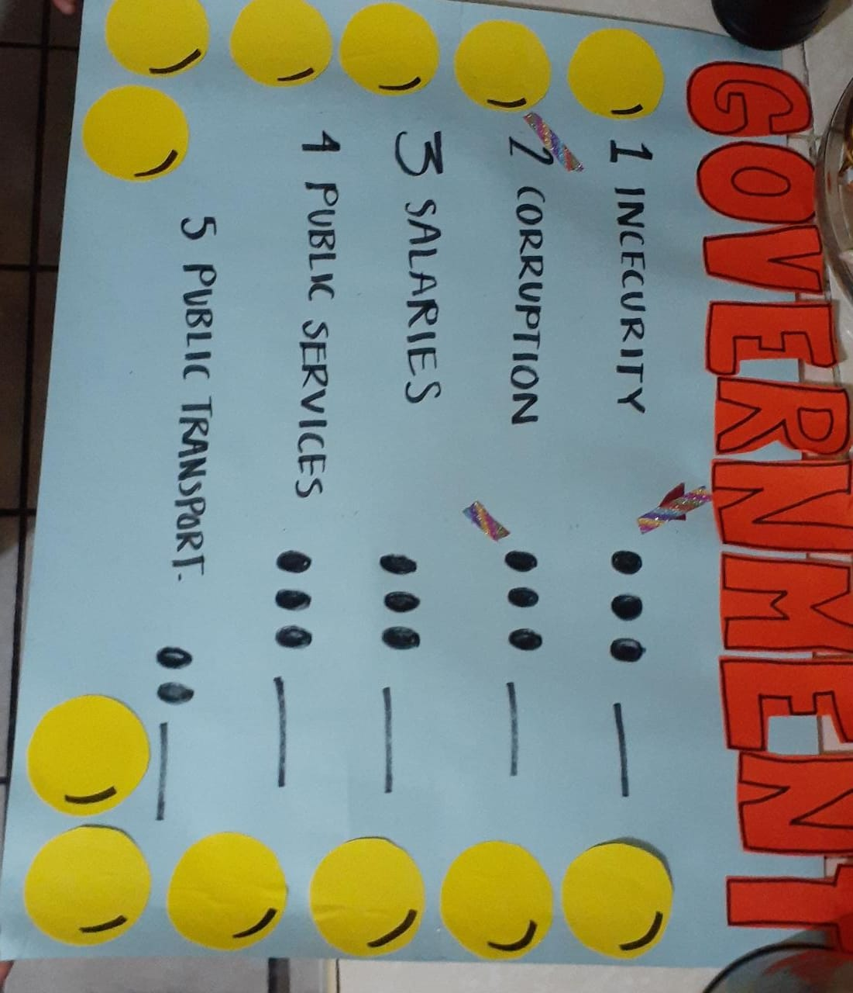***Activity***

***Conclusion***

With this work it was possible to appreciate the different complaints of people on a specific topic, to do it was fun, the game in class was fun and exciting because they all participated as if it were a real contest!

***Rubrica***

|  |  |  |  |  |
| --- | --- | --- | --- | --- |
| Category | Score 5 | Score 4 | Score 3 | Score 2 |
| Required elements | Goes over and above all required elements stated in the instructions | Includes all of the required elements stated in the instructions | Missing one or more of the required elements. | Several required elements are missing from the project |
| Overall effectiveness and completion of task | Project is organized and presents material captivating for viewer | Project is somewhat organized and complete and holds attention of viewer | Project is disorganized and incomplete at times and is somewhat able to hold attention of viewer | Project is incomplete and not easy to follow |
| Organization for game | Exceptionally organized | Thoughtfully and uniquely organized | Well organized but can be improved | Little organization is shown |
| Grammar | No grammatical or mechanical mistakes | 2 or 3 grammatical mistakes which are not distracting | 4 to 6 grammatical mistakes which are distracting | More than 6 grammar or mechanical mistakes which are very distracting |
| Conclusion | A thoughtful and reflexive conclusion included shows learning of unit content | Good conclusion, show some learning of unit and project content | Conclusion is somewhat goo but can be imporved | Conclusion is weak and not reflexive on learning of unit and project content. |
| Understanding of content | Shows a sophisticated understanding of the themes | Shows an understanding of the themes | Displays a somewhat limited understanding of the themes and may have few misinterpretations | Does not show an understanding of the themes. Has quite a few misinterpretations. |
| Total /30 pts |  |  |  |  |