**MARIANA PAOLA PARDO SENA**

**CAMBRIDGE**

**UNIT 3 AND 4**

**ENGLISH A1**

**TEACHER CRISTINA ALVARADO**

**ESCUELA NORMAL DE EDUCACIÓN PREESCOLAR**

**ACTIVITIES INTRO GAMES**

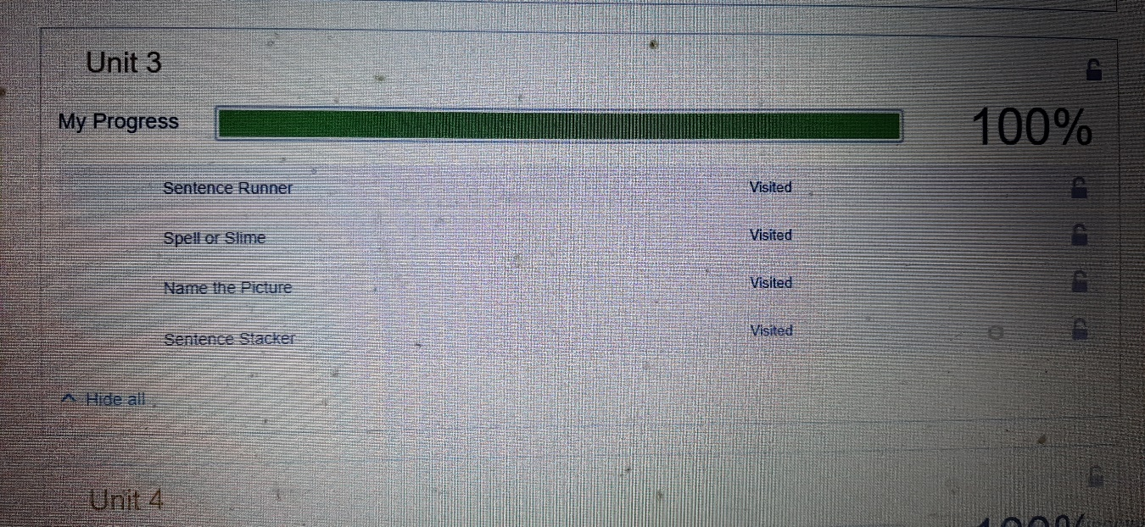

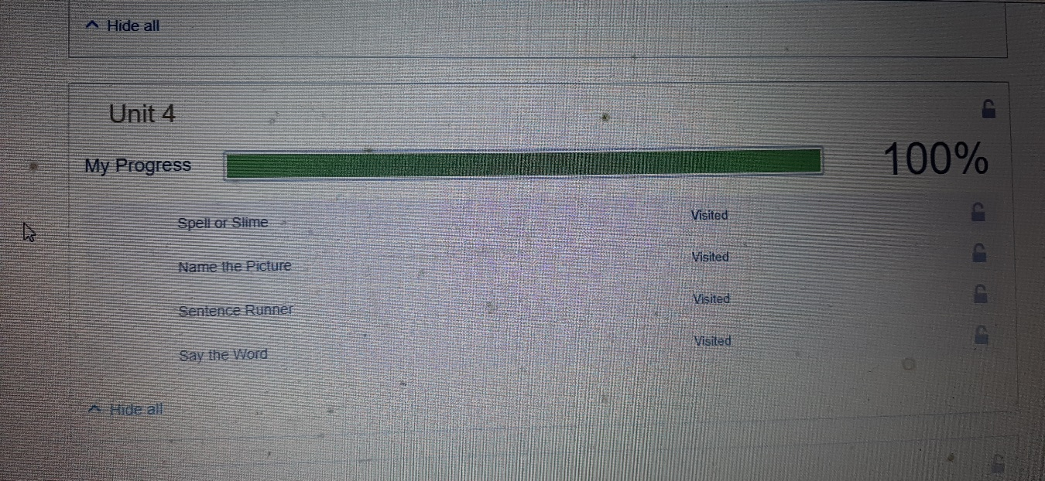

**ACTIVITIES SELF-STUDY**

