**ESCUELA NORMAL DE EDUCACIÓN PREESCOLAR**

**ENGLISH B1.1 OPENING NEW GLOBAL PERSPECTIVES**

**PROJECT UNIT**

**CELEBRATIONS**



Planning

Make three teams and look for information about Thanksgiving, Christmas and New Year’s Eve. Find information about the date people celebrate each one of them, people’s traditions (food, drinks and rituals) and activities people do before and after each celebration.

Preparation

**Look at the example and write facts about the celebration you chose (date, places, motive).**

*Ex. The Mexican Independence Day is a celebration which takes place on September 16th.*

1. New Year’s Eve is celebrated on December 31 of the current year.

2. New Year's Eve is a reason to receive each year with new purposes and goals.

3. The New Year party is celebrated at the home of a host family, and family and friends attend.

4. The New Year is the celebration of the beginning of the year following the Gregorian calendar, which was established by Pope Gregory XIII in 1582.

5. The Chinese New Year is based on the lunar calendar, and this cannot become an exact date of the Gregorian calendar, and is celebrated between January 21 and February 18.

**Write sentences about what people do before, during or after each celebration.**

*Ex. The Independence Day is a day when people eat Mexican food like tamales and pozole.*

1. New Year's Eve is a night when people eat 12 grapes and make 12 wishes by dialing 00:00 am on the clock.

2. New Year's Eve is a night when people usually eat stuffed turkey, roast beef, pozole, marinated loin, apple salad and punch.

3. The New Year party is a night when the family has fun dancing, singing and playing games.

4. The New Year party is a night when family and friends launch fireworks by marking January 1 on the calendar.

5. January 1, after New Year's Eve, is a day when family and friends get together to eat "overheated."

**Write three advices to spend a great holiday.**

*Ex. Try not to use fireworks during the Independence Day because you could get hurt.*

1. Remember to plan the new year party for everyone to have a good time and do not hesitate to ask your family for help

2. Don't forget to write your purposes for next year.

3. Be sure to see all your family and friends on the guest list and send a reminder message.

4. Try not to drink too much alcohol so you don't end up drunk.

5. Remember that some people, in addition to fireworks, shoot the sky, be very careful!

Products

* Share the information you found with the rest of the class.
* Choose five sentences and make a creative label about each one for the bulletin board, include your sentences and colorful pictures.
* Paste the pictures of your labels in this document and upload it to Escuela en Red.

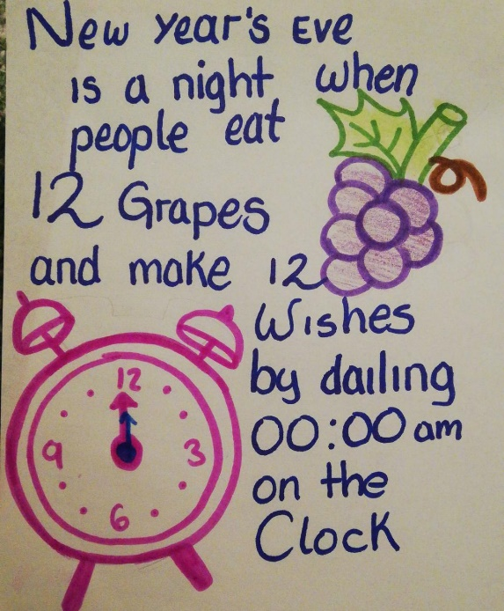

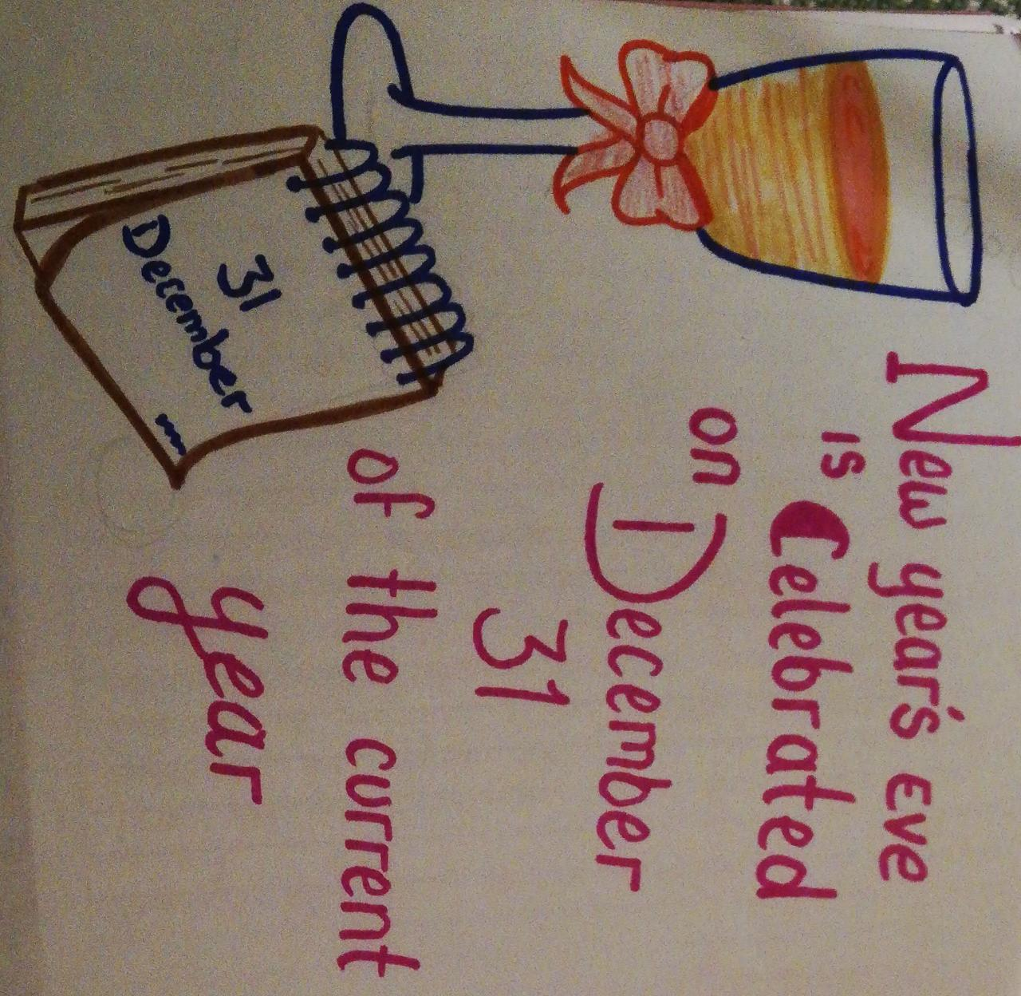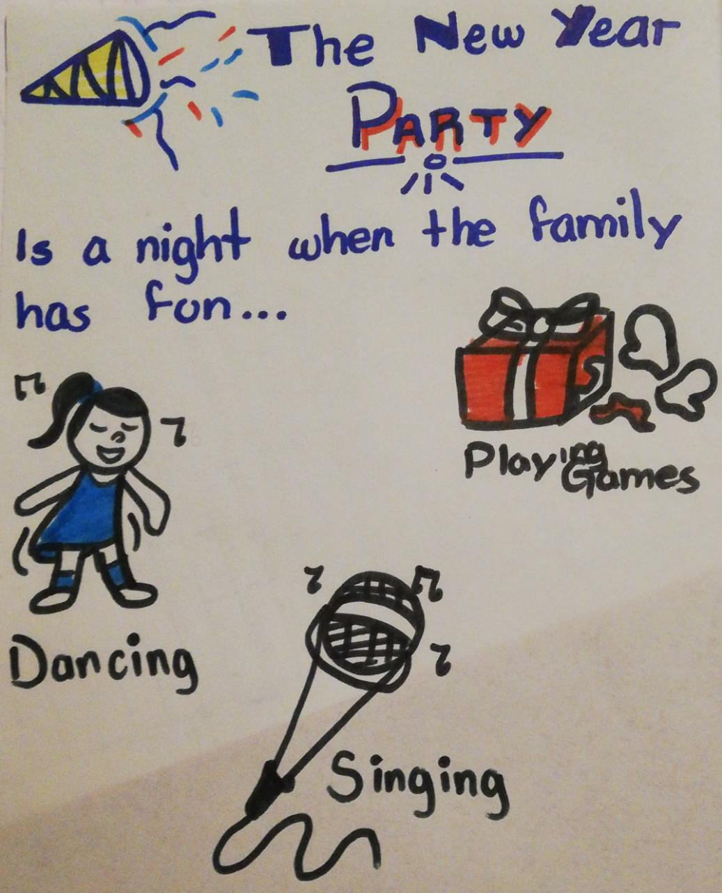

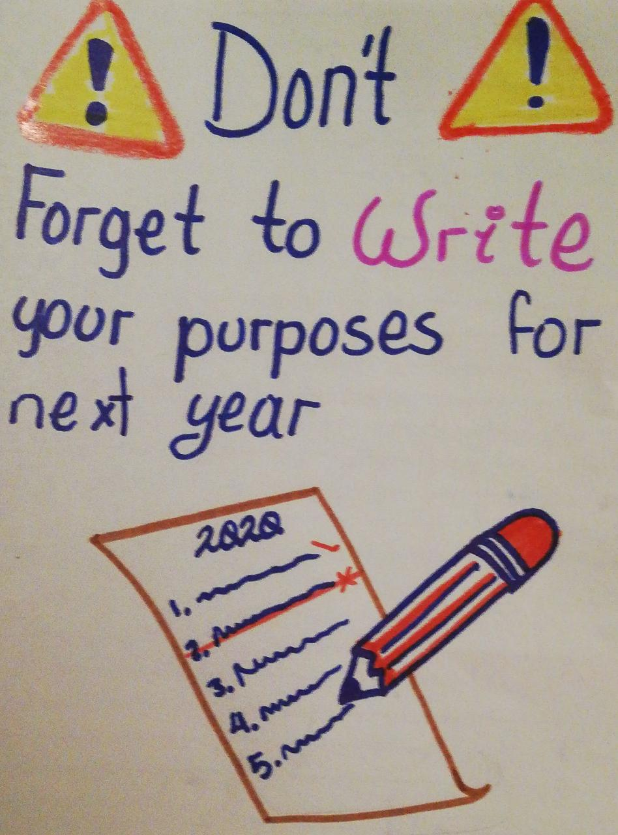

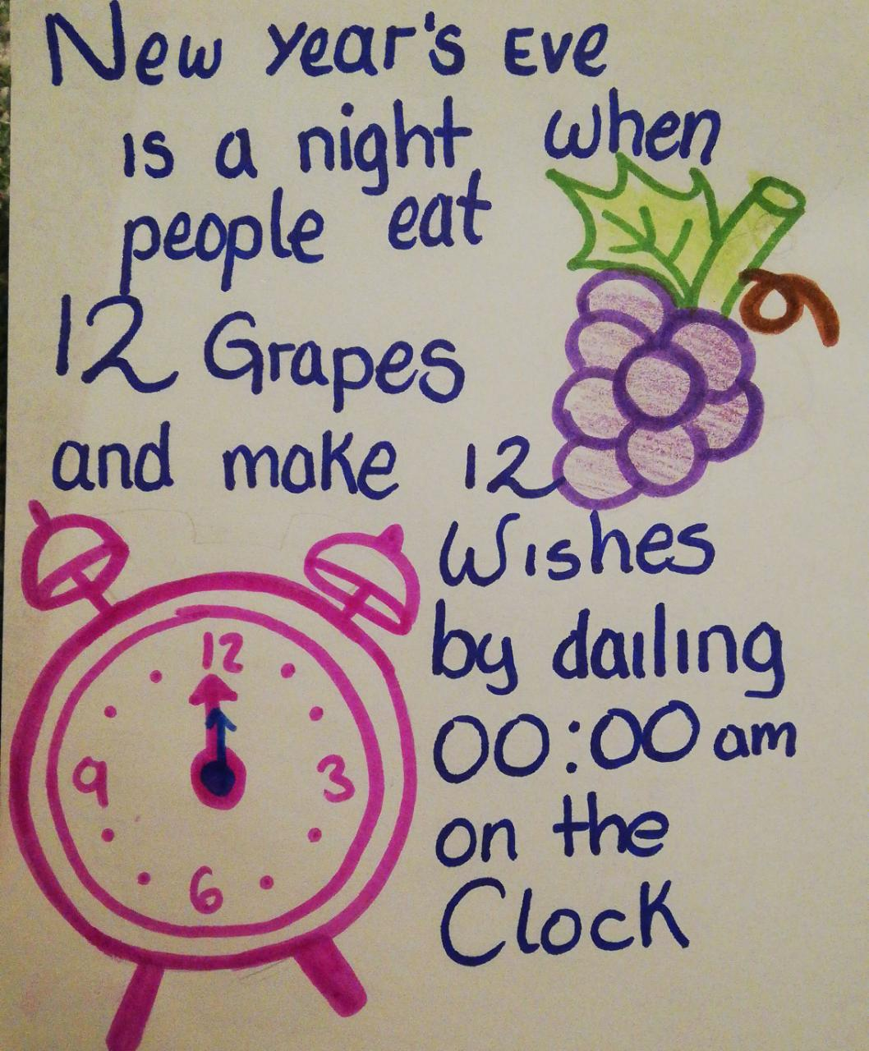

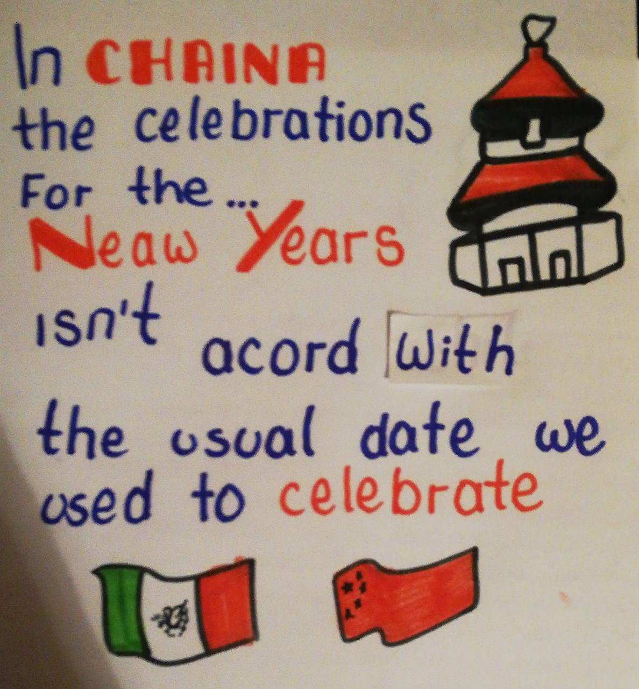

Rubric

|  |  |  |  |
| --- | --- | --- | --- |
| EVALUATION CRITERIA | NEEDS IMPROVEMENT | GOOD | EXCELLENT |
| PRODUCTS | Preparation activity or labels missing.  **1 point** | Incomplete preparation activity or labels.  The labels do not include creative material or pictures.  **2 pts.** | Preparation activity and labels presented and complete.  The students make creative and original labels using varied material  **3 pts.** |
| CONTENT | The information in the document is not accurate and the sentences have several spelling or grammar mistakes.  **1 point** | There are some missing items in the preparation activity.  The sentences have some spelling or grammar mistakes.  **2 pts.** | The task meets the requirements in the guideline with no major spelling or grammar mistakes.  **3 pts.** |
| SPEAKING TASK | Expresses him/her ideas with many hesitations and poor intonation.  Uses incomplete sentences.  Mispronounces several words.  Rarely uses appropriate vocabulary and grammar structures.  **1 point** | Is able to express his/her ideas with some hesitation but managed to maintain flow and adequate intonation.  Uses correct vocabulary and grammar structures appropriately most of the time  **3 pts.** | Is able to express his/her ideas fluently with correct intonation using complete sentences and with no major production errors.  Uses vocabulary and grammar structures appropriately.  **4 pts.** |