team:

dAIVA RAMIREZ TREVIÑO, PAULINA GUERRERO SANCHEZ ANDREA FLORES SANDOVAL

22 de noviembre de 2019

proyect unit 4 , celebrations

Escuela Normal De Educación Preescolar

**ESCUELA NORMAL DE EDUCACIÓN PREESCOLAR**

**ENGLISH B1.1 OPENING NEW GLOBAL PERSPECTIVES**

**PROJECT UNIT**

**CELEBRATIONS**

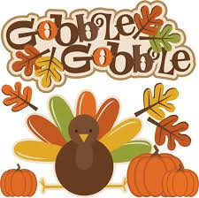

Planning

Make three teams and look for information about Thanksgiving, Christmas and New Year’s Eve. Find information about the date people celebrate each one of them, people’s traditions (food, drinks and rituals) and activities people do before and after each celebration.

Preparation

**Look at the example and write facts about the celebration you chose (date, places, and motive).**

*Ex. The Mexican Independence Day is a celebration which takes place on September 16th.*

1. Thanksgiving is a North American holiday celebrated in Canada, the United States, and in certain parts of the Caribbean islands.

2. This year thanks giving takes place on Thursday, November 28, 2019

3. Thanksgiving Day in the US is celebrated on the fourth Thursday in November.

4. The day was declared a federal holiday by Abraham Lincoln in 1863. It is also a day off to American workers.

5. The main reason for the holiday is to express gratitude.

**Write sentences about what people do before, during or after each celebration.**

*Ex. The Independence Day is a day when people eat Mexican food like tamales and pozole.*

1. Thanksgiving Day is a day when people invite their friends and family to thank them

2. In Thanksgiving people clean and organize their kitchen to be ready for guests.

3. On this day, families get together and prepare different meals with turkey meat and others massive amount of cooking.

4. It´s a day when people eat a lot and give some thanks to their guests.

5. After dinner they clean up all the table and start washing the dishes.

**Write three advices to spend a great holiday.**

*Ex. Try not to use fireworks during the Independence Day because you could get hurt.*

1. You have to start thawing the turkey, before your guests arrive.

2. Try not to buy the kitchen materials on the same Thanksgiving Day, they are more expensive.

3. Remember to make the pie crust.

4. Try to make a schedule of events for Thanksgiving day.

5. Don´t forget to invite friends and family.

Products

* Share the information you found with the rest of the class.
* Choose five sentences and make a creative label about each one for the bulletin board, include your sentences and colorful pictures.
* Paste the pictures of your labels in this document and upload it to Escuela en Red.

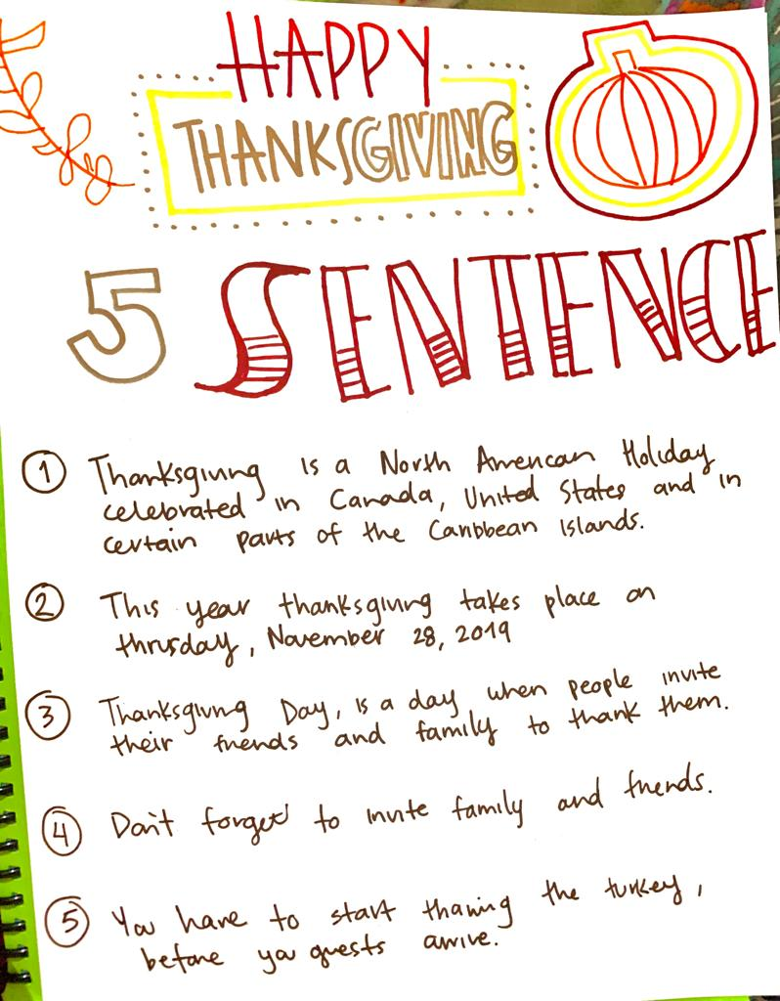

Rubric

|  |  |  |  |
| --- | --- | --- | --- |
| EVALUATION CRITERIA | NEEDS IMPROVEMENT | GOOD | EXCELLENT |
| PRODUCTS | Preparation activity or labels missing.  **1 point** | Incomplete preparation activity or labels.  The labels do not include creative material or pictures.  **2 pts.** | Preparation activity and labels presented and complete.  The students make creative and original labels using varied material  **3 pts.** |
| CONTENT | The information in the document is not accurate and the sentences have several spelling or grammar mistakes.  **1 point** | There are some missing items in the preparation activity.  The sentences have some spelling or grammar mistakes.  **2 pts.** | The task meets the requirements in the guideline with no major spelling or grammar mistakes.  **3 pts.** |
| SPEAKING TASK | Expresses him/her ideas with many hesitations and poor intonation.  Uses incomplete sentences.  Mispronounces several words.  Rarely uses appropriate vocabulary and grammar structures.  **1 point** | Is able to express his/her ideas with some hesitation but managed to maintain flow and adequate intonation.  Uses correct vocabulary and grammar structures appropriately most of the time  **3 pts.** | Is able to express his/her ideas fluently with correct intonation using complete sentences and with no major production errors.  Uses vocabulary and grammar structures appropriately.  **4 pts.** |