**ESCUELA NORMAL DE EDUCACIÓN PREESCOLAR**

**ENGLISH B1.1 OPENING NEW GLOBAL PERSPECTIVES**

**PROJECT UNIT 4**



**Write facts about the celebration you chose (date, places, motive).**

1. Christmas Day is a celebration which takes place on December 25*th.*
2. In Japon Christmas is celebrated on December 31th.
3. In Mexico Christmas is when born baby Jesus.
4. In North Korea not celebrated Christmas.

**Write sentences about what people do before, during or after each celebration.**

1. Before Christmas Day is placed the Christmas tree.
2. The houses are decorated with lights, inflatable and all decorations of Christmas.
3. During Christmas many people give presents.
4. After midnight many people open the gifts.
5. During the dinner of Christmas people eat turkey.

**Write three advices to spend a great holiday.**

1. Remember wrap the gifts.
2. Don’t forget turn on the star of Christmas tree.
3. Try not to drink a lot of vine.
4. Try not to use the fireworks
5. Be sure to turn off the stove.

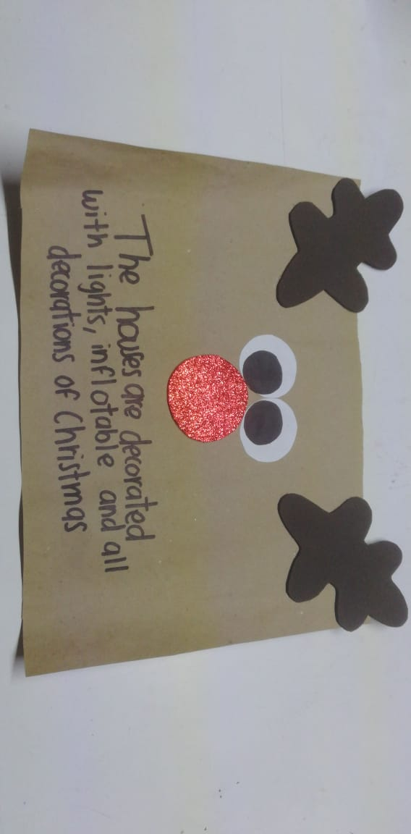

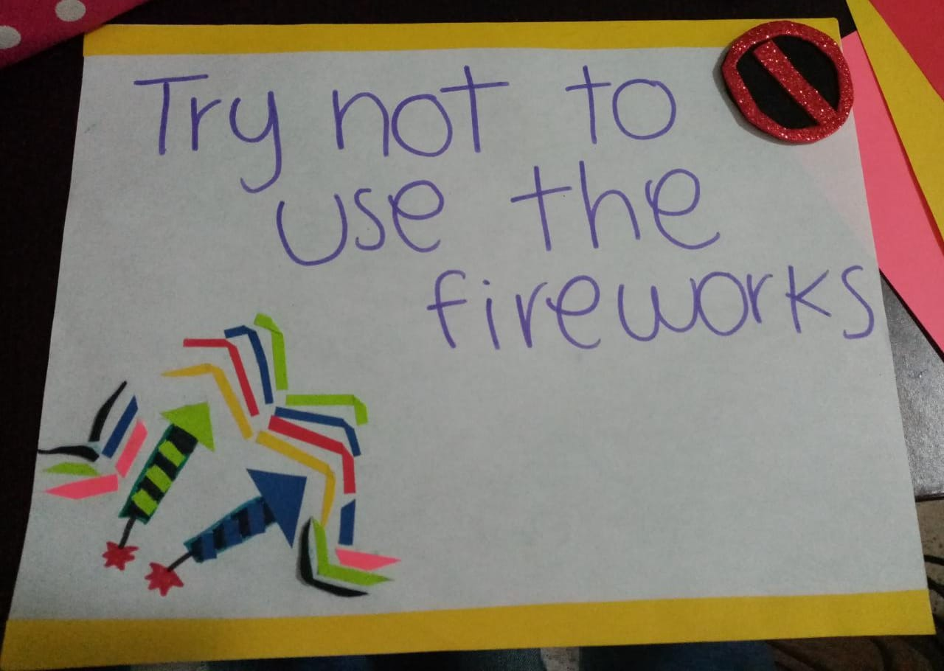**Annexes.**

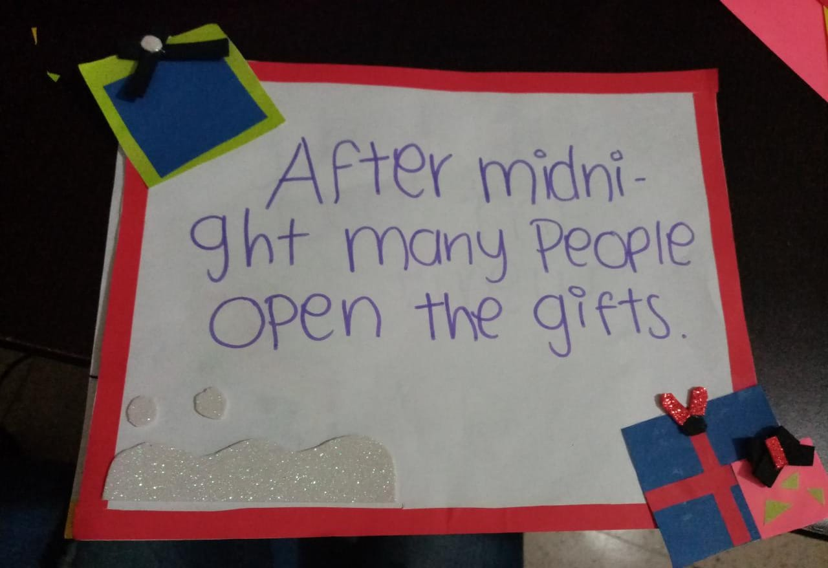

Rubric

|  |  |  |  |
| --- | --- | --- | --- |
| EVALUATION CRITERIA | NEEDS IMPROVEMENT | GOOD | EXCELLENT |
| PRODUCTS | Preparation activity or labels missing.  **1 point** | Incomplete preparation activity or labels.  The labels do not include creative material or pictures.  **2 pts.** | Preparation activity and labels presented and complete.  The students make creative and original labels using varied material  **3 pts.** |
| CONTENT | The information in the document is not accurate and the sentences have several spelling or grammar mistakes.  **1 point** | There are some missing items in the preparation activity.  The sentences have some spelling or grammar mistakes.  **2 pts.** | The task meets the requirements in the guideline with no major spelling or grammar mistakes.  **3 pts.** |
| SPEAKING TASK | Expresses him/her ideas with many hesitations and poor intonation.  Uses incomplete sentences.  Mispronounces several words.  Rarely uses appropriate vocabulary and grammar structures.  **1 point** | Is able to express his/her ideas with some hesitation but managed to maintain flow and adequate intonation.  Uses correct vocabulary and grammar structures appropriately most of the time  **3 pts.** | Is able to express his/her ideas fluently with correct intonation using complete sentences and with no major production errors.  Uses vocabulary and grammar structures appropriately.  **4 pts.** |