**Assessment Criteria**

**School Year 2019-2020**

|  |  |
| --- | --- |
| **EVALUATION OF EACH LEARNING UNIT (1-3)** | |
| Exam | **35%** |
| Projects (2) | **20%** |
| Participation | **15%** |
| Homework | **10%** |
| Portfolio | **10%** |
| English Discoveries Platform | **10%** |
| **EVALUATION OF EACH LEARNING UNIT (1-3)** | |
| Exam | **35%** |
| Projects (2) | **20%** |
| Participation | **15%** |
| Homework | **10%** |
| Portfolio | **10%** |
| English Discoveries Platform | **10%** |

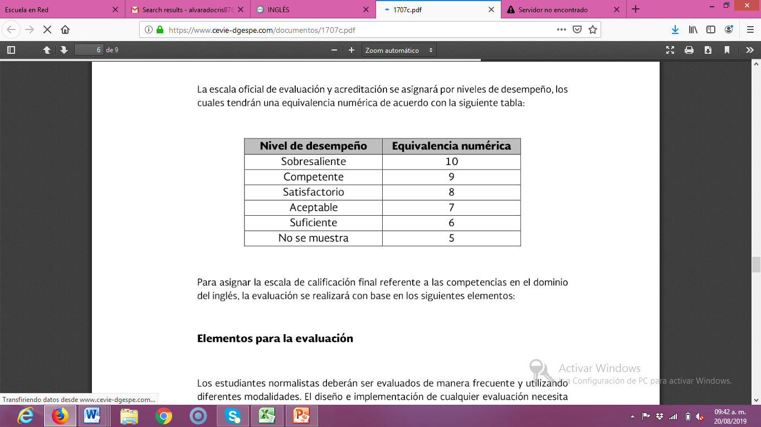

**Attendance, punctuality, attitude, complete materials, respect, and classwork**