UNIT 1 “Where are you from?”

“**SHARING INFORMATION AND IDEAS”**

**OBJECTIVE: TO GIVE STUDENTS PRACTICE GIVING INFORMATION ABOUT SOMEONE ELSE**

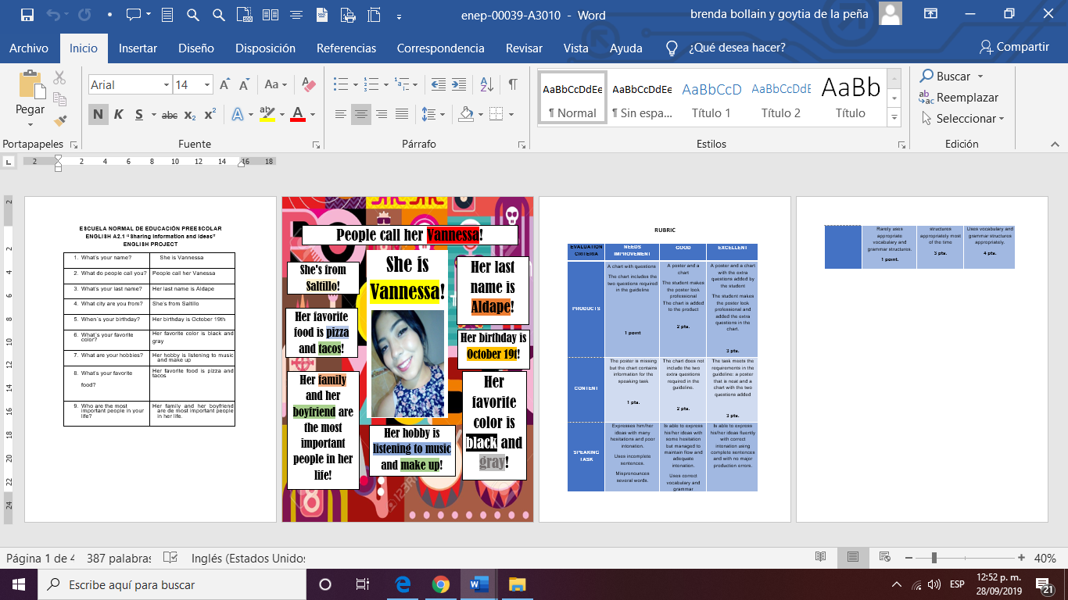

UNIT 3 How much is that?

“**SHARING INFORMATION AND IDEAS**

**Aim:** To describe prices and discuss preferences. To use demonstratives, one, and ones in a conversation to ask about prices while shopping

**Instructions**: You must upload *this* word document in Escuela en red. with your full name, your team´s number, the answers for the conversation and your list of items for sale. (individually) **Prepare for your oral presentation.**

|  |  |
| --- | --- |
| **Items for sale (description)** | **Prices** |
| Gold necklace  Leather brown belt  Wool black gloves  Short blouse  Black and white plastic bag  Pink leather bag  Silver earrings  Cotton sweater  Floral blouse  Denim jacket  Wool sweater  Plaid sweater  Blue wool cap  Pink plastic cell phone case  Gold earrings  Green velvet lycra  Black leather sandal  Pink polyester dress  Black silk skirt  Flowered polyester dress  Flowered cotton dress  Red silk dress  black leather jacket  green polyester jacket  Red striped shirt  Blue denim cap  Green and white flowered dress  White Wool Sweater.  Blue striped blouse. | 1-$20.00  2-$49.99  3-$10.55  4-$3.60  5-$15.95  6-$3.66  7-$18.50  8-$20.00  9-$6.00  10-$3.001  11-$15.00  12-$25.55  13-$10.00  14-$15.00  15-$3:00  16-35:00  17-$20.00  18-$26.13  19-$33:00  20-$25.99  21-$15.00  22-10.00  23-$25.50  24-$38.99  25-$30.00  26-$12.90  27-$5.80  28-$19.99  29-$8.99 |