Escuela normal de educación preescolar
english b1.1 unit 3 project
I HATE CLEANING!

Aim: Give Ss practice using infinitives and gerunds.
Preparation: Make one copy of the worksheet for every S.
Materials: Poster paper; colored pencils or pens

Plan
■ Give each S a worksheet.
■ As a class, brainstorm chores Ss hate to do. Elicit reasons.
■ Have Ss write their least favorite chores and reasons.
Prepare
■ Divide the class into small groups.
■ Explain the task. Ss choose one chore they dislike.
■ Ask Ss to design an invention to perform their chore.
■ Have Ss make an ad for the invention. Encourage them to draw pictures and to describe what the device can do.
Present
■ Have groups share their inventions with the class. Encourage them to describe how the invention works and what it could be used for.

I HATE CLEANING!
Plan
What are some chores that you hate to do? Why do you dislike them?

 | Chore | Reason
1.
2.
3.
Prepare
GROUP WORK Choose a chore that you dislike and design an invention to do
it for you. Then make an advertisement. Be sure to draw a picture of your invention
and list its features.
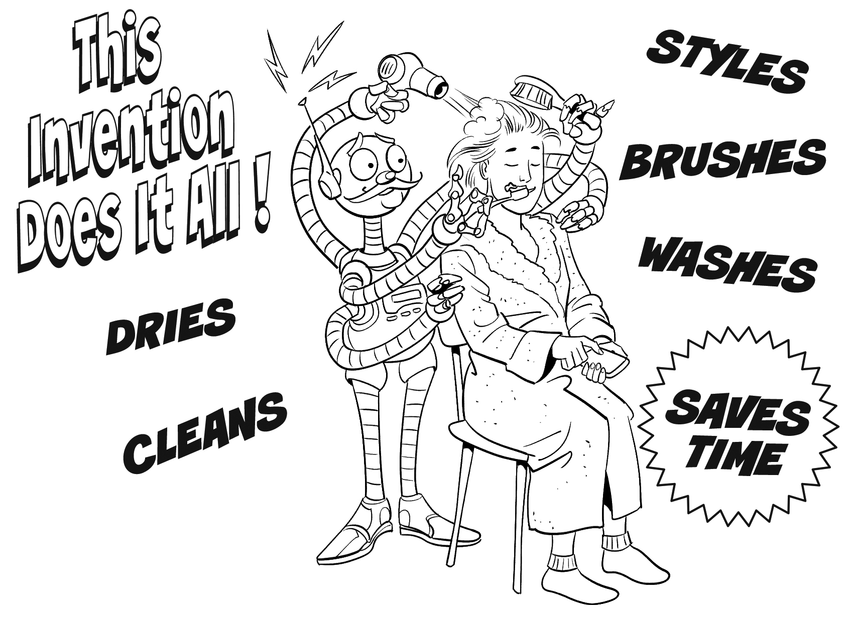
Present
CLASS ACTIVITY Share your invention with the class. Explain how it works and what it can
be used for. UPLOAD THE PLANNING CHART AND A PICTURE OF YOUR ADVERTISEMENT.

RUBRIC
EVALUATION CRITERIA | NEEDS IMPROVEMENT | GOOD | EXCELLENT
PRODUCTS | The planning chart is completed correctly.  The advertisement is not creative or original with varied materials.  The poster does not include a draw of the invention and the list of its features.  1 point | The planning chart is completed correctly.  The advertisement is creative and original.  The poster does not include a draw of the invention or a list of its features.  2 pts. | The planning chart is completed correctly.  The advertisement is creative and original.  The poster includes a draw of the invention and a list of its features.  3 pts.
CONTENT | The presentation does not meet the requirements in the guideline (3 or more sentences missing)  1 pts. | The presentation does not meet the requirements in the guideline (1-3 sentences missing)  2 pts. | The task meets the requirements in the guideline (5 usages of the invention and 5 suggestions for use)  3 pts.
SPEAKING TASK | Expresses him/her ideas with many hesitations and poor intonation.  Uses incomplete sentences.  Mispronounces several words.  Rarely uses appropriate vocabulary and grammar structures.  1 point. | Is able to express his/her ideas with some hesitation but managed to maintain flow and adequate intonation.  Uses correct vocabulary and grammar structures appropriately most of the time  3 pts. | Is able to express his/her ideas fluently with correct intonation using complete sentences and with no major production errors.  Uses vocabulary and grammar structures appropriately.  4 pts.

