Unit 5 and 6 project: What’s a good job for me?
COMPETENCES OF THE DEGREE PROFILE DEVELOPED THROUGHOUT THE LEARNING UNIT(S): | - Use language to establish harmonious and responsible relationships when exercising citizenship.  - Reflect on one´s own learning process to act consciously in communicative exchanges.  - Understand and produce texts to participate in a variety of everyday and concrete situations.  - Exchange basic information about personal and professional experiences.
The Student can: | - Describe people and things in the past, present, and future  - Discuss possible consequences of actions  - Understand descriptions of skills and personality traits  - Discuss job skills  - Give reasons for their opinions
TASKS
1. WRITING  a) Write a cover letter for a job application using gerunds and clauses with because.  b) Imagine you are applying for a teacher position, which you are very interested in, and so you will need to give reasons for hiring you. Write about things that you do and can do. Topic: “How would I describe myself?” (120-160 words) |  | 2. SPEAKING  Talk to your partner about the following subject: Do you think you’d make a good teacher? Why?  Use the expressions and vocabulary in the Language Summary of unit 6.  1. Expressing feelings and opinions. I like… I love… I enjoy… I’m good at... I’m interested in… To be honest: I’m not good at… I don’t like… I hate… I can’t stand… I don’t mind… And also, 2. Talking about possible occupations (involved with education in your case). 3. Agreeing with feelings and opinions. 4. Disagreeing with feelings and opinions.
- The written work, both a) and b), must be done in a word file and uploaded in the activity at Escuela en Red by March 12th, 2020.
- Written work b), must be turned in hand written by March 12th, 2020.
- Feedback will be given within a week.
- The speaking part will be presented in class on March 12th and 13th.
Writing part will be assessed according to:  Did the student apply the new functions? 1 2 3 4 5  Did the student apply the new structures? 1 2 3 4 5  Did the student apply the new vocabulary? 1 2 3 4 5  The written work is neat, and understandable? 1 2 3 4 5  Does it contain the required elements? 1 2 3 4 5  total  General Comments:  Suggestions for improvement: | Speaking part will be assessed according to:  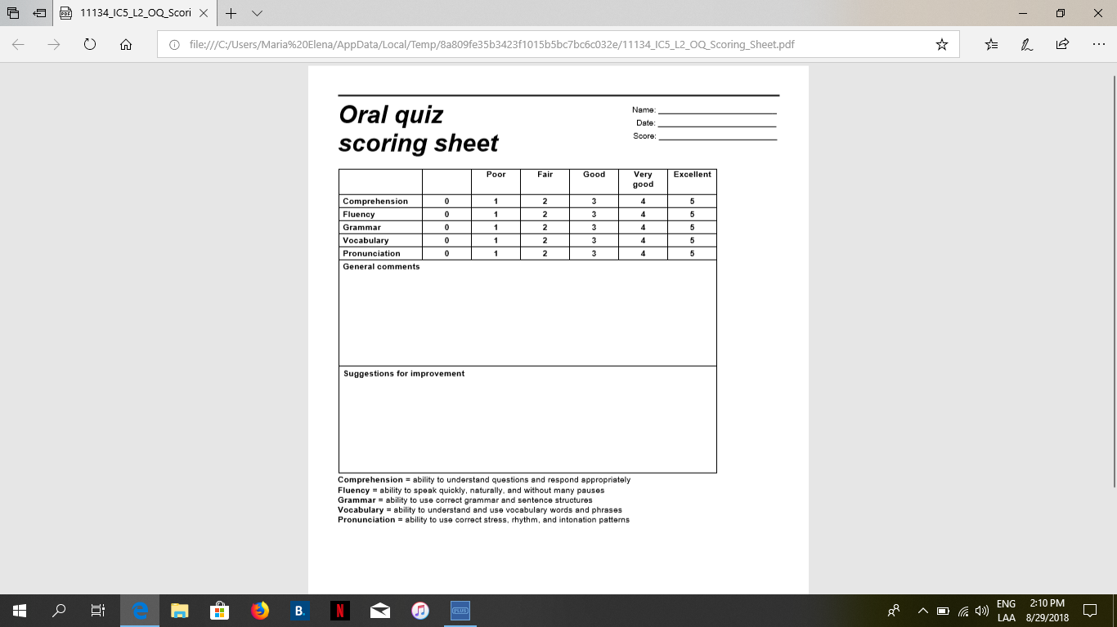

COVER LETTER

Early Childhood Educator
Picture  - Name  - Telephone number to get in contact with you  - e-mail | EDUCATION  Example:  2015-2017 Escuela de Bachilleres Dr. Mariano Narvaez  EXPERIENCE  CERTIFICATES  REFERENCES
PROFILE
Interests, Skills, Preferences
skills:

