**ESCUELA NORMAL DE EDUCACION PREESCOLAR**

**CICLO ESCOLAR 2014-2015**

**RUBRICAS PARA ELABORACIÓN DEL PROYECTO BIMESTRAL DE INGLES A2**

|  |  |  |
| --- | --- | --- |
| Unidad modulo o bloque | **Module 8** Traveller ELEMENTARY | |
| Tema | **“ ADVENTUROUS EXPERIENCE ”** | |
| Competencia a desarrollar | * Utilizar la lengua para expresar conceptos propios de la unidad. | |
| Aprendizaje esperado | * Present Perfect Simple *(ever, never, before*) * Present Perfect Simple Vs Past Simple * Talking about experiences / misfortunes * Talking about countries * Describing a holiday | |
| Rasgos o competencias del perfil de egreso. | * Aplica sus habilidades comunicativas en diversos contextos.   oDesarrolla sus habilidades comunicativas para adquirir nuevos lenguajes.  oUtiliza una segunda lengua para comunicarse.   * Emplea las tecnologías de la información y la comunicación.   oParticipa en comunidades de trabajo y redes de colaboración a través del uso de la tecnología. | |
| **TRABAJO A DESARROLLAR. E-mail “ ADVENTUROUS EXPERIENCE”**   * Individual activity * Write an e-mail to a friend telling him/her about an adventurous experience you have had in your last trip. (must be an e-mail format) * Use the following reference as an example. | | |
| Acuerdos sobre la forma de evaluar. Incluir: estructura general del portafolio, autoevaluaciones, coevaluaciones. | | Read all the instructions before you begin.  **STEP 1 PRE-TASK**  Students acquire new structures, vocabulary and functions of language in complete module 8 (Traveller Elementary)  **STEP 2 PREPARATION**  Students practice withgrammar structures, vocabulary and functions of language in complete module 8(Traveller Elementary)  **STEP 3 REALISATION**  Students develop the project using enough functions, vocabulary and structures on it.    **STEP 4 POST-TASK**  Students close unit with the project which is going to be shared with the group and evaluated by the teacher |
| Identificación de los productos por unidad, tema o actividad (Nombrar los productos) | | Turn in the TASK PROJECT by **Wednesday the 17th of June.**  It should contain:   * Cover page with the rubrics * Develop the project including grammar, functions and vocabulary from the unit. * Upload the project in Escuela en Red by **Wednesday the 17th of June.** |
| Señalar con precisión de características, tiempos y condiciones de entrega | | Project (physical product) must be handed out same day as oral presentation on class time, by Wednesday the 17th of June.  Requirements:   * Individual work * Write an e-mailyou can include include some images, e-mail format includes Subject, greeting and farewell, introduction, body text, etc. (interesting and creative +5) * Include interesting information about your experiences. * You must talk about an adventurous experience you have had Grammar from module 8: Present perfect and simple past. (+10 colored in blue) * Include: Vocabulary/ functions / expressions from module 6 (+ 5 colored in red) * Upload document in Escuela en red and hand out the printed work to the teacher. * Deadline time **Wednesday the 17th of June** |
| Señalar con precisión Tiempo estimado para la retroalimentación | | The teacher’s feedback for the project will be given by the teacher the next English session on Wednesday the 17th of June. |
| Describir condiciones y ambiente para la presentación final del portafolio | | * **All the elements of the project must be shown to the teacher on Wednesday the 17th of June.** |
| Matriz o rubrica de evaluación con un apartado de retroalimentación u observaciones por parte del docente y análisis por parte del alumno | | The written presentation will be graded as:  Does the student correctly use grammar from the module?  Does the student use appropriate vocabulary form the module?  Overall, is it easy to understand the student?  Does the student express himself or herself fluently?  The written work will be graded as:  Did the student apply the new functions, structures and vocabulary?  The written work is neat, complete and understandable. |

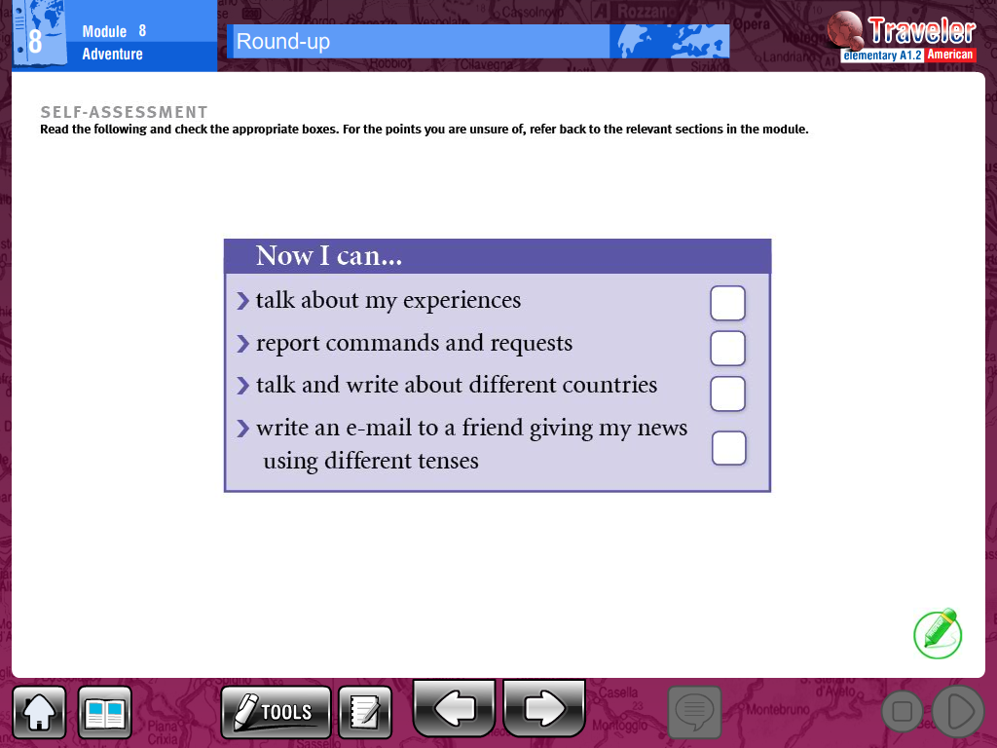



Name____________________________________________ Date________________