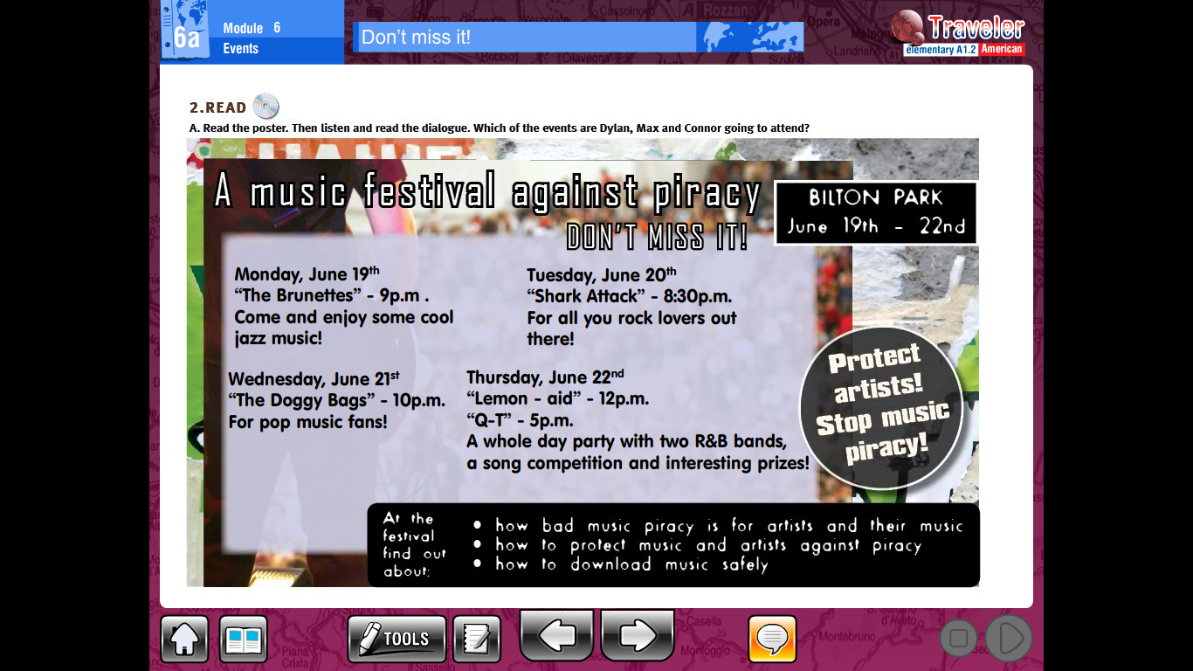 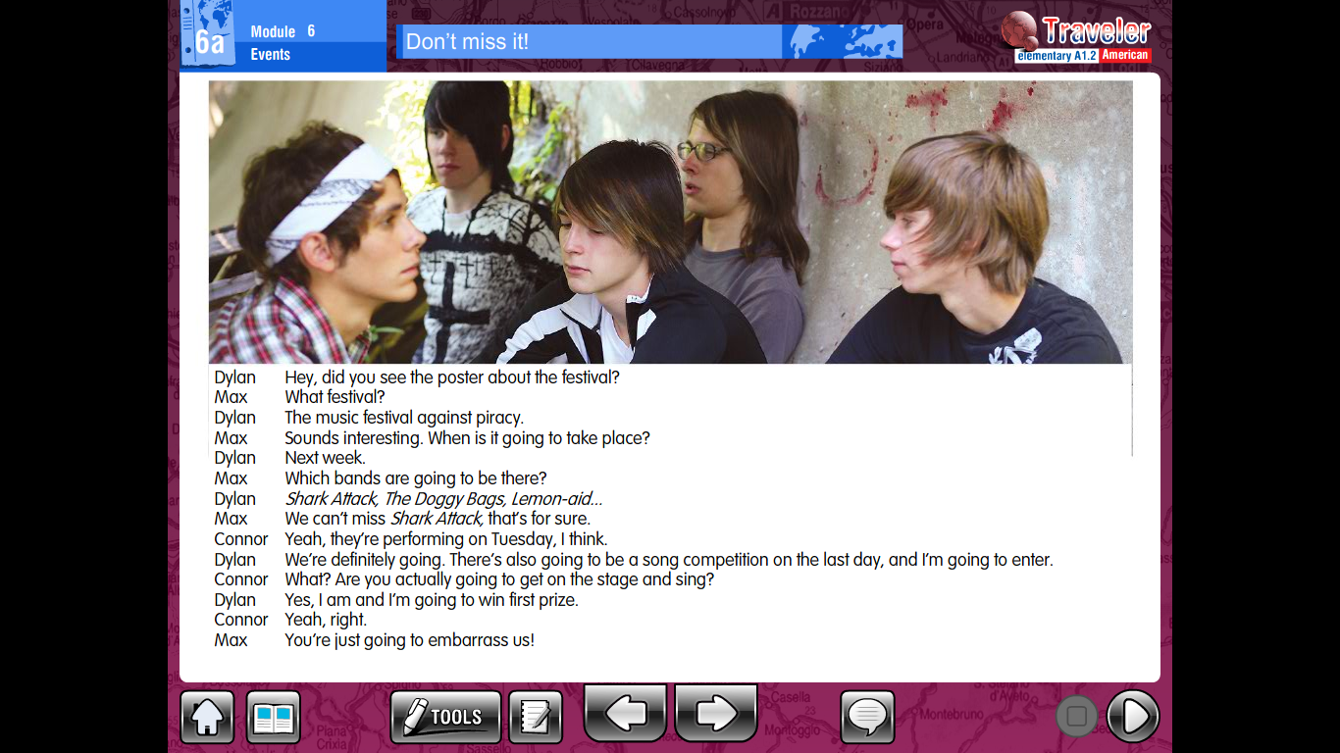

Read through the poster and answer the following questions in your notebook. You may print the questions.

1. Where is the musical festival taking place?
2. When is it taking place?
3. What kind of music do “Shark attack” play?
4. When can pop music fans go to the festival?
5. What will the last day’s party include?
6. Can piracy help artists and their music?
7. What will people who download music learn at the festival?
8. When can jazz fans go to the music festival?
9. What kind of music do *The Doggy Bags* play?
10. When’s the party?
11. How did Dylan find out about the festival?
12. On which Day(s) is Dylan definitely going to attend the festival?
13. According to Dylan’s friends, is Dylan going to win?
14. Which of the events are Dylan, Max and Connor going to attend?