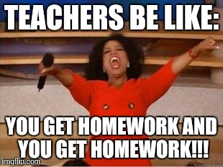

Dear student,

Yes, you do have homework!

I have assigned you several tasks on the platform English Discoveries.

The due date is **Monday the 13th.**

Remember that this is part of your evaluation, but above all, self-study is a more important part of your path to success.

Keep yourself motivated and be the best version of yourself EVERYDAY!!

If any doubts about how to access the platform (HOPE NOT) contact your teacher.