

**Escuela Normal de Educación Preescolar.**

**Student: Lucia del Carmen Laureano Valdez.**

**Teacher: Mayela Alejandra del Carmen Gaona Garcia.**

**English A1.2 Group: 3**

***Portfolio Learning evidences Unit 7***

**Unit 7: Does it have a view?**

**Contents: Asking and describing houses and apartments, rooms and furniture. Use of simple present, and short answer, use of there is, there are, there no, there isn't, there aren't any, there are no.**

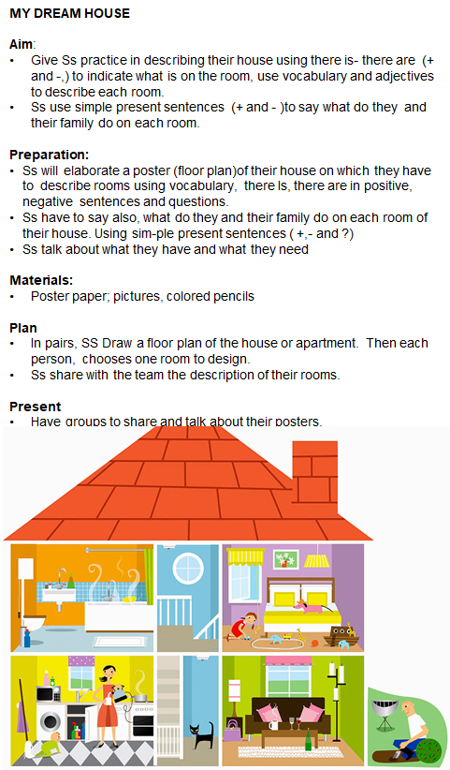

**Evidence Unit 7**

-Do you live in an apartment?

No, I don't. I live in a house

-That's great!! Does his house have a yard?

Yes it does. My house has a beautiful yard

-Do you have plants in the yard?

Yes, there are plants in the yard

-Do you have chairs in the yard?

Yes, there are two chairs in the yard

-Do you need a coffee table in the yard?

No, I don't. I have a table in the yard

-Do you have swimming in the yard?

Yes, There's a swimming in the yard.

-Does your house have many bedrooms?

No it doesn't. My house has only one bedroom

-Do you need a stove in the kitchen?

No I don't. I need a microwave in the kitchen

-Does the bathroom have a bathtub?

No it doesn't. I need abathtub in the bathroom.

-Do you have books in your bookcase?

No, there aren't any books in the bookcase.

-Does your bedroom have pictures?

Yes, There're three pictures in the bedroom

-Does your bathroom have a mirror?

Yes, There's a mirror in the bathroom

-Do you have a sofa in the living room?

Yes, I have a sofa in the living room

-Do you have a T.V. in the living room?

Yes, There is a TV in the living room

-Does your bedroom have a rug?

No, There isn’t a rug in the bedroom. I have rug in the bathroom.

